Section 1:- introduction

Section 2:- Components

Section 3:- Directives

Section 4:- Services Section 5: Posting data

Section 6: using multiple services

Section 7: Rest api using Express JS not done

Section 8: angular client and routing Section 9 : pipes

Section 10: reactive forms Section 11: template driven forms Section 12: custom directives Section 13: project usecase

Section 14: create the java backend

Section 15: create the flight reservation app Section 16: develop flight checkin app

Section 1 : Introduction (mysql root/test)

###### Single page application

Web application are entirely run in web browser and they do not need any page reload. In traditional application:

When any request from ui , it will go to server and fetch data and as in html page it will back to ui as page refresh.

But in SPA page is loaded only once initially. Request is send to backend but backend is only responsible for sending data.

And the frontend will dynamically update the html dom without refreshing the entire web page.

###### Examples

**Fb and gmail**

Using JS we are going to generate html page dynamically

###### Advantages

**Better user experience :** end user feel entire application Is running on his machine

**Fast** :- once the data is loaded in web browser we do not need to fetch data again and again only in case data has to be updated,

created we need to go in backend.

**Easy development :** it will separate out frontend and backend and also same backend can be use by multiple frontend

**Work offline :** SPA can work offline once all the data is fetched

D/A

Less secured : we need to enable cross side scripting which will enable attacker to inject client side scripting Memory leak

###### What and why angular

**Angular JS :** is single page application development framework or platform that is build using html and typescript

###### Architectural features

**Components:**

Every angular component is made up of atleast one component.

Component is combination of **data and logic** and associated html template that renders the data using the logic onto the web browser.

Every application will have root component followed by several other component to render the different part of our application

Onto the browser.

###### Html template (two types)

**Angular directives** : we can define logic in our html page **Data binding** : we can bind data to the html dom element Event binding

Property binding :--bind html input properties to the model in our angular application

###### Services

Usually we fetch data from backend , DI we can use to fetch data in component and then we can render data in html

###### Routing

As user click on button we need to route it to appropriate view

###### Software setup

**Install angular Step 1: Install node js**

<https://nodejs.org/en/download/>

Node to be installed so the we can use npm( node packaging manager to install angular) Installed node js

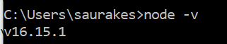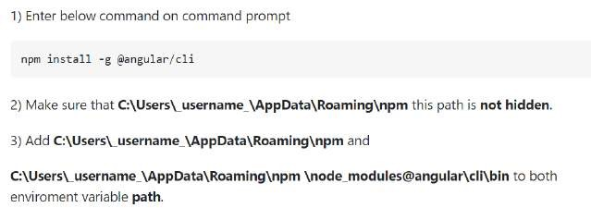

###### Step 2: install angular cli using npm

npm install -g @angular/cli

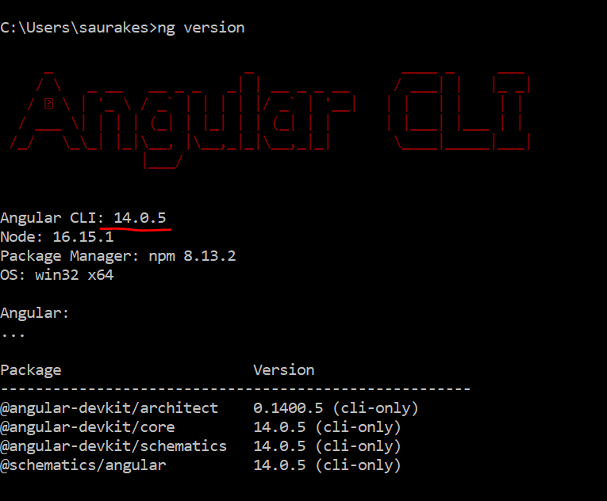

=====================================================================

**Create angular project :** Ng new application name

**to run application :**-Go inside project

run : **ng serve -o** ( -o will open in web browser)

That will compile all code in our angular application it will pkg it then it will launch the application on particular port and it will

Open web browser

###### Npm install -g @angular/cli Ng new my-app

**Cd my-app Ng serve -o**

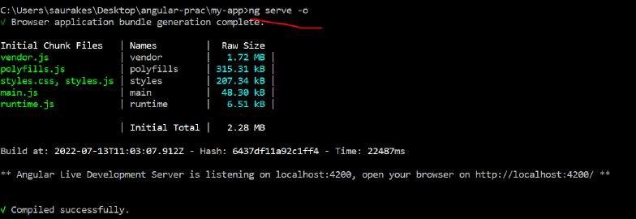

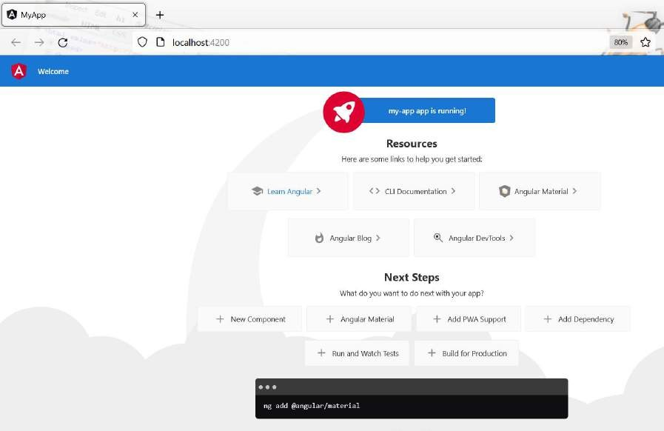

**Ng serve -o :** started the angular application **NPM** : it is utility to install several node modules **Install yarn** : it is required to work with express js

###### npm install --global yarn Yarn --version

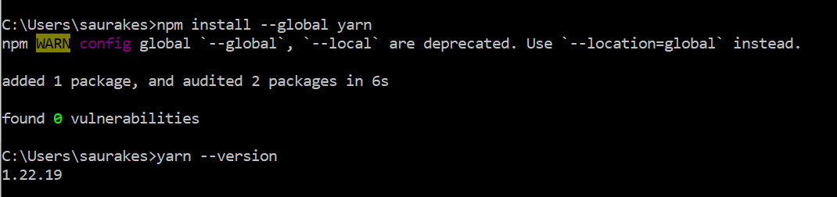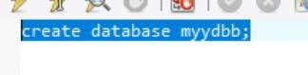

Note

**node modules** will get added very first time we run project.

**Node modules** will contain all the dependencies required by the project

**Npm install** will run inside project : will get all the node-modules required by project

**Section -2**

**Components (combination of model and view)**

**It is key feature using which we create our own html like element**

These are custom element which have their own look and behaviour

<navbar> <mymenu> <footer>

We structured our application using bunch of component

**Application build on angular that is a combination of multiple componen**t which is nothing but custom html(like header component, search component) that can talk with each other

This is the html that is responsible for rendering this component Class here will have all the data and logic

Think component as combination of this class here which represent the model (data) and it can also make backend call Through services and this html page is responsible for rendering the ui page to the end user

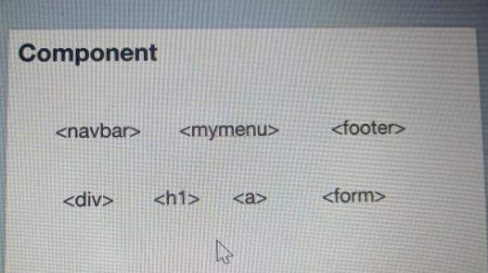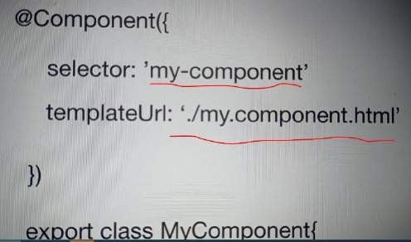

###### Within component annotation there are two attribute

**Selector :** give a name for our custom html now we can use my-component in any html page of our application

**Model** class is responsible for data and logic

**And html** class is responsible for rendering the ui to the end user

###### Create the project



**ng new** : the angular cli makes it easy to create an application that already works, right out of the box

**Ng generate :** generate components, routes ,services and pipes with a single command . The cli will also create simple test shell for all of these

**Ng serve** :- easily test your app locally while developing

**Ng serve -o** : build the application and launch the application in web browser



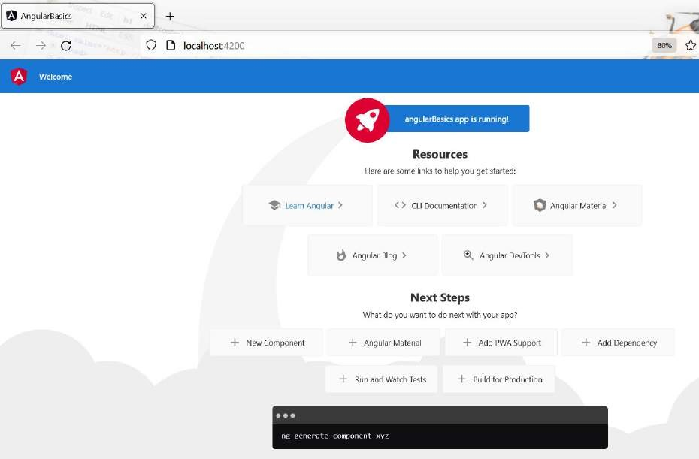

###### Important project files and folders

When we access application **localhost:4200** the default page will be served for us that is **index.html**

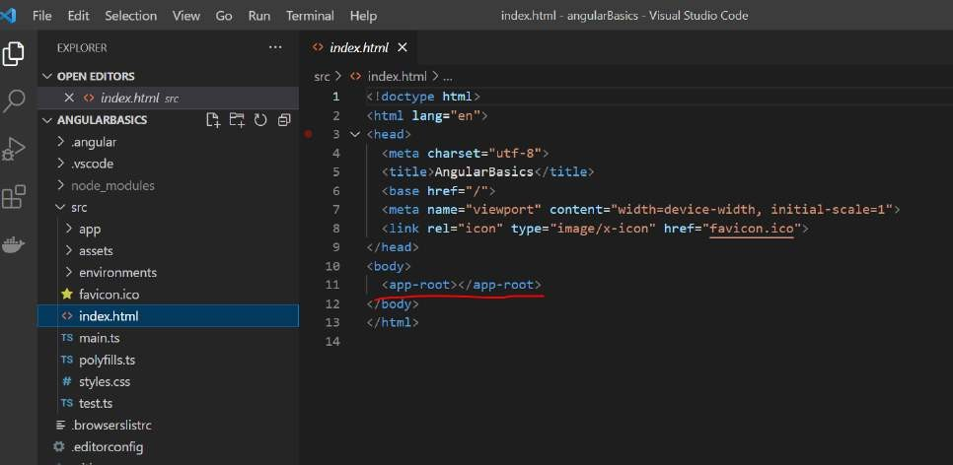

App-root :--- is angular component that got generated automatically when we created our application

**These 5 are default component** when we created our project

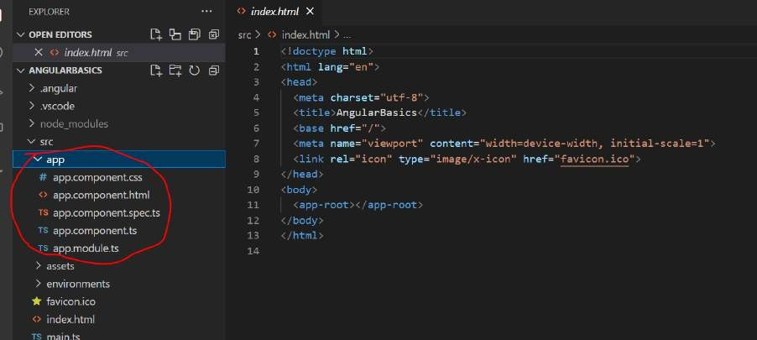

Selector will specify when this component should be used

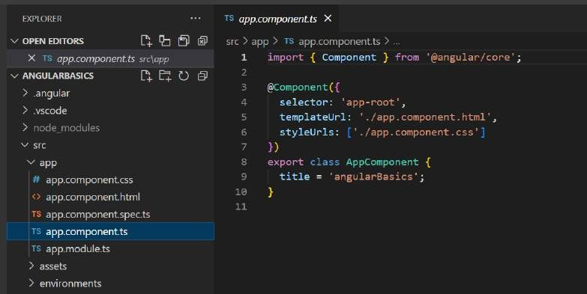

When we use <app-root> in html then angular knows any component that marked with this should be executed. That is the mapping happening using **selector**

###### Note :

**Every component have**

Typescript file Css

Html file

###### Imp file :- package.json

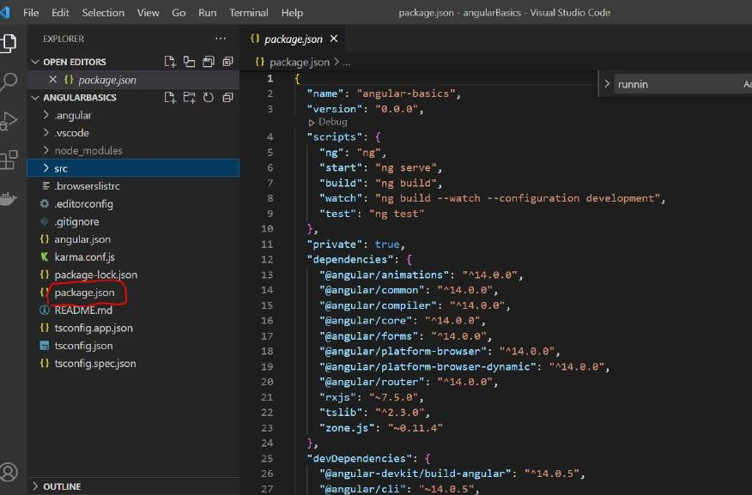

All the **angular lib** are listed here

**Create the first component Angular cli** create a default component under **the app**

This component is referred by using selector which angular did it by using in index.html. Ts file will define all the logic , html knows how to render it

###### Will define our own component then will follow same structure. Create component

**Ng generate component product or ng g c product**

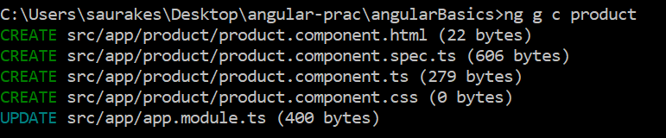

**Note :**

The new component will be added in **app.module.ts**

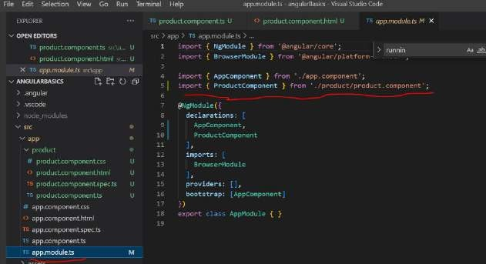

Under app it will create product and all the 4 files is there

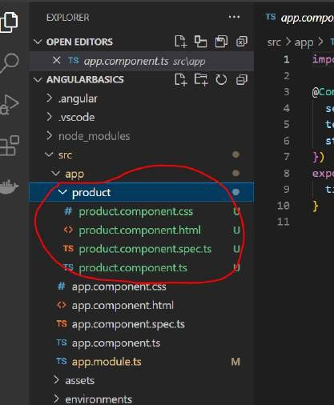

This is method will get executed when component is created and initialized Step 1

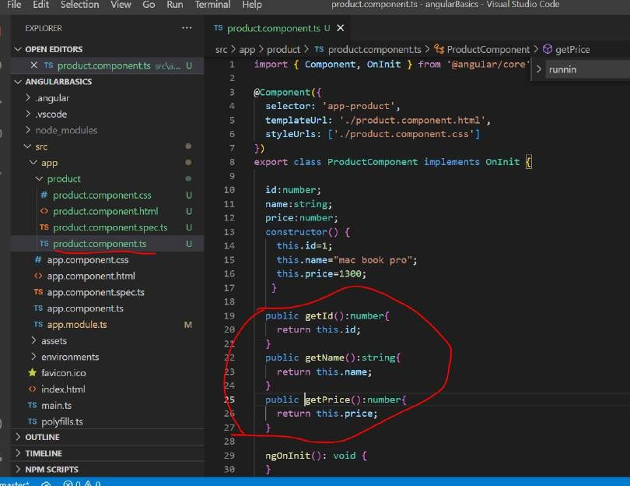

###### Step 2:

We have to use this component in html and render it

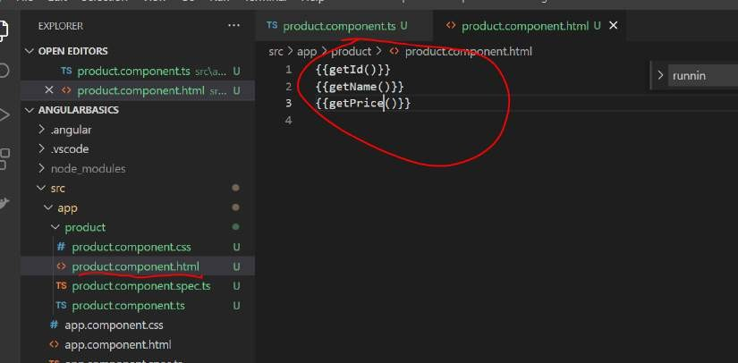

We have use component method to render the properties in html method

###### NgModules

Every angular application has atleast one root module that bootstrap all the functional module together. Components and services are called functional ngModules and appModule where we configure or bootstrap all these together

So that we can run our application.

ngModules define compilation context for set of component and services that addressed particular functionality in our application

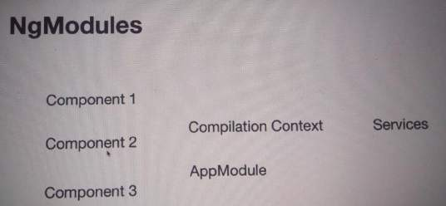

#### What are NgModule in Angular?

NgModules configure the injector and the compiler and help organize related things together. An NgModule is **a class marked by the @NgModule decorator**. @NgModule takes a metadata object that describes how to compile a component's template and how to create an injector at runtime.

Example :

AppModule will tie all the components and service together which connect to backend.

**Once we have one particular module define we can use in other application or within application we can use it in multiple places by importing them**

We will import router in multiple application we create and also will import http in multiple application we create

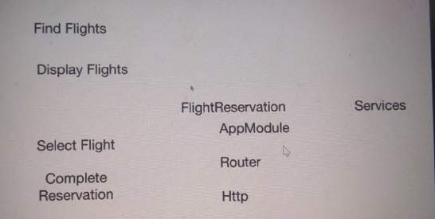

###### Advantages :

**Reusablility**

**Bootstrap and run the first component App.module.ts :** configuration file for entire application

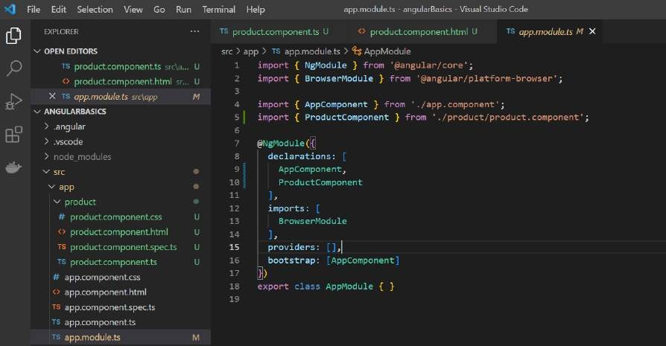

###### Declarations

Where we put all the component of our application

###### Imports

Will import external module for our application that is required to work All the angular application need browserModule to render the application.

**Bootstrap** :-------

###### starting point of our application

It tell what is the first component that will be use when application starts up It will invoke app.component.ts

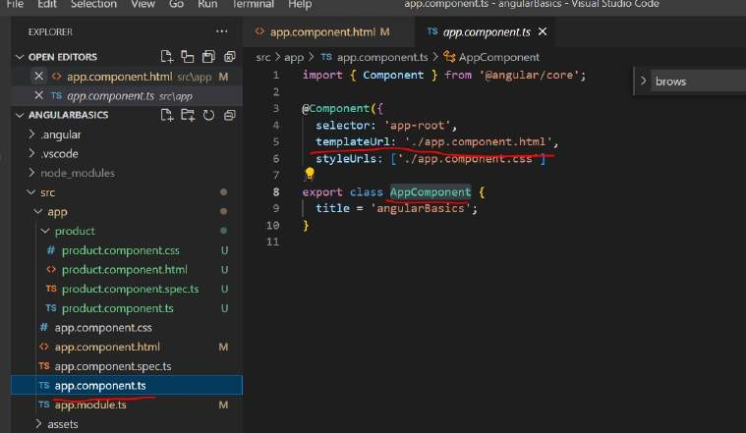

From here it will invoke **app.component.html**

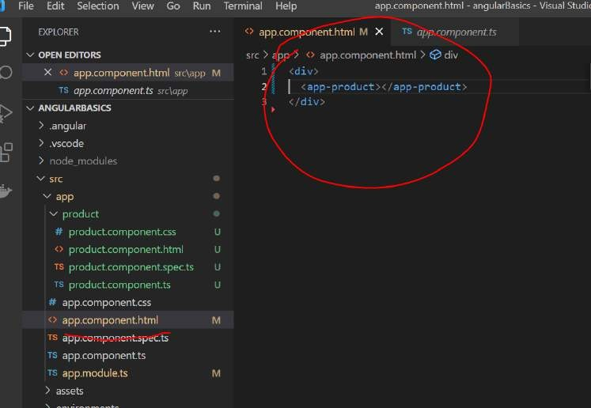

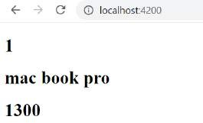

###### Note:

We can use one component inside another component and as the application grows the component tree will build up We use product component inside the app component which is default component.

###### Using the new component as the root component

We have included **custom component in the root component Imp:**

We can make **product component** as the **bootstrap component**

###### For this we need to make change in two place ( configuration file and index.html)

1. **Index.html**

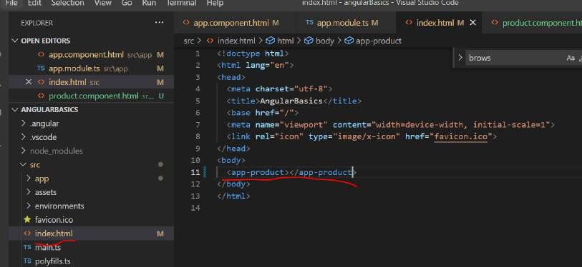

1. **App.module.ts**

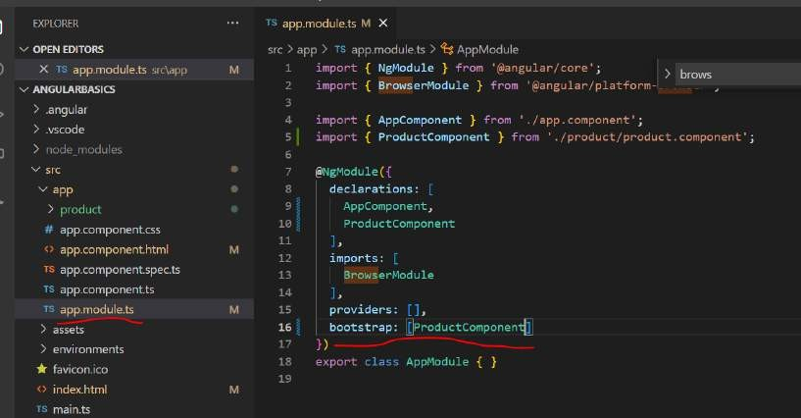

**The beauty of angular js server** already detected the changes and build our application and pushes those changes to the web browser and we still see the same output.

Note :

**Now inside product component** we can start including other component and we can include element in product.component.html

###### Create a seller component

**Objective**

Will create another component that will list out all the seller of this product It will create component and it will also update **app.module.ts**

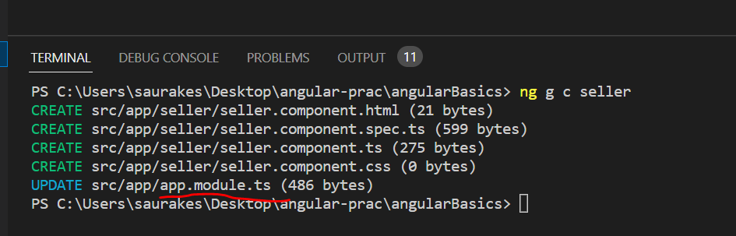

It is also added in declaration section means it is ready to be use

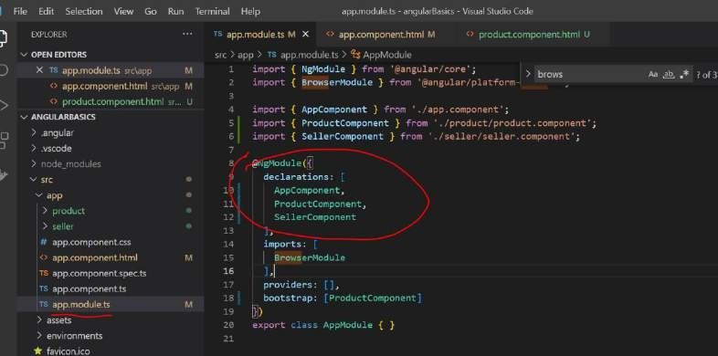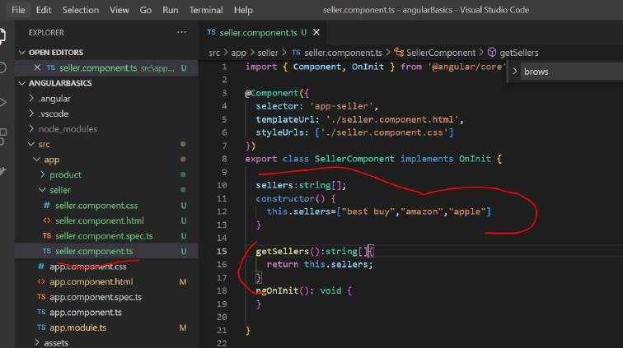

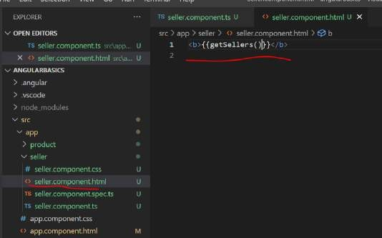

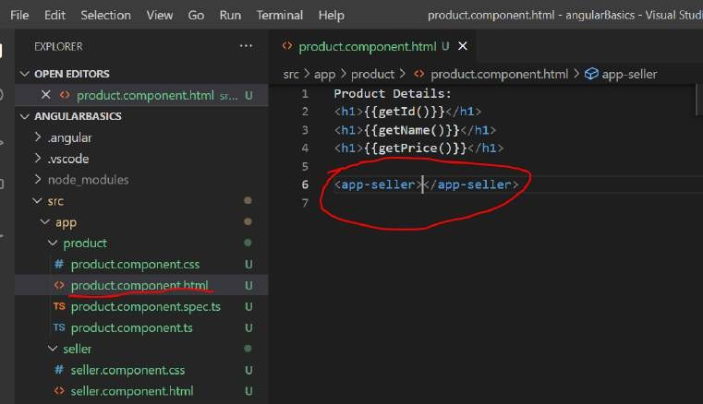

* **Angular started with main.ts.**
* **Then we bootstrap an angular application and we pass app.module.ts as an argument. In app.module.ts we tell angular: *"There is the app component which you should know when you try to start yourself".***
* **And angular now analyze this app component, reading the set up we pass there and there is *SELECTOR app-root*.**
* **Now, angular is enable to handle *app-root* in the index.html and knows rules for the *SELECTOR*.**
* ***SELECTOR* should insert the app components and have some HTML code - a template attached to him**

**- html component.**

* **This is how Angular application starts.**

**Note :**

**We are using seller component** as child component insid**e product component**

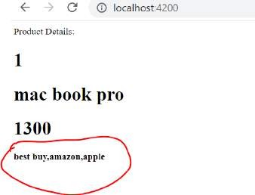

**Using Arrays of data and ngFor directives**

**Objective :**

How to deal with arrays of data

Instead of single product if we have multiple product we can use ngFor directive.

Inside the html loop the product and display their details

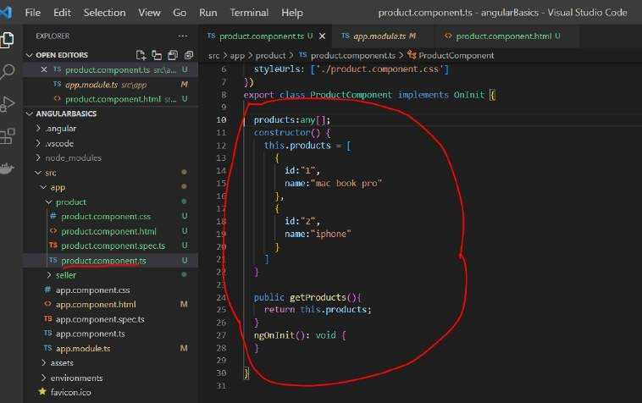

**ngFor** : structural directive because it is going to effect our dom structure

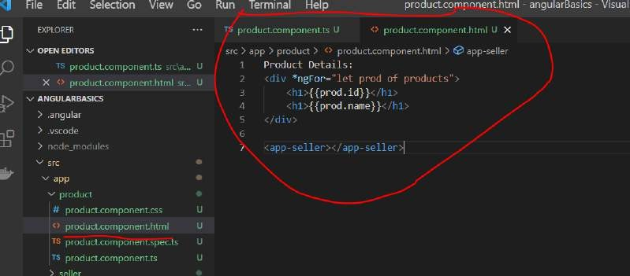

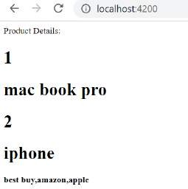

###### Use the functions

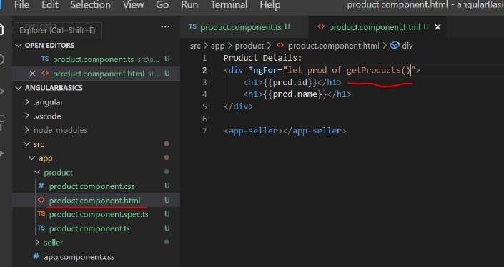

**Input property binding**

**Angular support two way binding**

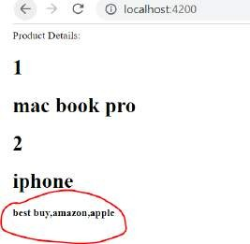

**Objective :**

Want to hide seller info when ui render initially. It will appear only when user clicks on button.

###### To hide seller component use hidden property

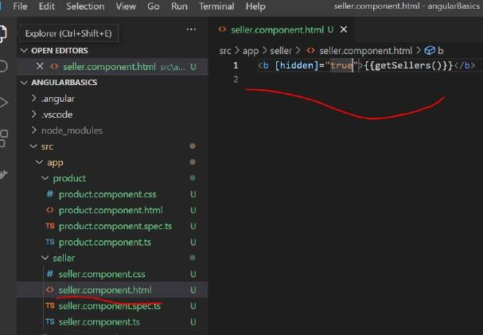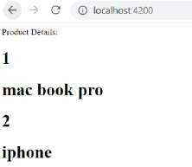

**Note :** we can use properties also directly into html page

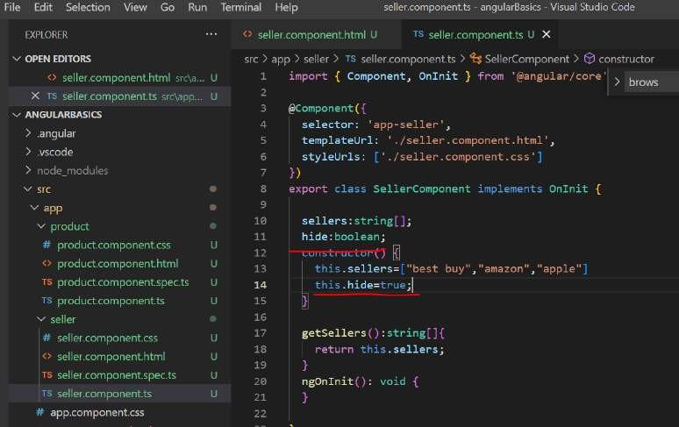

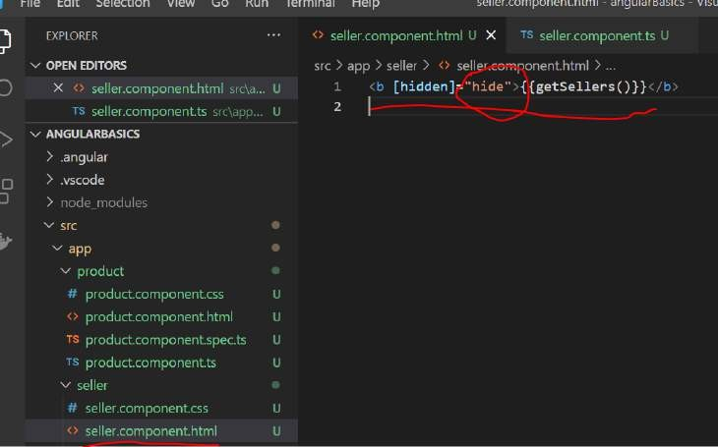

Hide will be use by the html. This is how **angular input property binding** works Hidden is **dom property** not html property

###### input property binding

We are binding a property on our component for our model to the ui that is getting generated depending in the value of it

The ui will be hidden or shown

###### Output event binding

**Objective :**

Will create a button , it will display and hide seller based on click on button.

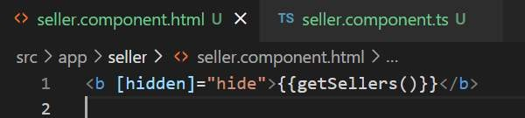

We are manipulating dom and hiding seller component

The syntax of output event binding on a property(input) within regular bracket .

Here we use event click in regular bracket is assign with handler or come with logic in double code

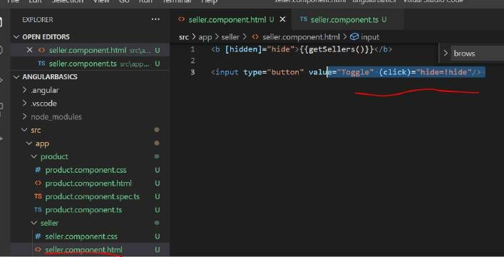

The above logic we can move in ts file

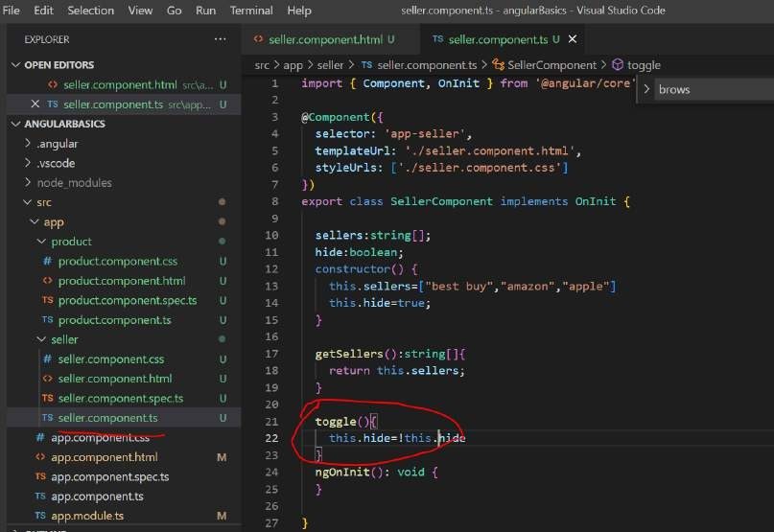

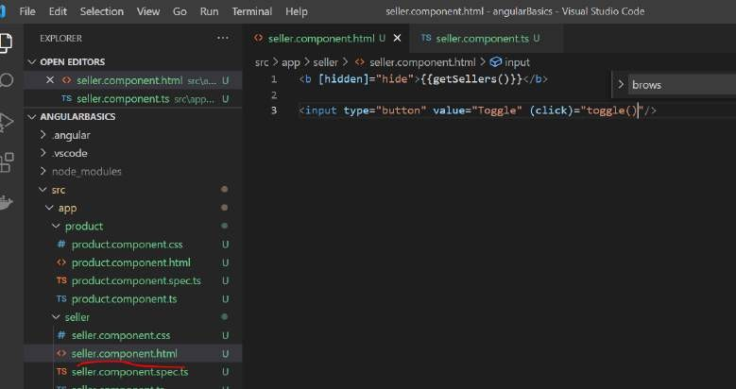

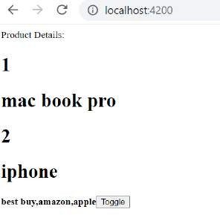

**Input property binding** : we use square bracket []

Output property binding : we use () ---regular bracket syntax

Section 3: Directives

Directives:

Are attribute we add in html element which directly effects the **html dom** that get generated when our page is render. Using the directive which are attribute on every html element we can control the way our dom is generated.

Will explore various inbuilt directive that we are going to use throughout the course

###### ngIf : <b *ngIf="true"> My text </b>

is use to display element conditionally.

If the result is RHS is true then this element will be added in the dom.

If false then this element will not added to DOM or removed from the dom True value in ngIf can be function call or javascript variable as well.

###### ngSwitch

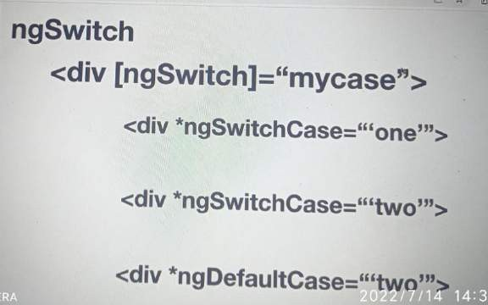

**ngFor :**

it is used to repeat given dom element based on each element in the array.

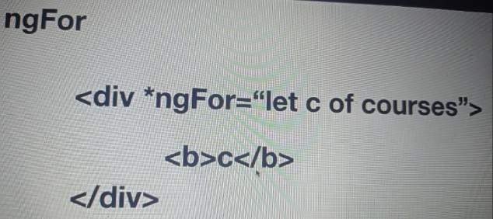

###### ngNonBindable

We use this to tell angular not to bind or compile a part of our page. Here string interpolation will not be compiled if we make this

ngNonBindable

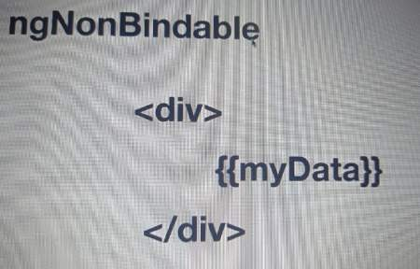

**ngStyle and ngClass** : help us in styling

###### ngIf

**Ng new directives**

**Ng g c components/if**

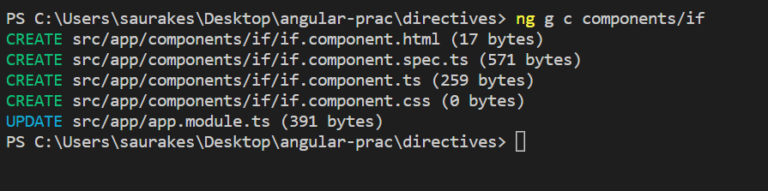

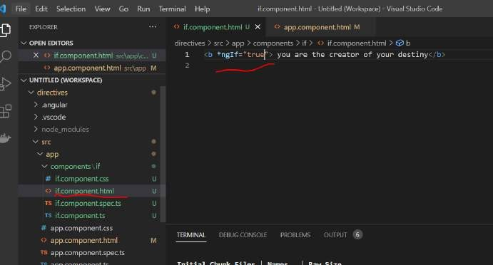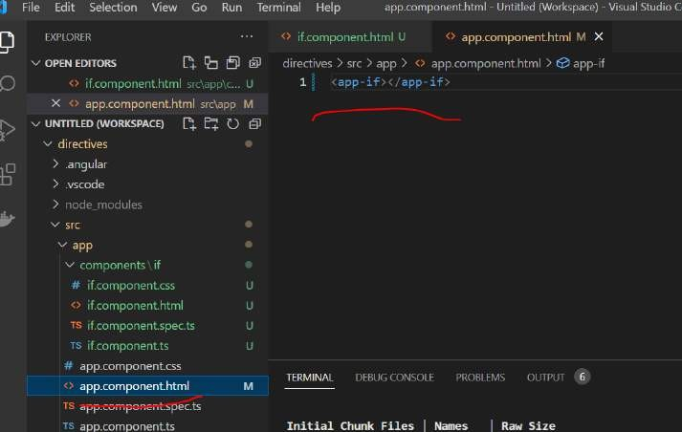

Ng serve -o

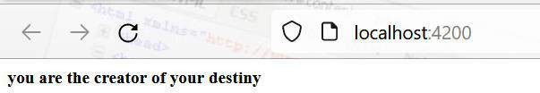

###### Using ngIf Dynamically

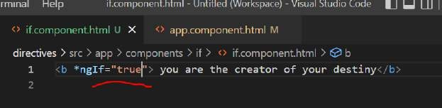

We rarely check like this

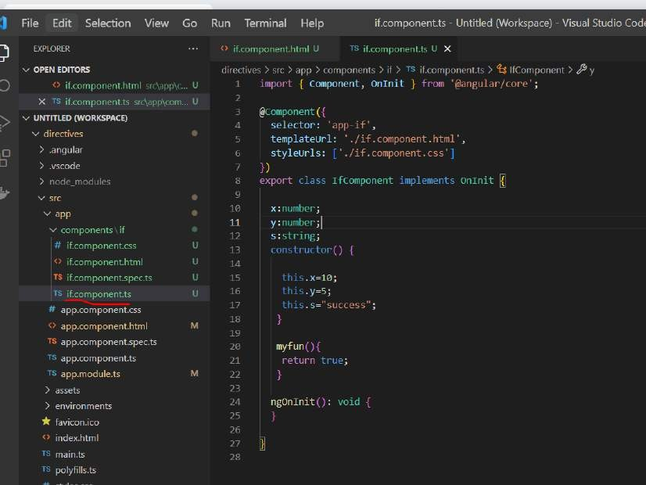

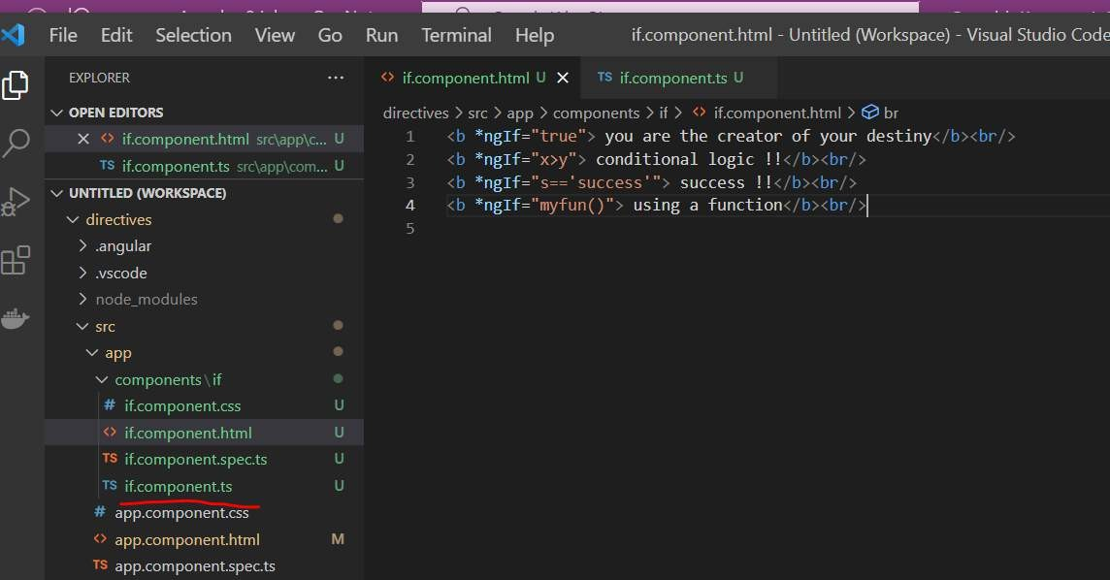

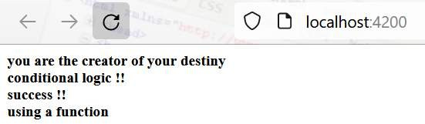

###### ngSwitch

**Ng g c components/switch**

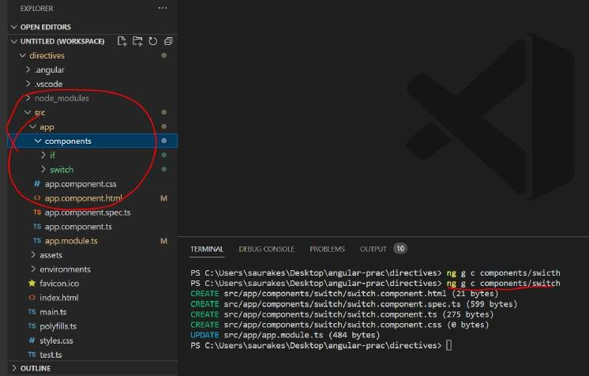

When case matches with switch value entire div will be render

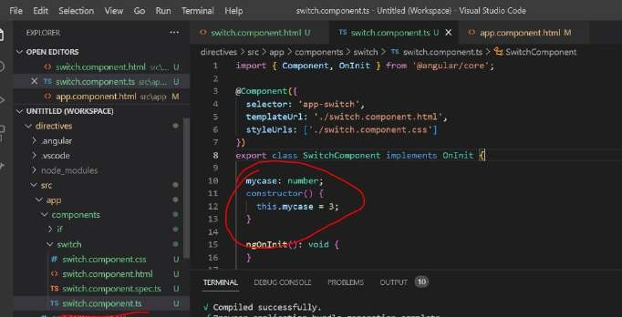

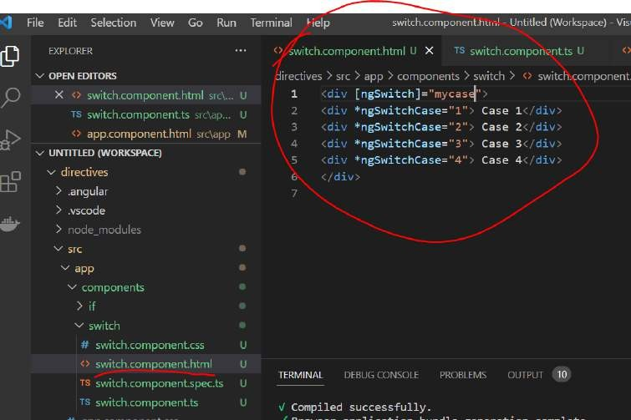

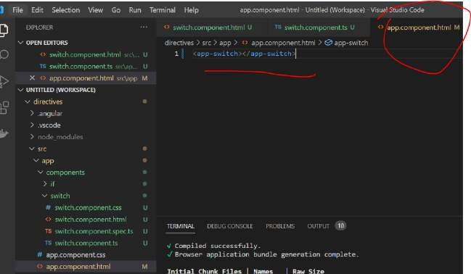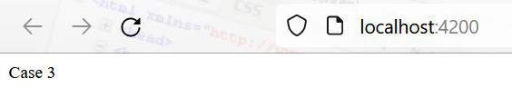

###### Using ngSwitchDefault

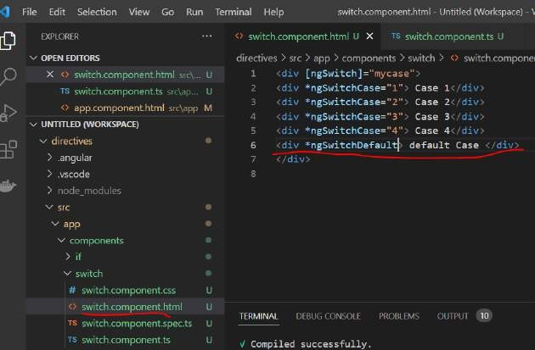

**Using ngFor**

**Ng g c components/for**

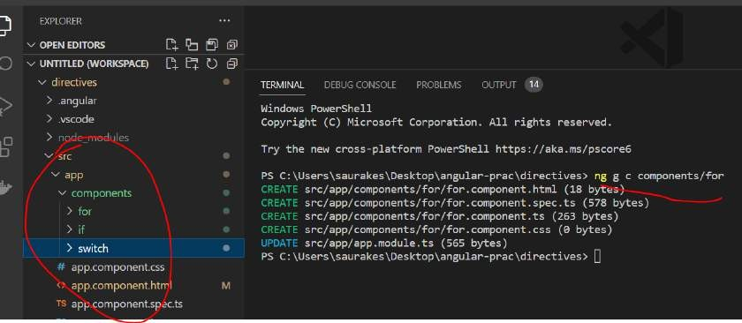

**Let** is a prefix which is use to define variable

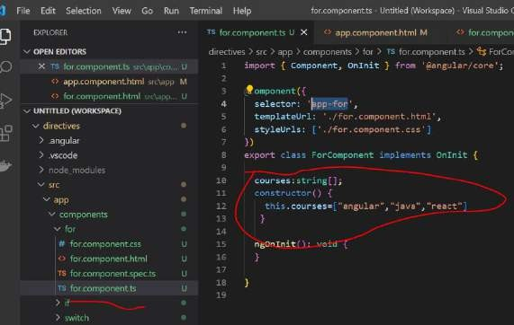

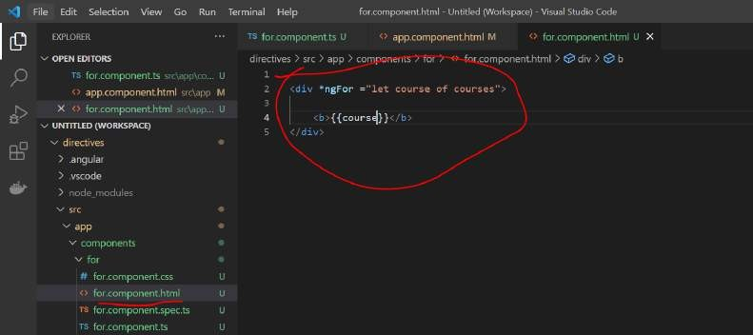

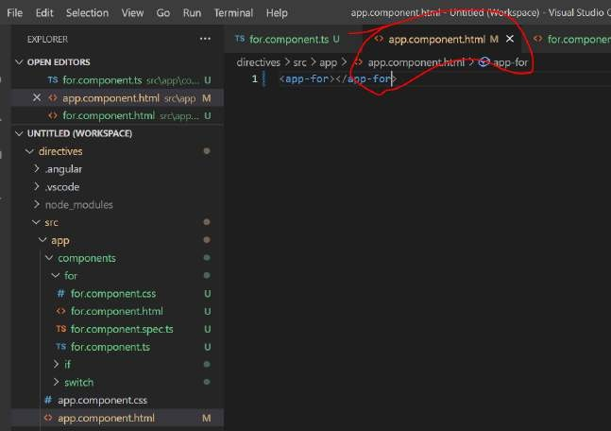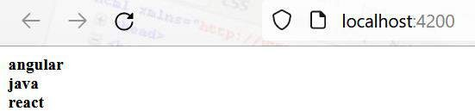

###### Using ngFor with objects

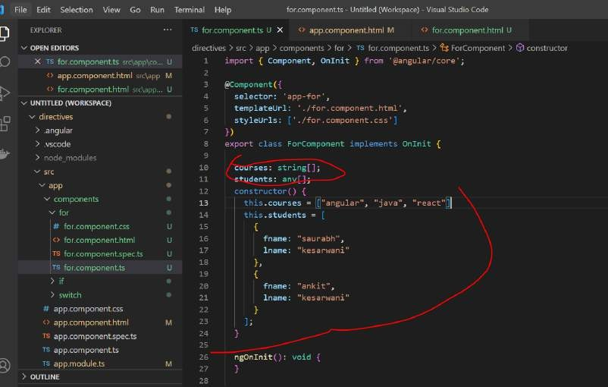

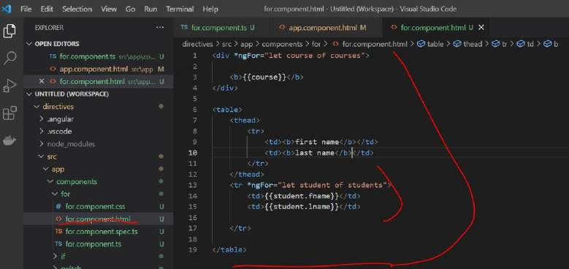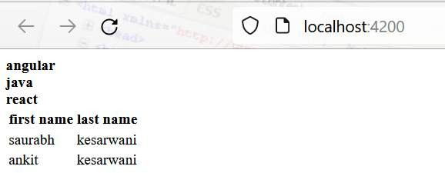

We learn how to deal with array of object

###### Using ngNonBindable

As it is it will show in browser

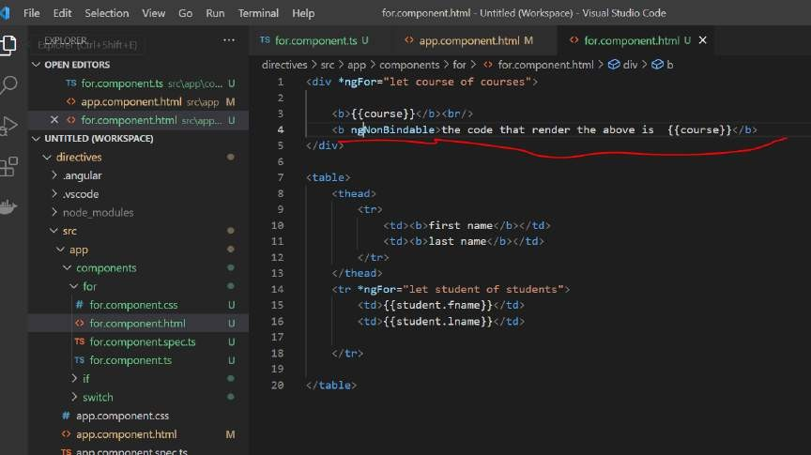

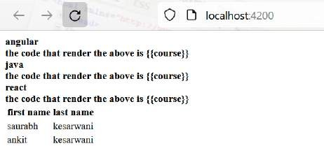

###### NgStyle

Using ngStyle directive we can set css property from the angular expression on html dom element.



Will apply styling in this

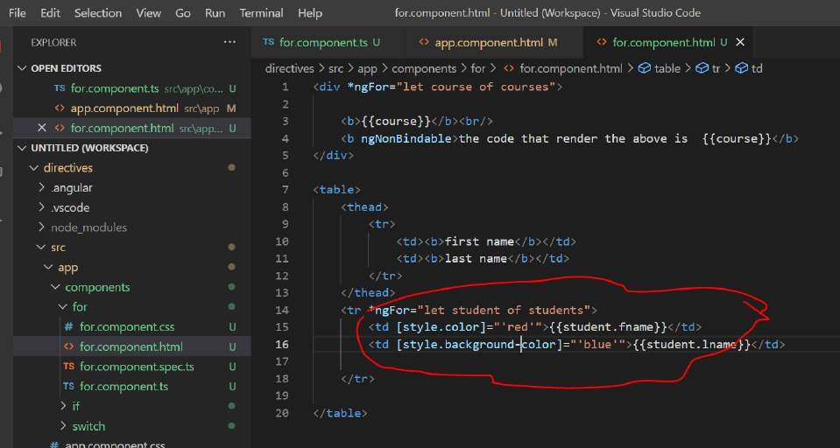

This is like one css property we are applying but if we have multiple property then will use ngStyle

###### [style.<cssproperty>]="value"

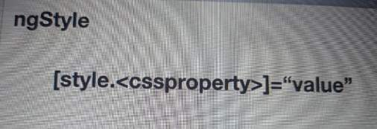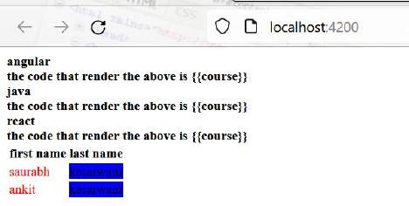

**ngStyle**

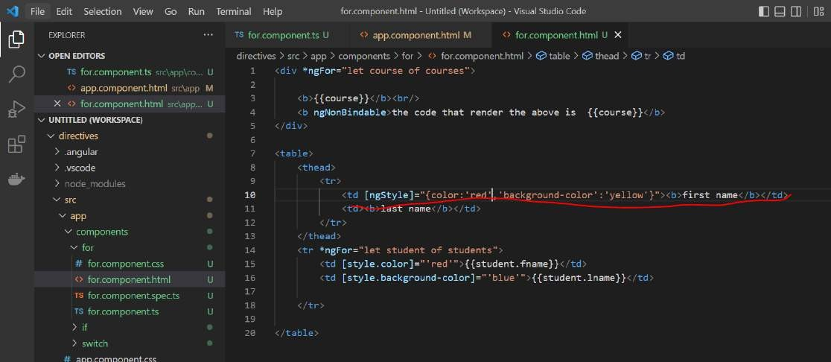

**'background-color' :-** wrap in single code, whenever we have hyphen need to wrap in single code

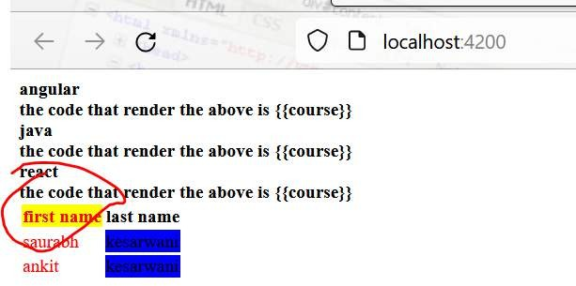

###### Dynamic styling with ngStyle

**In ngStyle** we don’t need to hardcode the value , we can get it from typescript file.

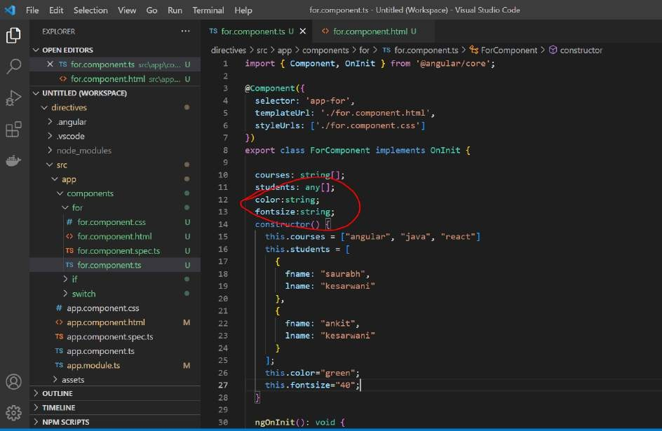

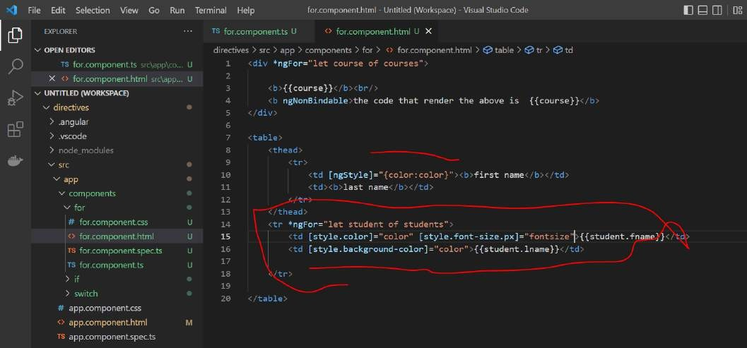

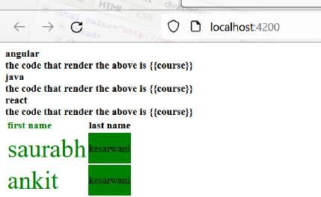

We have learn how to dynamically pass styling info from component and use that in ngStyle

###### Using NgClass

**ngClass directive** help up us to assign a particular css class to html element

###### [ngClass]="{tdata:true}"

Tdata: css class which will be apply to html element

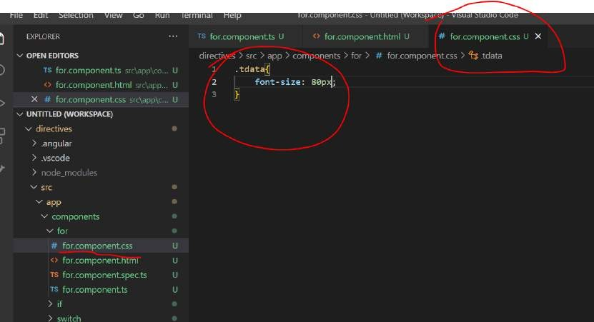

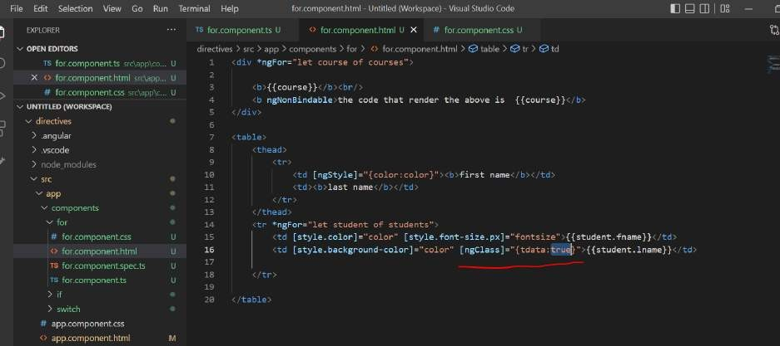

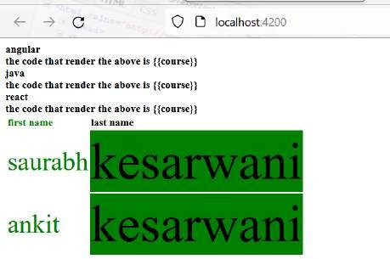

###### Dynamic NGClass

How to pass dynamically object value to ngClass

**Section 4: Services Service fetches the data from rest api and component send back data to ui**

**Objective :**

How to do dependency injection in angular in two simple step. Note :

When we build angular application or huge application we don’t put all code in one component.

The code will be spread across component

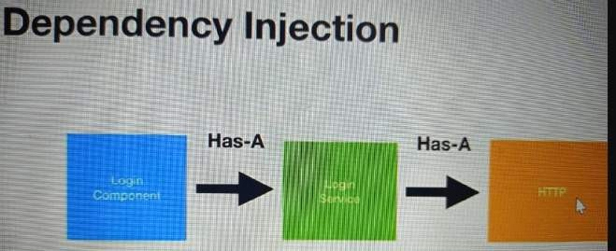

###### DI

Will tell angular we need this login service. It will create login service at run time and inject it as a filed in login component then we can use it

We can do DI in two simple step in angular

* Configuration file :- app.module.ts .

Register any component or dependency inside ng module

We need to register it in app.module.ts. **Import** it and provide in **providers** for DI, that is how angular knows that component,

or service or any other module is injected.

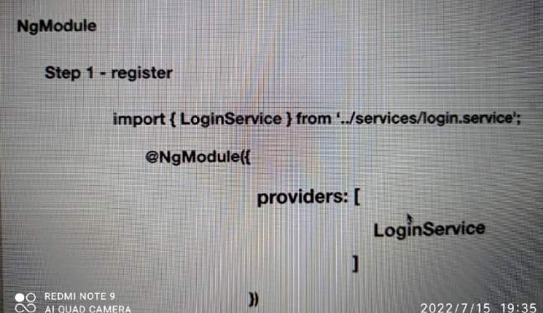

* To use or inject itself.

by provide it in constructor.we are telling angular please inject login service. Angular will search this in app.module.ts and it if is register in providers then it will create singleton object of login service and it will inject in loginservice. We can then use loginService

Anywhere in login component

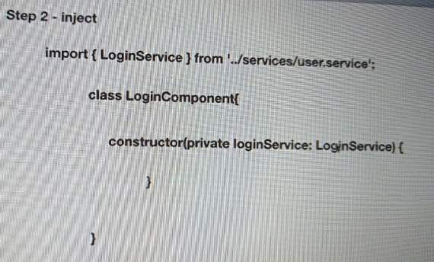

Add a dependency injection in provider section of ngModule and then simply provide a constructor. Angular will automatically

Inject by creating a singleton object

###### Usecase

Will create angular service that will fetch info from by consuming a restful webservice

**Restcountries.eu/**https://restcountries.com/ **: expose out restful api which we can consume**

###### Restful links

<https://restcountries.eu/rest/v2/all> <https://restcountries.com/v3.1/all>

<http://test-routes.herokuapp.com/test/uppercase>

<http://test-routes.herokuapp.com/test/hello>

<https://www.w3schools.com/angular/customers.php>

###### Create the project and service

Let organize service into folder

**Ng g s services/countries :---** it will retrieve country info

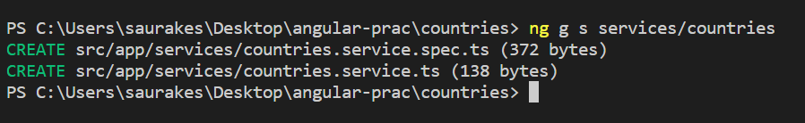

View - component- service

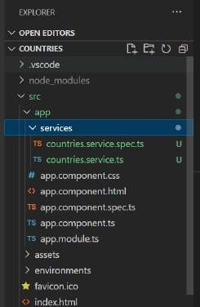

###### Service code walkthrough and import

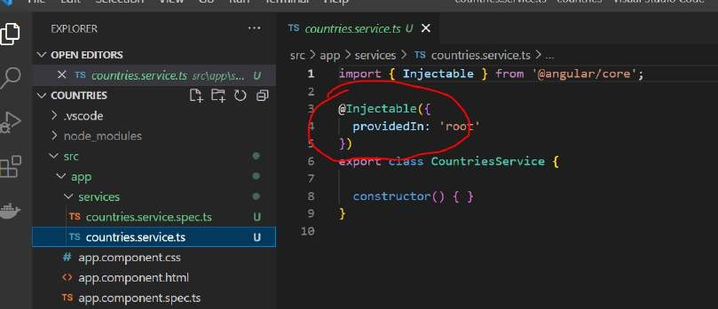

**Injectable is Decorator that is used on countriesService** tell angular this particular class object should be created at runtime and it should be injected into other component or classes when required so that is **DI**

**Angular comes** with default DI object that’s **is root** which is responsible for **creating object httpClient :-** it has support for all the restful calls

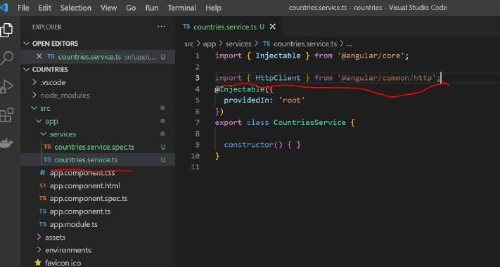

###### Implement the service

**First step**

is to inject Httpclient into the constructor

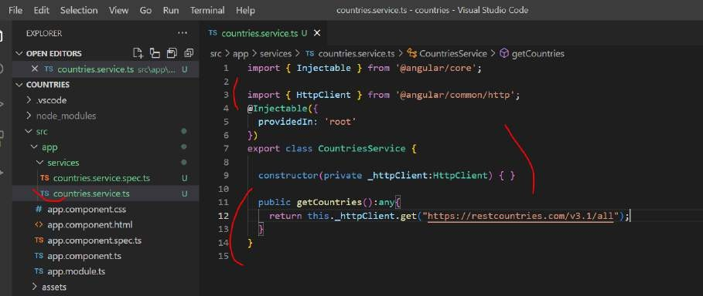

###### Create the component

**Objective :**

create component that will consume service or use service

###### Ng g c components/countries

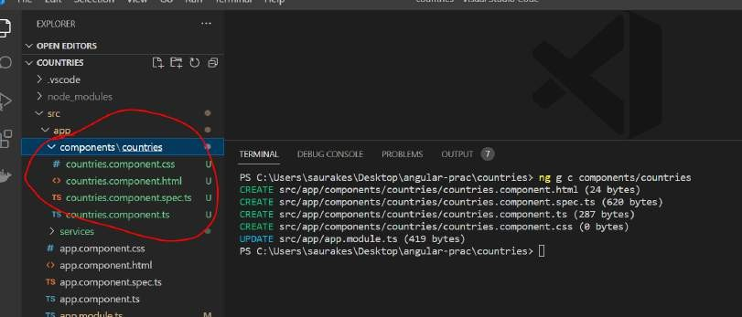

ngOnInit

* **ngOnInit** is a life cycle hook called by Angular to indicate that the Angular is done creating the component.

Step 1:

Import CountriesService

Step2 :

Inject it into constructor

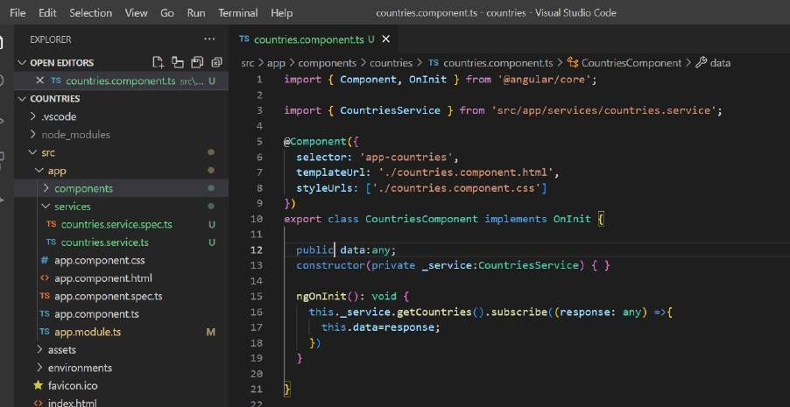

###### Handle errors

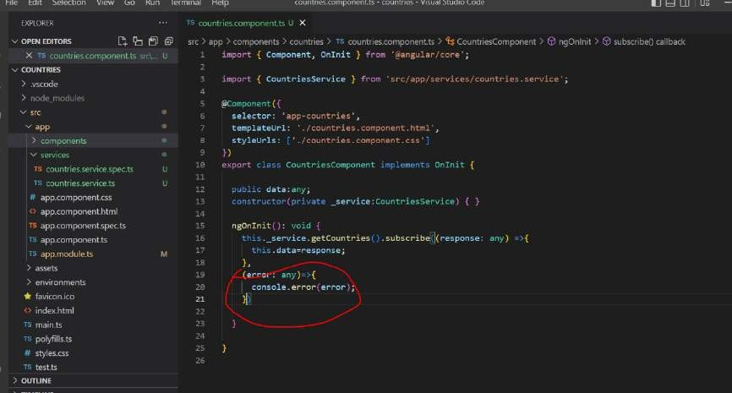

**Implement the html (view)**

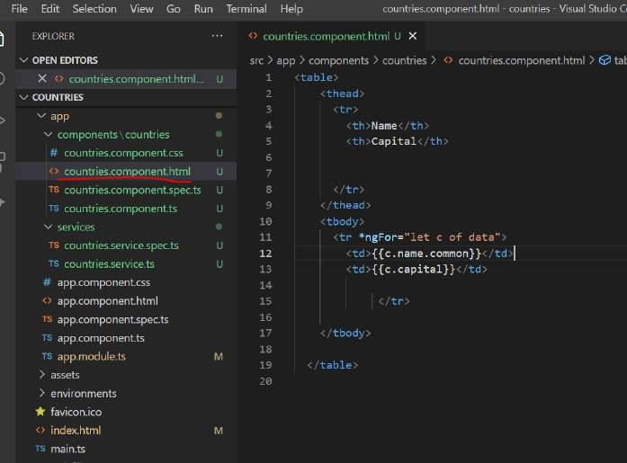

**Update configuration**

**App.module.ts :**

**We need to import http and also httpClient**

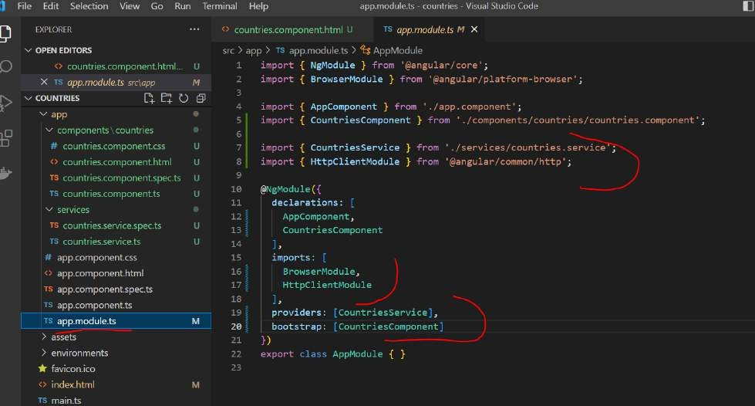

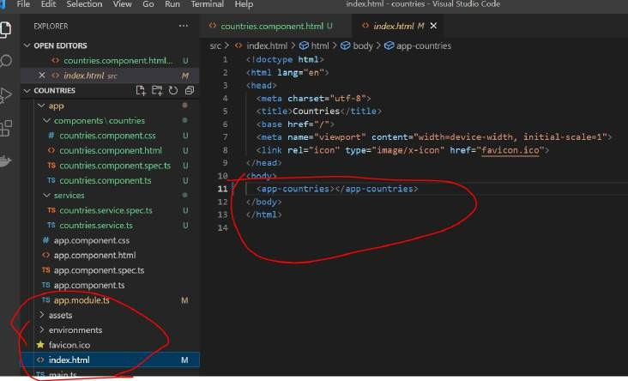

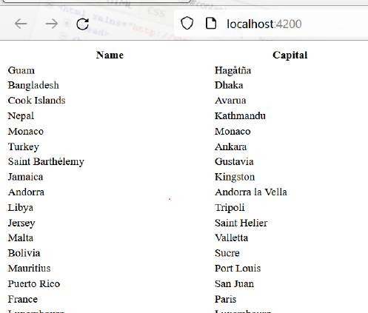

**Add styles**

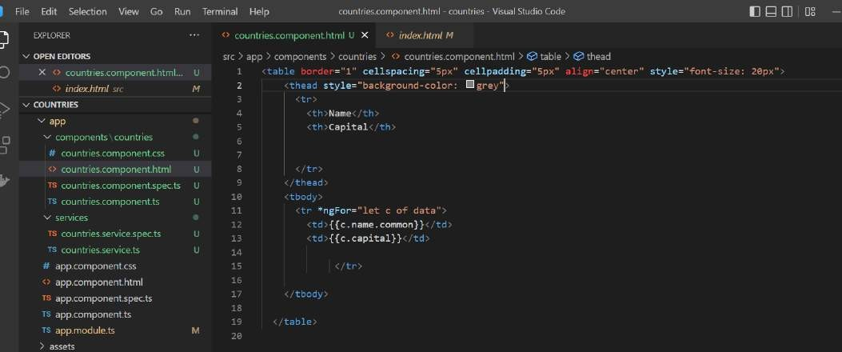

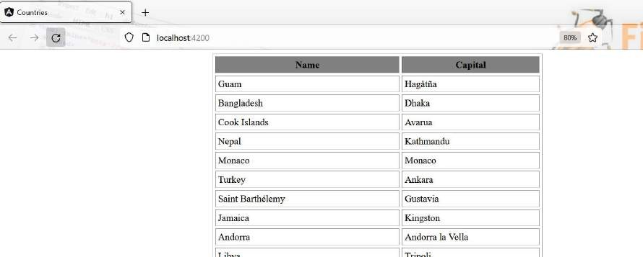

**Section 5 :- Posting Data**

Get input from user which component will send to service which will post data to restful url

###### Objective

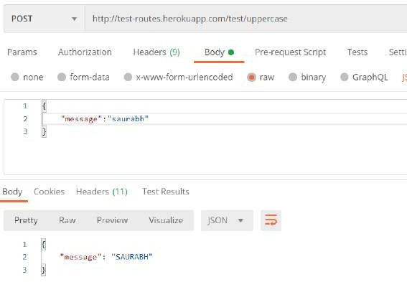Will develop a angular service that will post data to restful webservice <http://test-routes.herokuapp.com/test/uppercase>

###### Create the project

**Create project** then service then component

**Create project : -** Ng new postservice

**Create service:-** ng g s services/uppercaseConverter

**Create component :-** ng g c components/uppercaseConverter

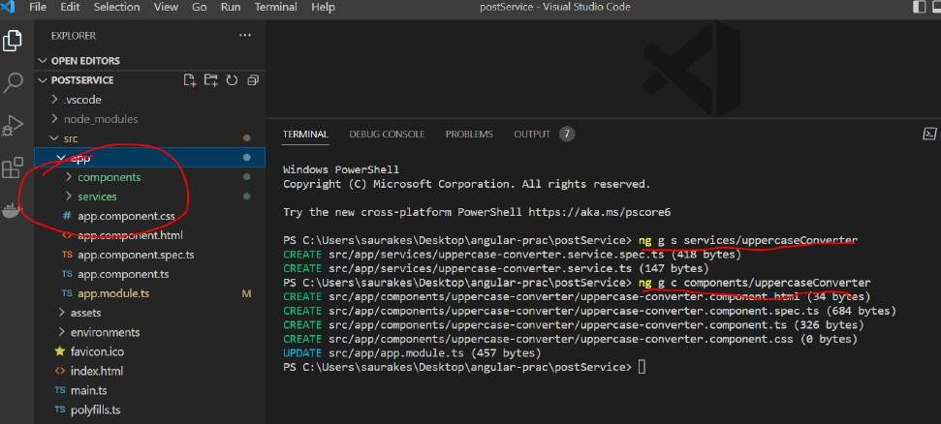

###### Implement the service

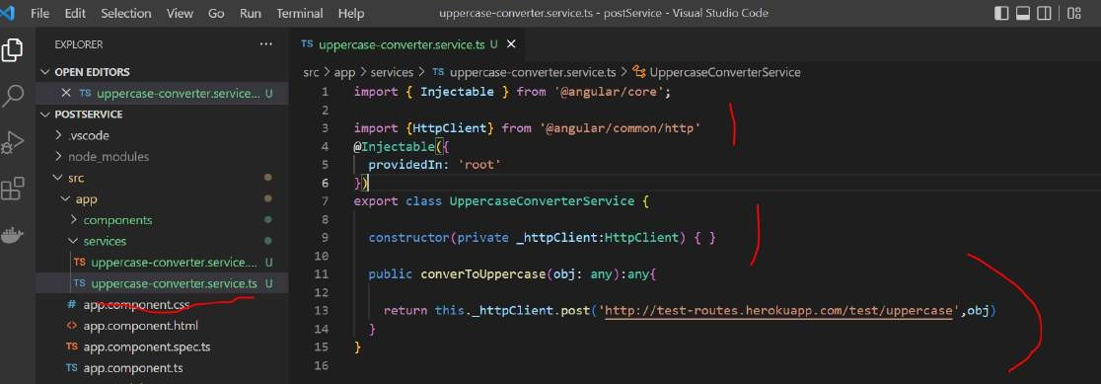This method will take a object which will send to restful service then it will return json back which will be return to the component

###### Implement the component Implement component which will use service

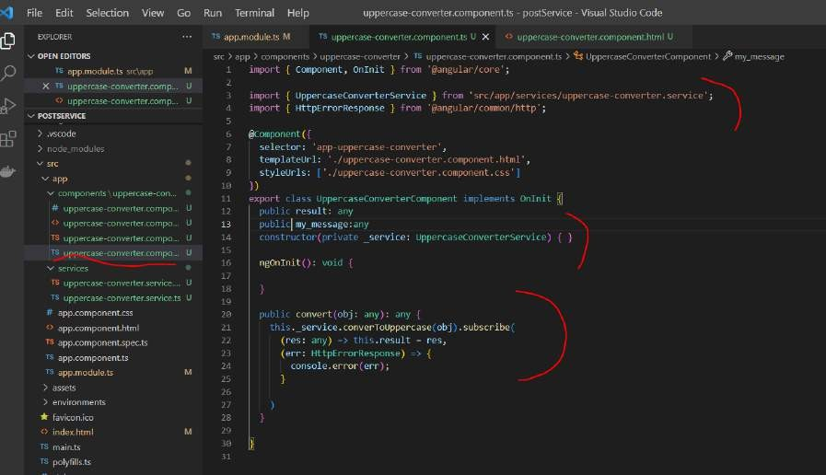

**Implement the html**



ngModel will take text from html and bind to my_message (java script variable) Then on click event we invoke function and pass the input

Note:

Message is key

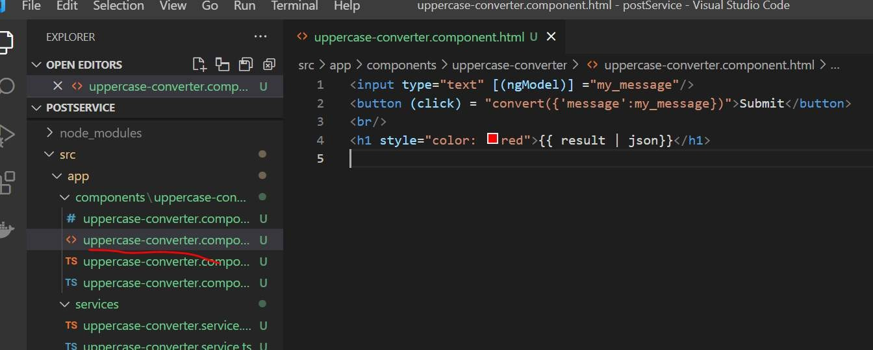

###### Bootstrap the application

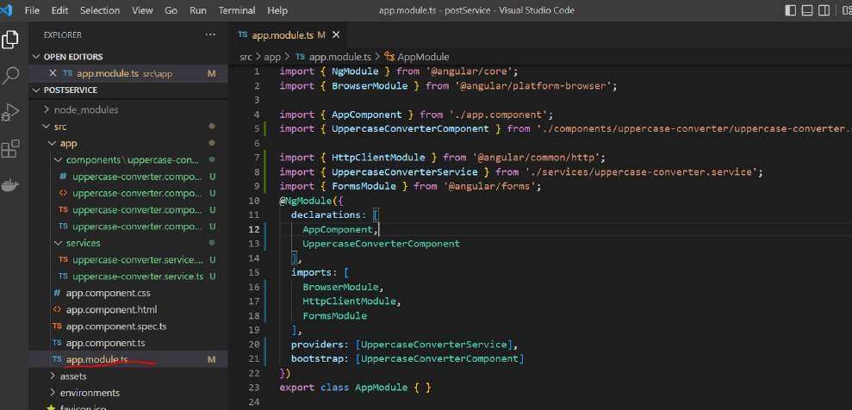

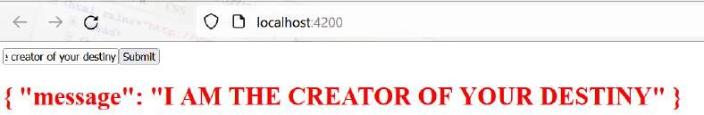

**Section 6: using multiple services**

**Objective :**

How to use multiple services within single component

Two service we are going to consume from single component.

These two restful services are hoisted on internet

<http://test-routes.herokuapp.com/test/hello> <https://www.w3schools.com/angular/customers.php>

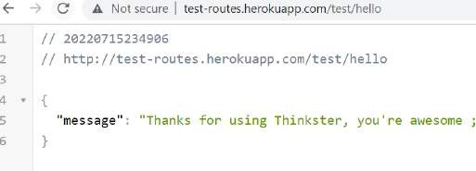

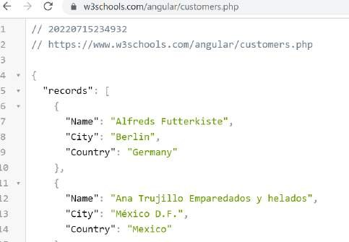

###### Create the project

**Create 2 service and one component**

**Create project :** ng new multipleServices

###### Create service

Ng g s services/helloService

Ng g s services/customerService

###### Create component

Ng g c components/multipleServices

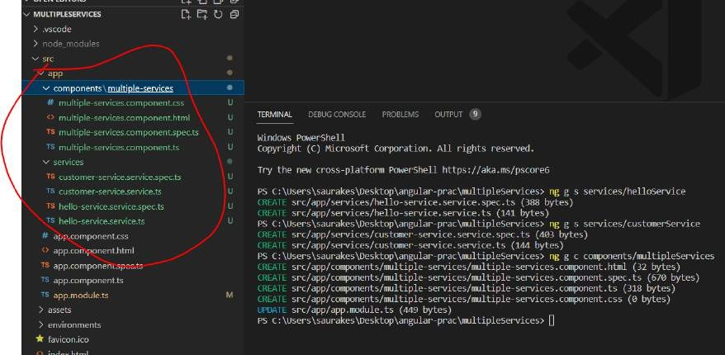

###### Implement The Services

Will implement hello service and customer service

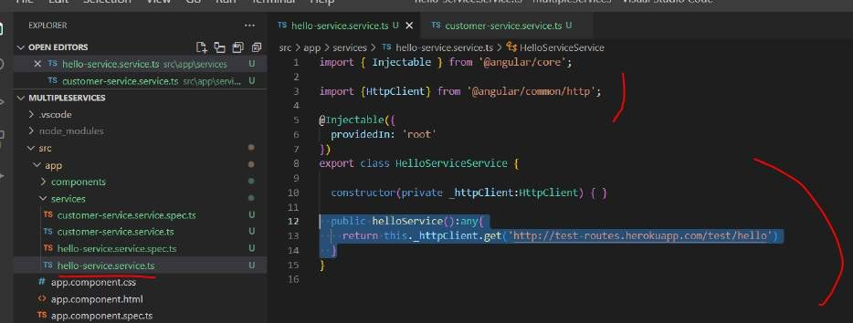

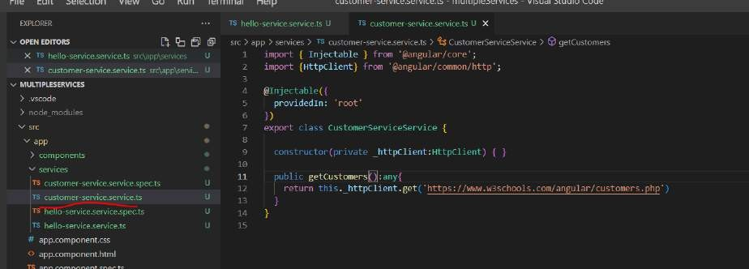

###### Use the services

Will use both services inside our components

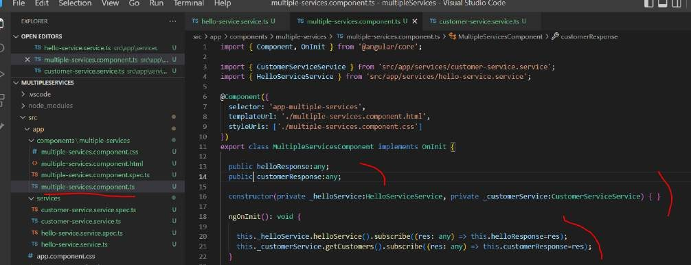

###### Implement the html

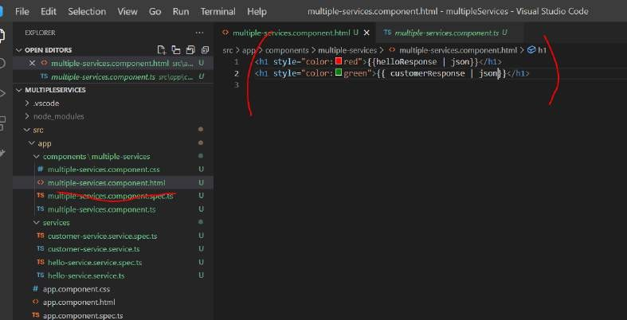

**Configure the app**

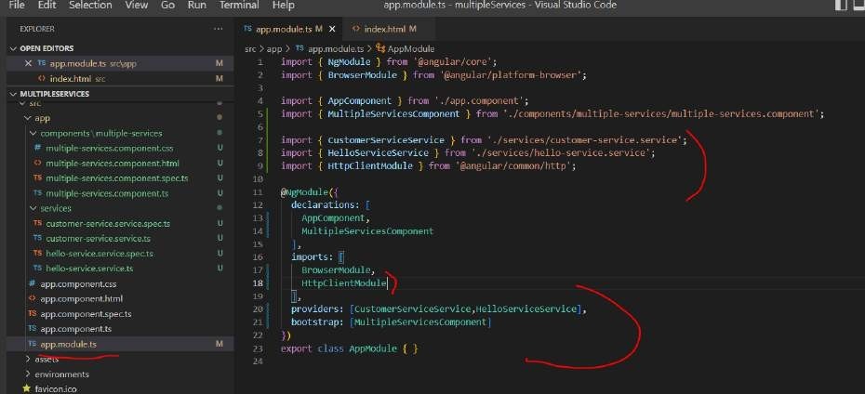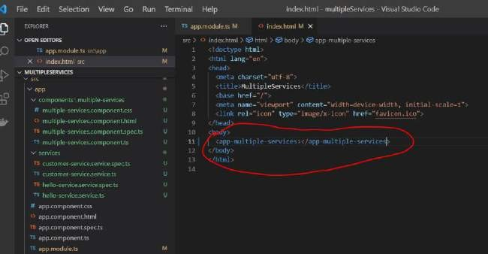

**First one come from first service and second one come from second service**

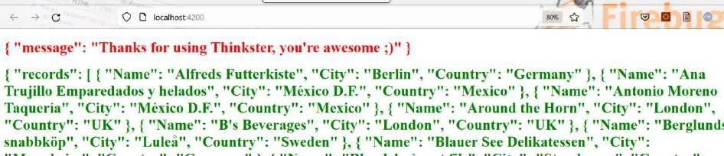

**Use fork join (deprecated)**

**How to make parallel call using fork join**

**Note :**

ForkJoin function can take an array of service call Now response will be array of response function

Section 8: angular client and routing

Table used in restful api

create table product(

id int AUTO_INCREMENT PRIMARY KEY,

name varchar(20), description varchar(100), price decimal(8,3)

);

Objective :

Creating angular front end ( crud client for our backend)

###### Create the project

Will create angular client project that will consume restful api Angular project

Service :- that will consume restful api Component:- that will use service Html

###### Ng new productClient

**Create and implement Get Products service method**

Cd productClient

###### Ng g s services/productData



Will implement read method It will retrieve product

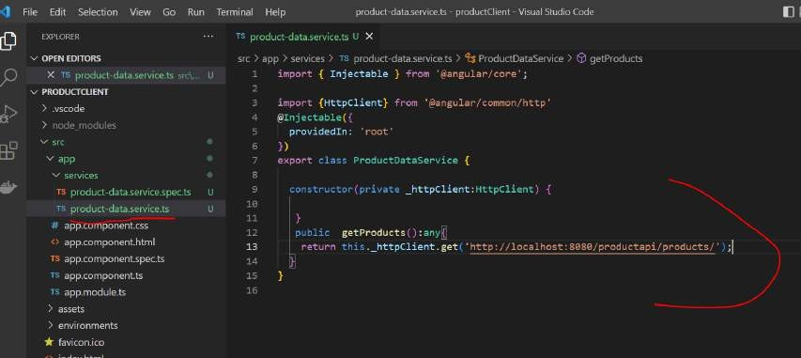

###### Create the component and view

Will implement ui logic that will consume getProduct service

###### Note

To perform crud operation we have four component typically in ui level

Since we haven't learn **routing which is required to navigate from one component to another**

Will use default component will implement everything in one single component and html but later on we refactor this project

Once we learn routing

**App.component.ts :** which will use service

ngOnInit(){} display the product as soon as component is created or initilised

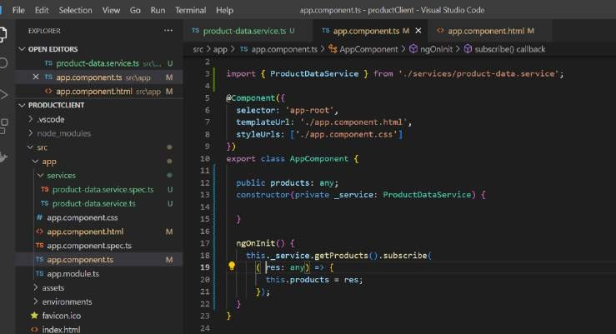

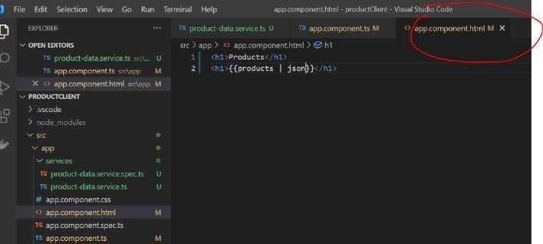

###### Update configuration

All DI will update in app.module.ts

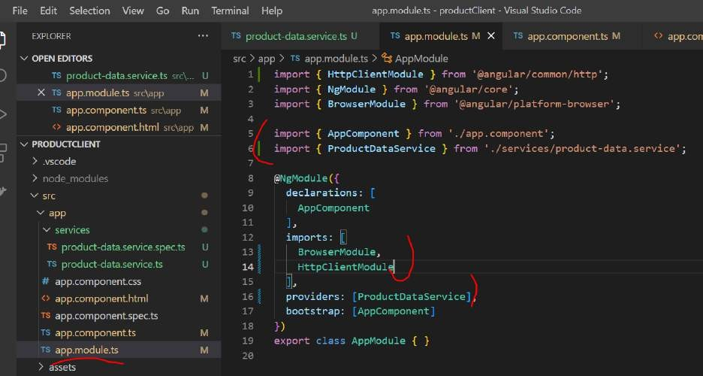

###### Implement the other method

**Create , update and deleting a product**

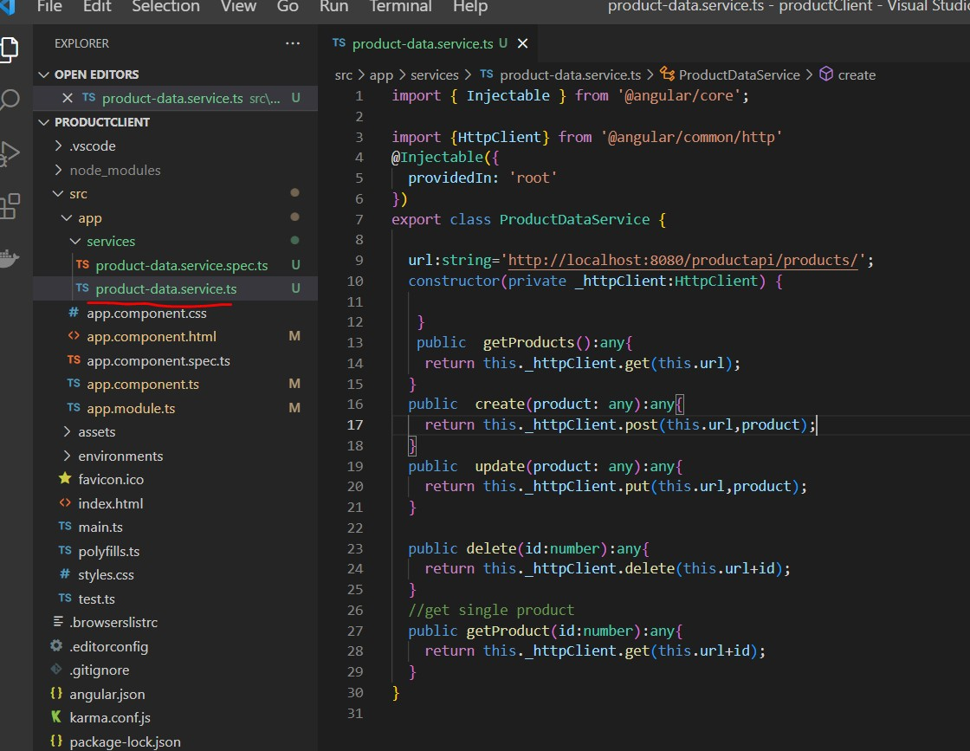

**Implement component method Right now we are putting everything** in one component and in one html

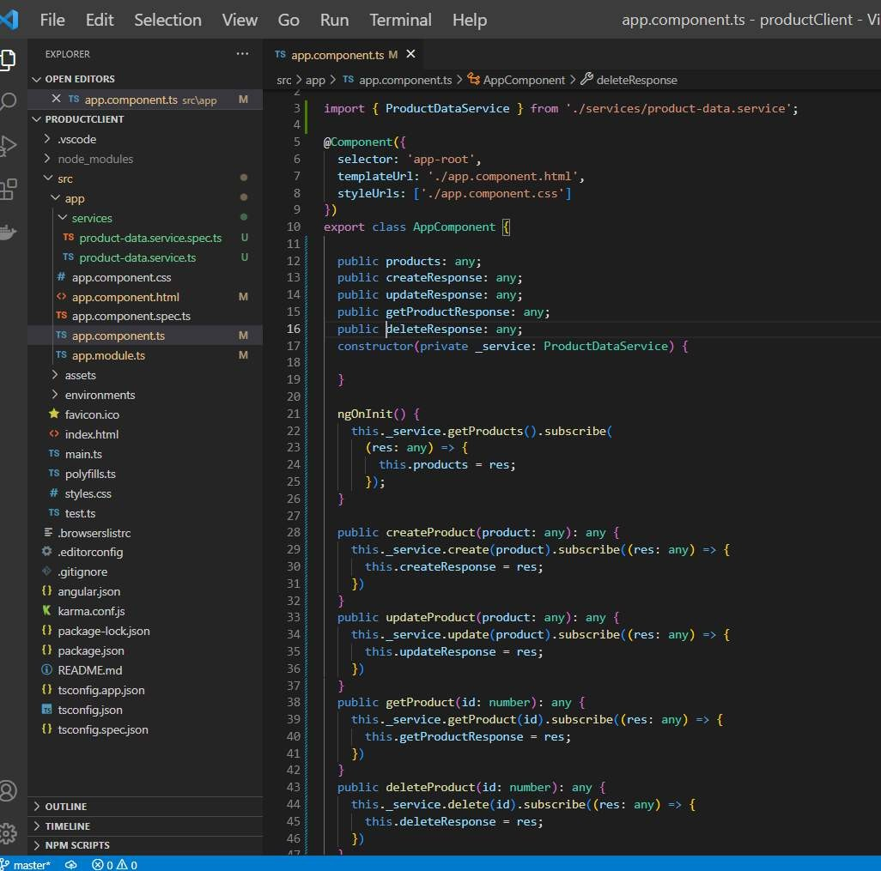

###### Implement the html

We will dump all here later will move it to appropriate component once we implement routing

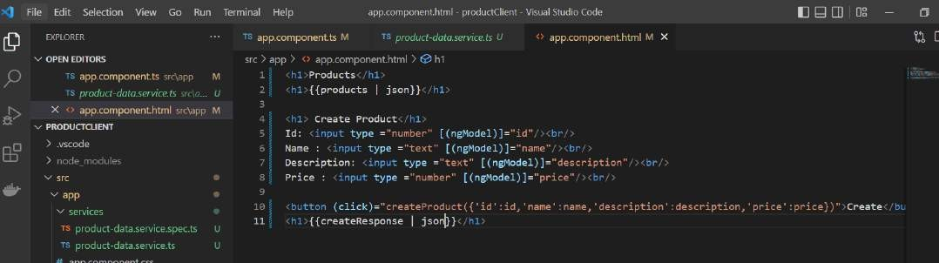

###### Update , fetch and delete

**Note :**

**All will go in individual component once we implement routing**

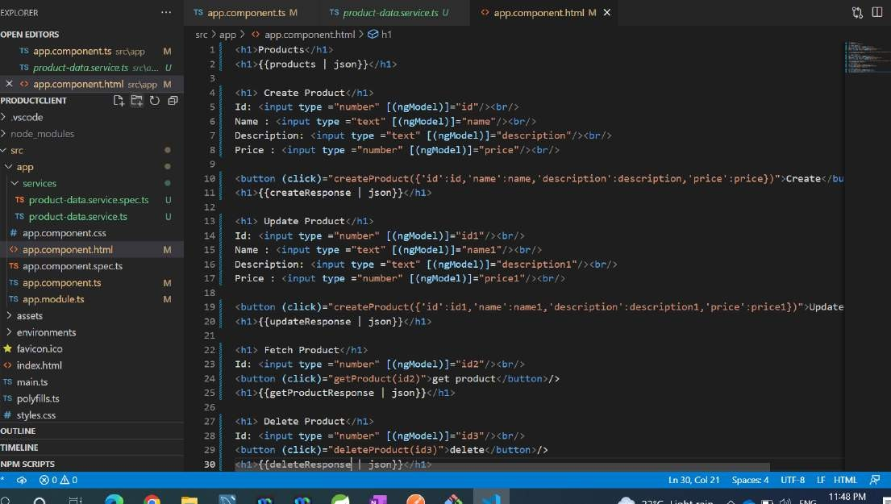

**Routing**

User navigate from one web page to another page that happens due to routing **Traditional application :** routing and navigation use to happen on server side **@angular/RouterModule**

There are three imp components in router module

###### Routes

represent all the routes , the navigation link in the application

###### RouterOutlet

this is the placeholder component that shows angular where to put the content of each route 3- **Router link**

using this will add link to html pages and click on that link client will automatically routed to appropriate page or router.

###### Usecase and refactoring

Right now we are showing in one page so will refactor it , create ,update ,delete all will have own screen

###### On home page

Will display all the product and link

Let create **4 componen**t create , update ,fetch and delete before routing

###### Ng g c components/create Ng g c components/update Ng g c components/fetch Ng g c components/delete

Default component will display product details and then it will display the link now we have four component which are Responsible for performing the crud

###### App.module.ts will also get updated

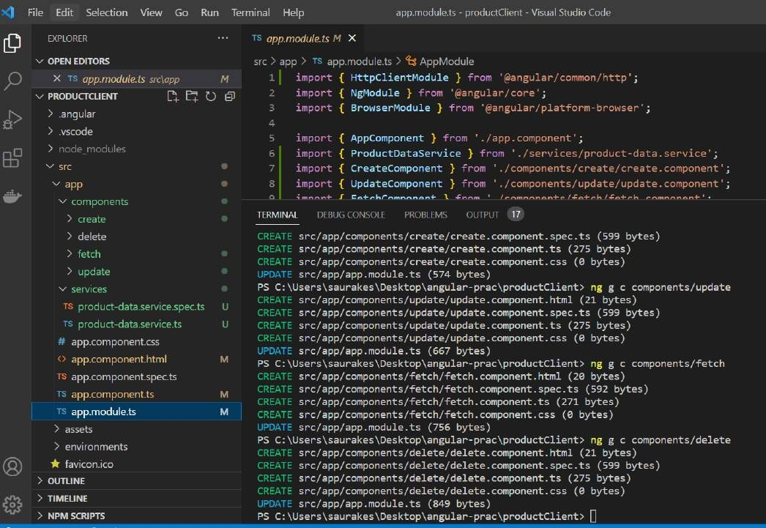

**Refactor component :-**

We will move component from app.component.ts into individual file

Default component is responsible for displaying all the product in the screen so ngInit is remain the same

###### Base component

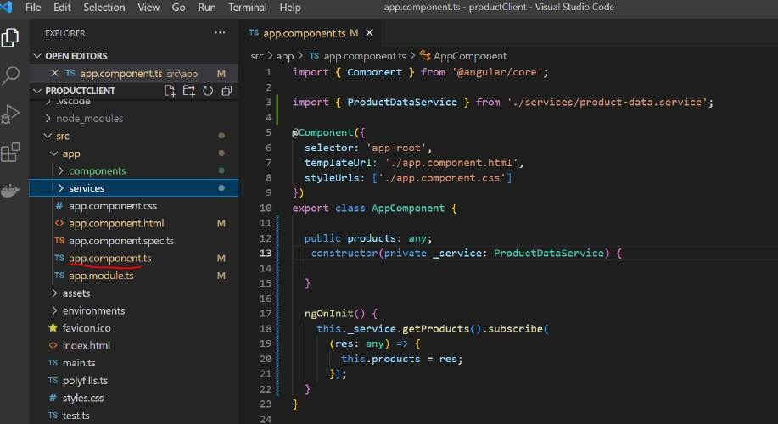

Create component

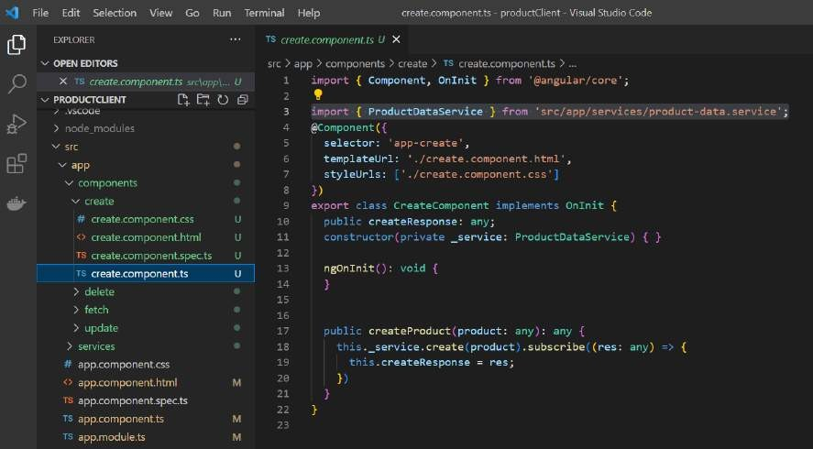

###### Delete component

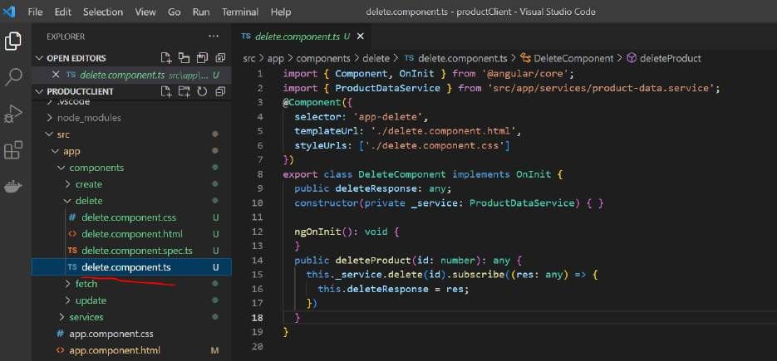

**Fetch component**

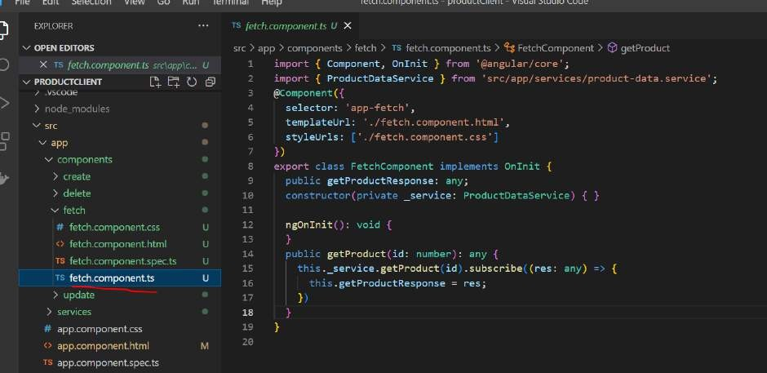

Update component

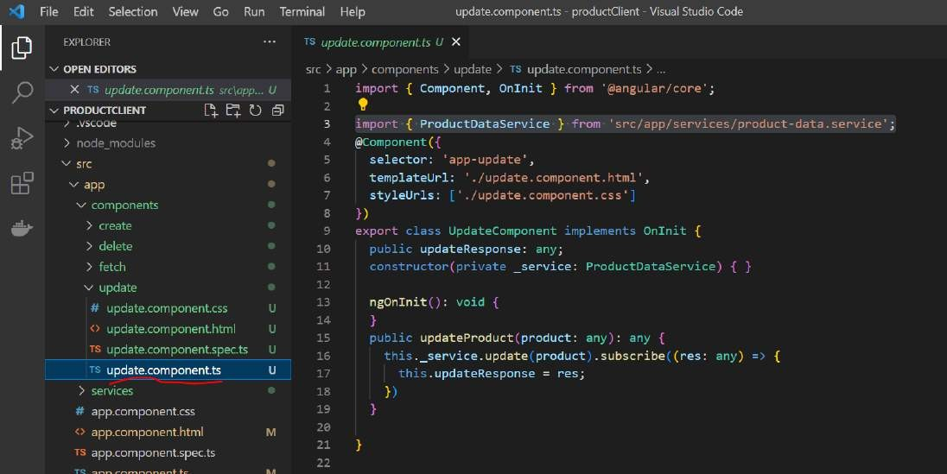

###### Refactor HTML

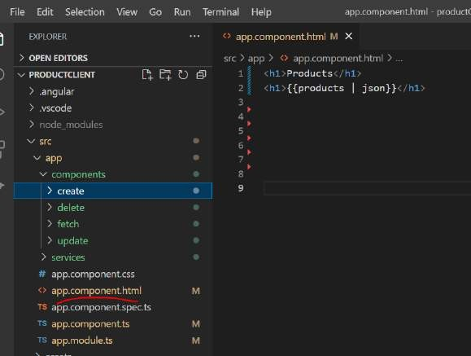

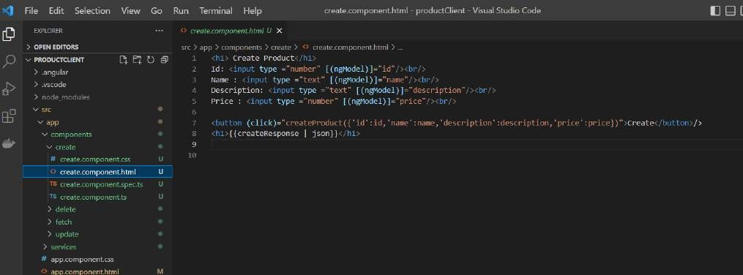

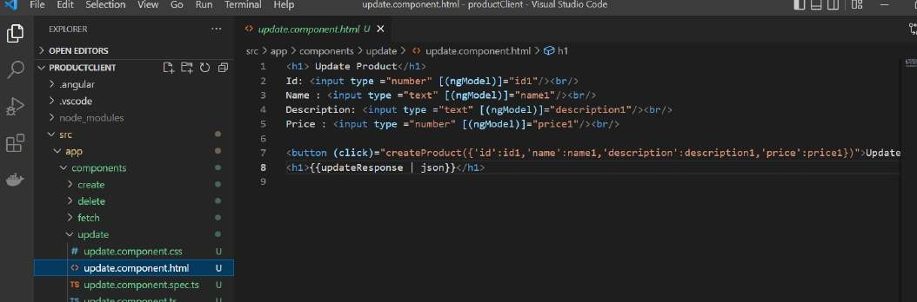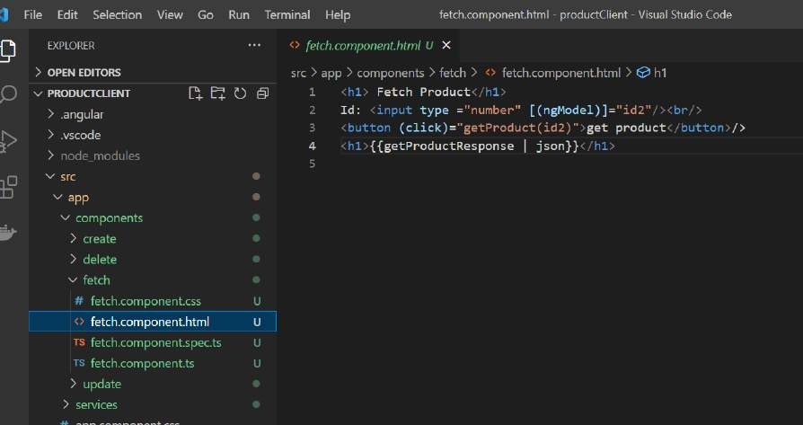

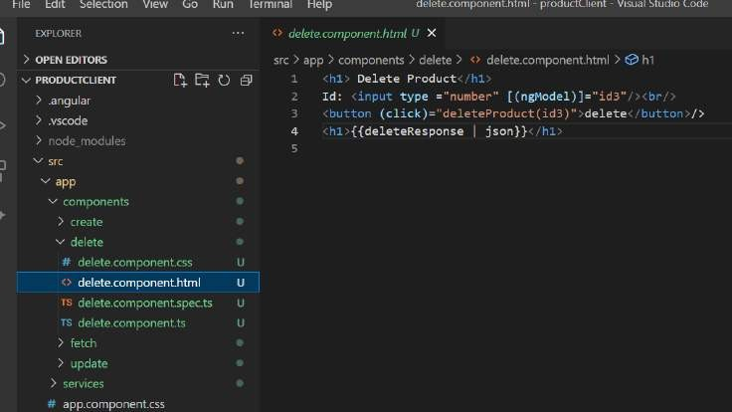

We successfully moved all html element to individual component

###### Add forms module (in app.module.ts)

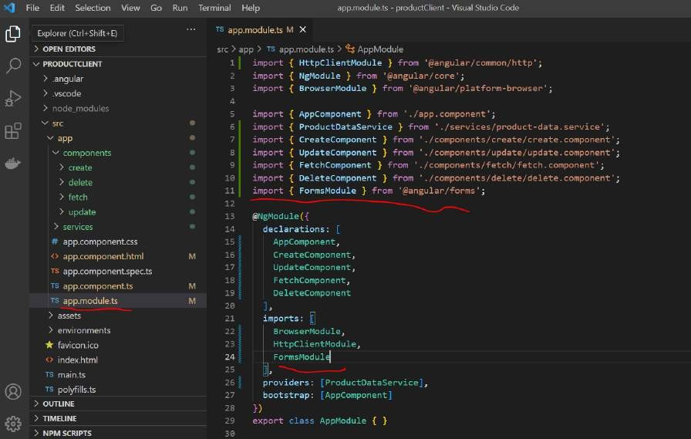

**Routing steps**

**Create routing.module.ts**

**Create < router-outlet> in html :** knows how to route when user click on link

###### Import routing.module.ts in to App module

**Note :**

We can create routing as beginning : Ng new project --routing but here we are configuring from beginning

Step 1:

Create routing, will define all the routes in this module

###### Create the routing modules

**First step :**

import ngModule because we will use this to initialize router Define array routes which will carry all the info of route info.

Inside ngModule will create instance of routerModule and export it out

**RouterModule.forRoot(routes) :** static method forRoot will create **routerModule** for the application with all the given routes

Import:- will initialize the routes Export : we are exporting it out

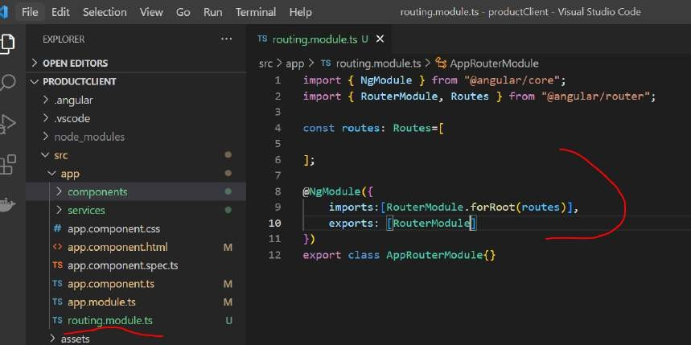

###### Add the routes

If nothing is used in path just go to default page ( localhost:4200/)

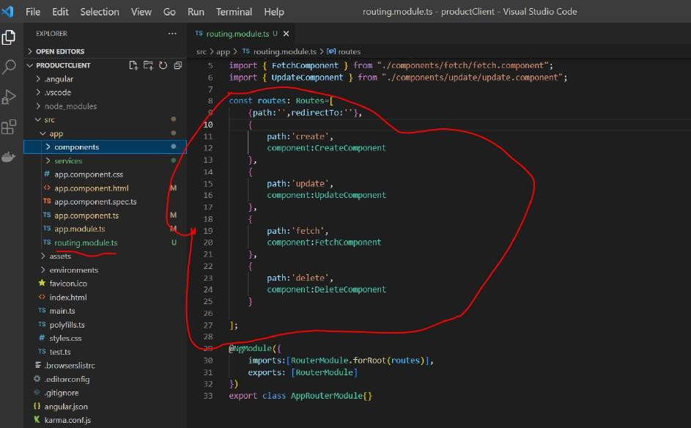

###### The pathmatch property:

pathMatch :'full; pathMatch :'prefix'

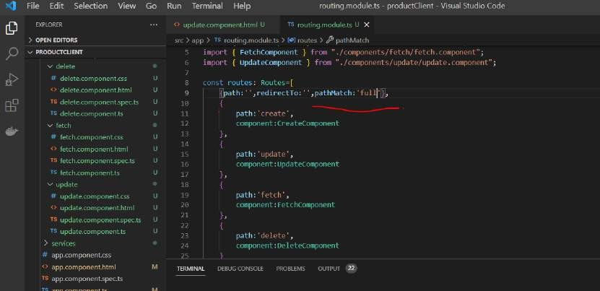

###### Configure the routing module

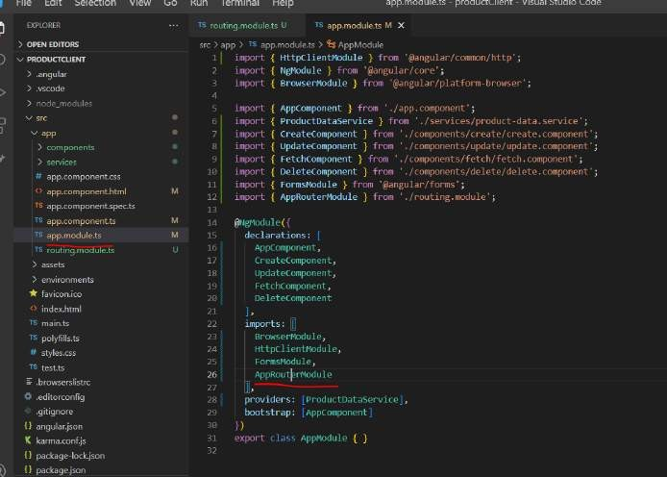

**Use routes in html** (app.component.html) Router link is angular directive and we are mapping this link to **router path called create**

**<router-outlet> :-** responsible for taking care to resolve all those links or router navigation for us

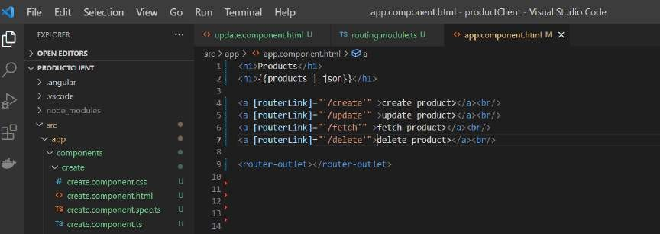

###### Angular upgrade and configure CORS in spring boot project

name!: string;

This says to the compiler:

*"There is a property called name with a type of string | undefined. It starts with a value of undefined. But every time I get or set that property, I want to treat it as type string."*

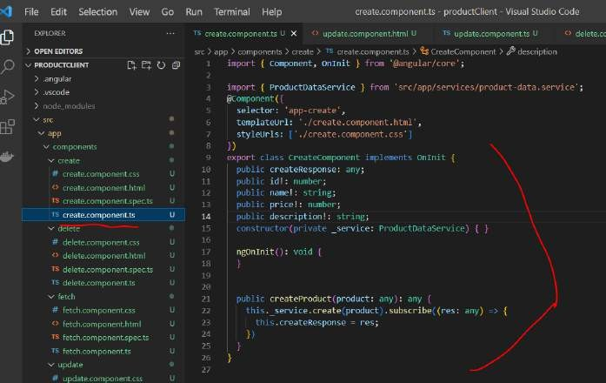

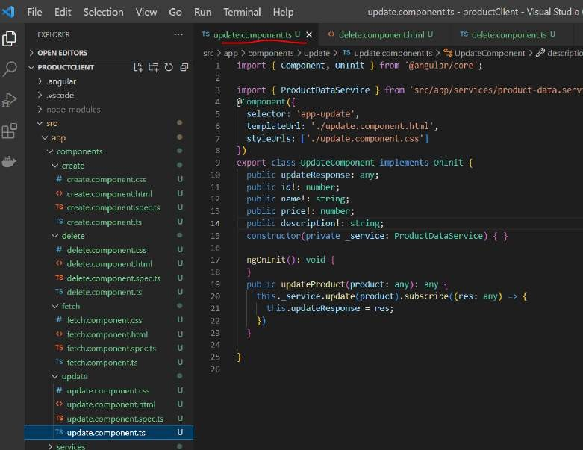

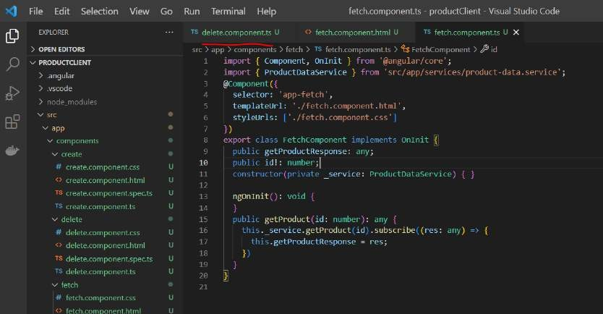

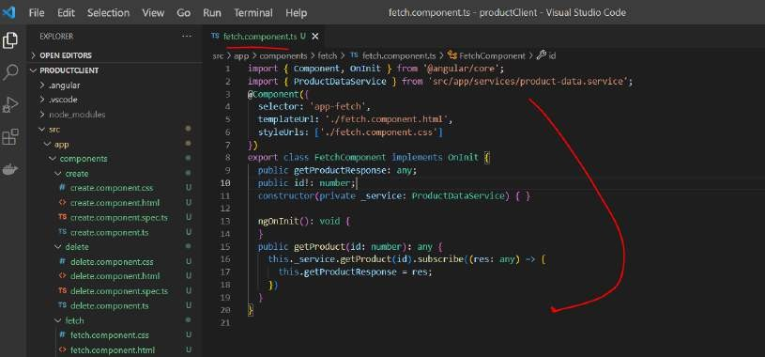

###### Routing in action

**Ng serve -o**

O Jocalhost:4200/create



##### [ { "id": 1, "naive": "house", "description": "awesome", "price": 20000 }, { "id": 2, "name": "watch",

"description": "awesome", "price": 2fi00 } ]

•sie srnHuct

P f• n • D t4C t

### Create Product

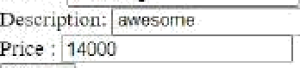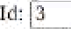

{ "id": 3, "nsme": "samsung", "description": "awesome", "price": 14000 }

£- D O• nca I osL1"OF d e'€ fi < fi i°i R *I O ° ause'

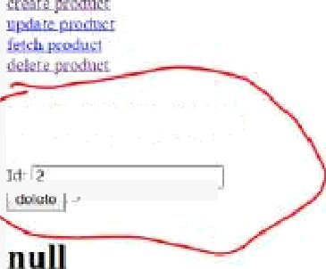

( "id": I, "name" "bousc", "dewriytion": "awesome", "yrice" 2000tj }, ( "id": 2, "oame": "watch’*, "description": "awesome", "yrice’". 2500 ) ]

* 'Delete Product

u c•eatr databz;e *yydbb;



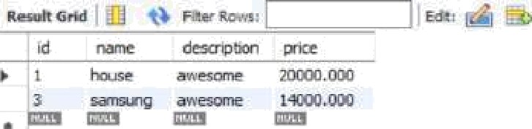



##### Proilucts

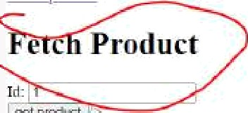

[ ( "id": 1, "name": "house", "description": "awesome", "price": 20000 ), ] "id": 2, "naiiie": "watch",

"description": "awesome", "price": 2W00 } }

*I mf • ufPflW I

( Product

{ "id“: 1, "naoie": "house", "description": "awesome", "price": 20000 }

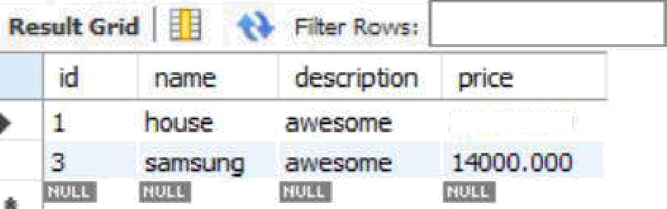

O O loca lhost:42OO/upd at e 

##### Products

[ { "id": 1, "name": "house", "description": "awesome", "price": 20000 ), ] "id": 2, "name": "watch", "description": "awesome", "piice": 2500 ) ]



ferhModiln

Update Product

Td: j 1



##### ( "id": 1, "name": "new house", "description": "newly constructed", "price": 21000 }

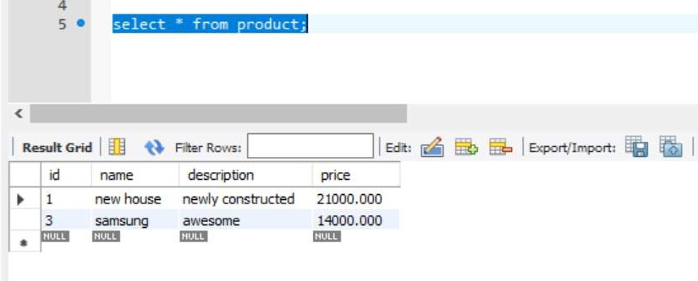

**Section 9 : Pipes**

**Introduction**

Pipes are use to format data in our html templates files

{{mydata | json}}

We can also model inside typescript files

Ex : **inbuilt pipes available in angular which work with text data. Titlecase** : convert the first letter into capital

###### Uppercase

**lowercase Date Currency**

**Json** : it convert the given javascript object into json

**Number** : to format number

**Percentages** : to convert a given number into percentage

**Async** : deal with promises

###### Text pipes

**Objective :**

**Titlecase, uppercase, lowercase :-** which work with text data Create project : **ng new pipes**

###### Note :

We are going to use default component for pipes

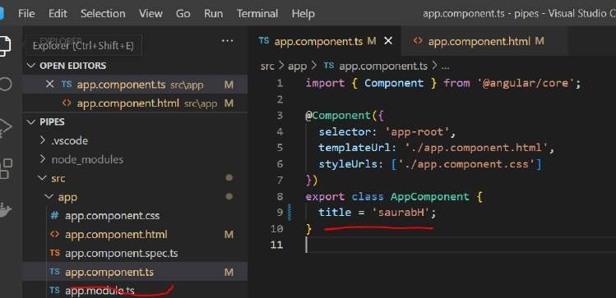

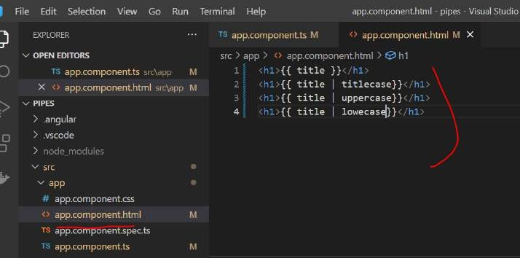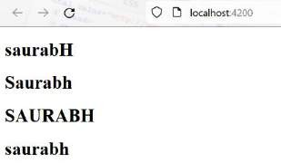

###### Date

myDate is initialized with current system date and time when we do new Date()

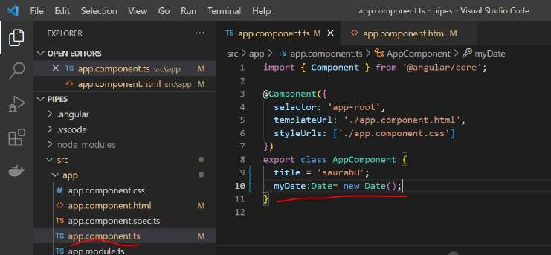

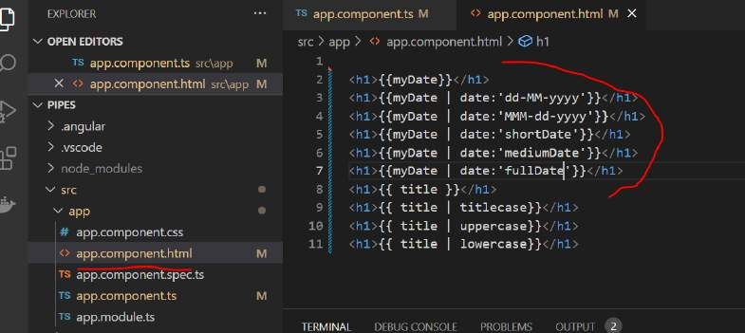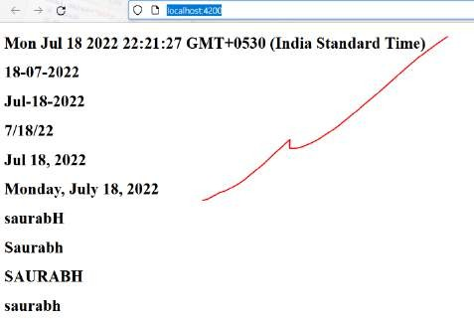

###### Currency

Help us to format the currency

###### Note :

By default dollar will be use as currency type and it will use US formatting

**GBP**: great britain

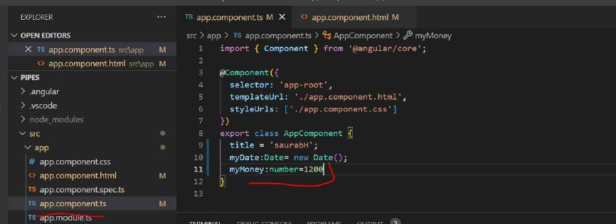

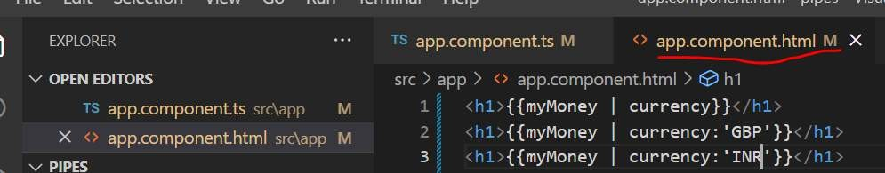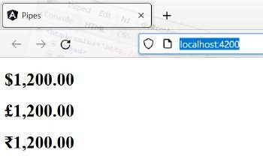

###### Json

It convert java script object into json string

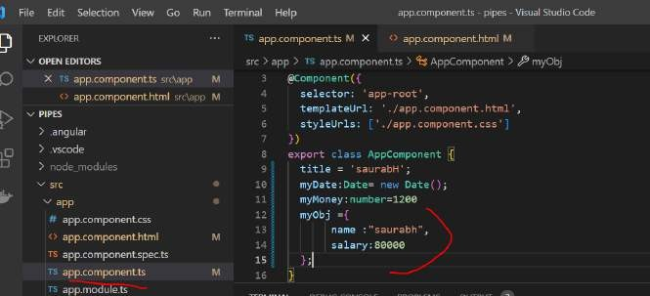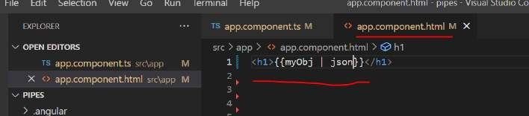

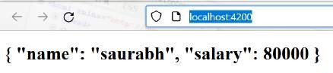

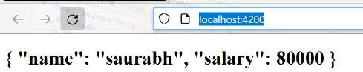

###### Number

**Syntax**

**Number:**{minIntegerDigits}.{minDecimalDigit}-{maxDecimalDigit}

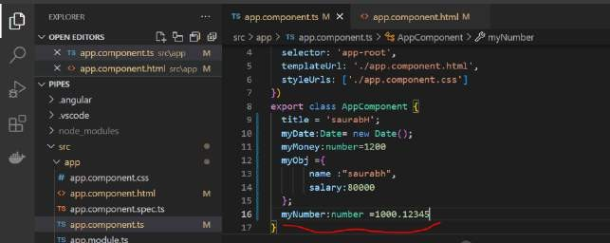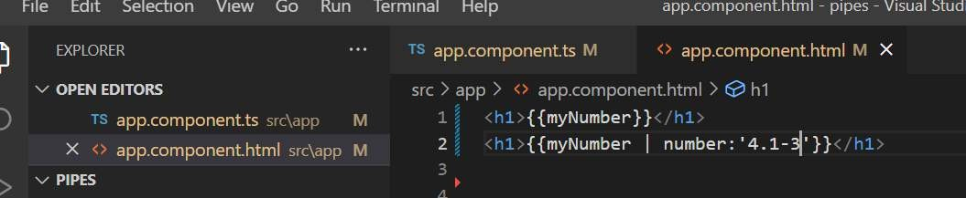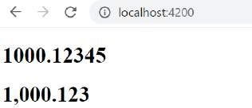

###### Percent

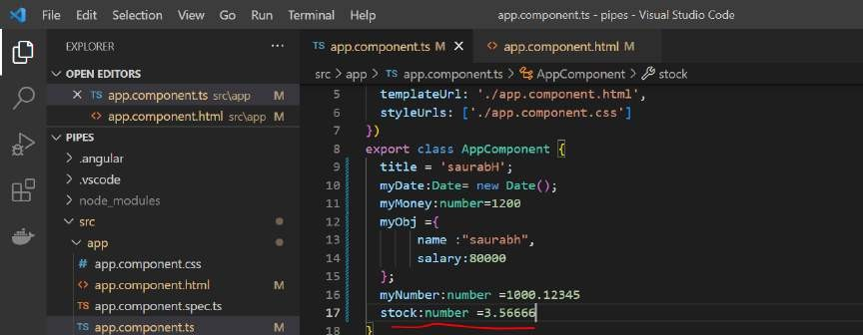

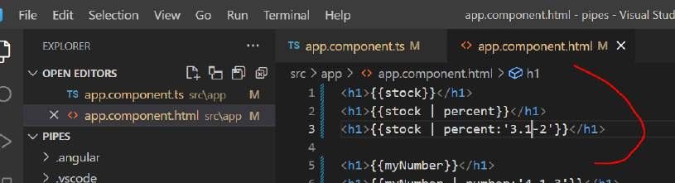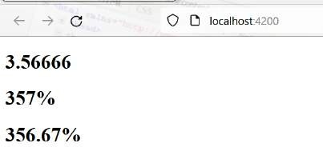

**slice**

**Note :**

Slice pipe we can use with array

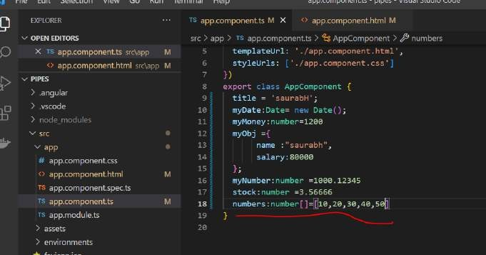

Two index before the last array

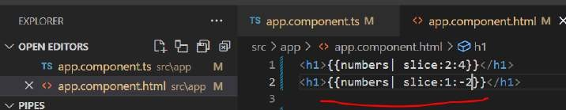

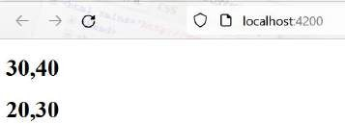

###### Using slice in for

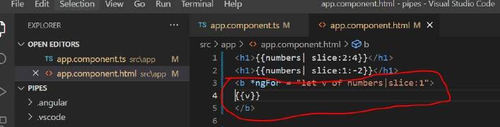

**o/p :** 20,30,40,50

###### Create a promise

Mypromise | async

###### We use promise for asynchronous processing , it is something that happen in future Going to create our own promise

**setTimeout :** first parameter is function call

Inside the constructor we are invoking the promise and handling the response that will returned by promise Resolve : use for successful

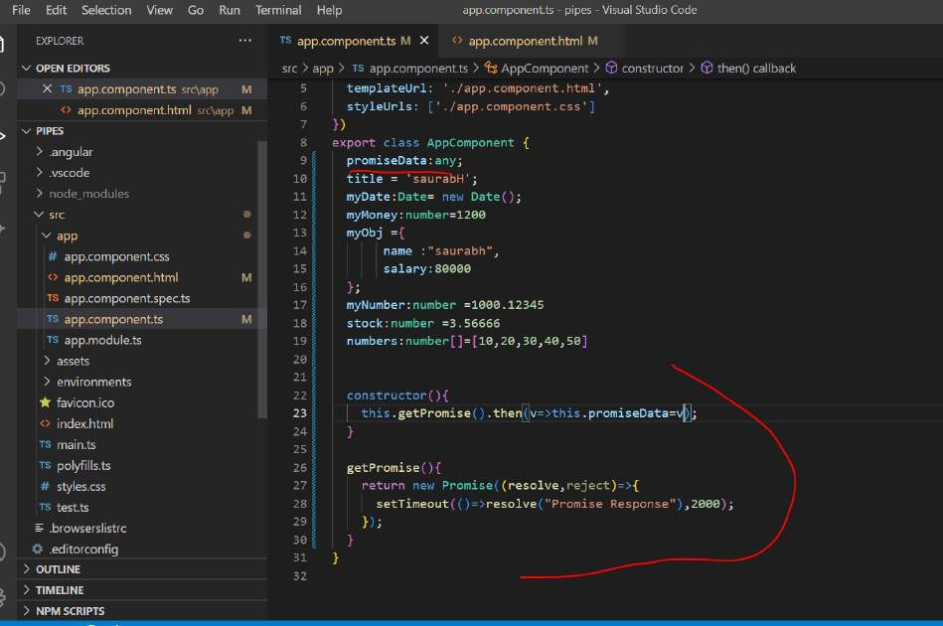

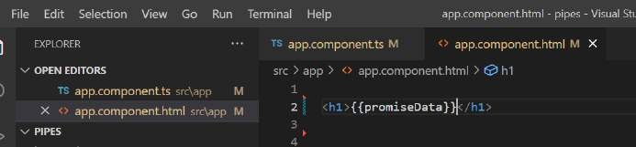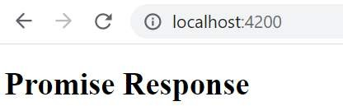

If it is a promise we use then to handle it.

If it is observable then it will do the same thing and use subscribe

###### Use async pipe

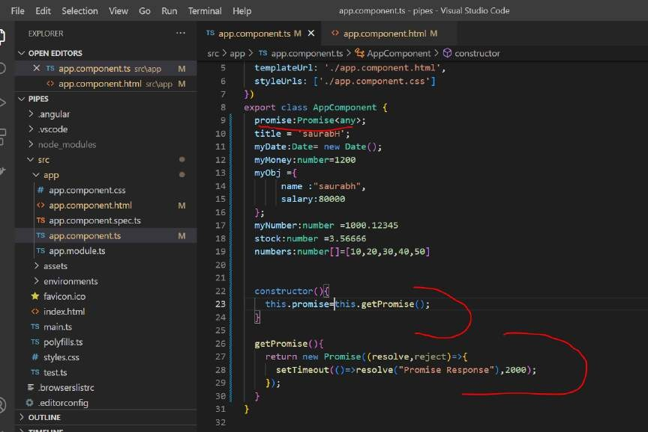

We are assigning promise to a promise directly and now we can use it directly this promise in the html

The async pipe knows how to handle the promise and whenever the response come from promise it will render it on the ui.

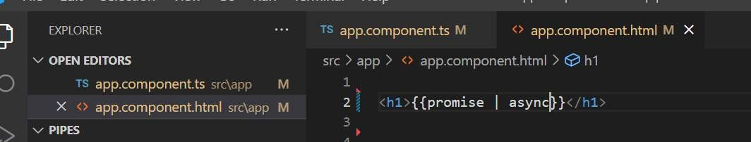

###### o/p : Promise Response

**Create a custom pipe**

**Objective :**

To create a pipe that will take a text or string and reverse the string

**Create a pipe** ng g p pipes/reversepipe

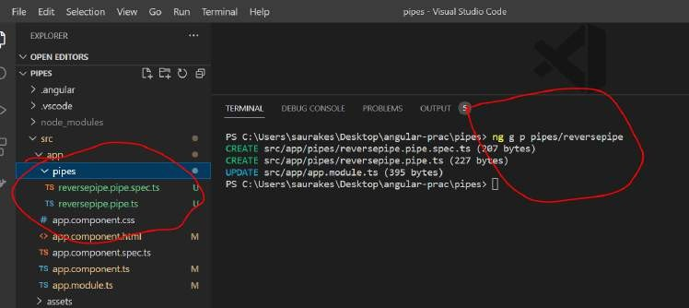

It will also get updated in app.module.ts

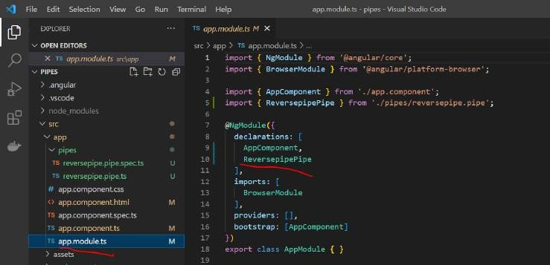

Note :

Every pipe we create is implement PipeTransform and it implement logic in transpform

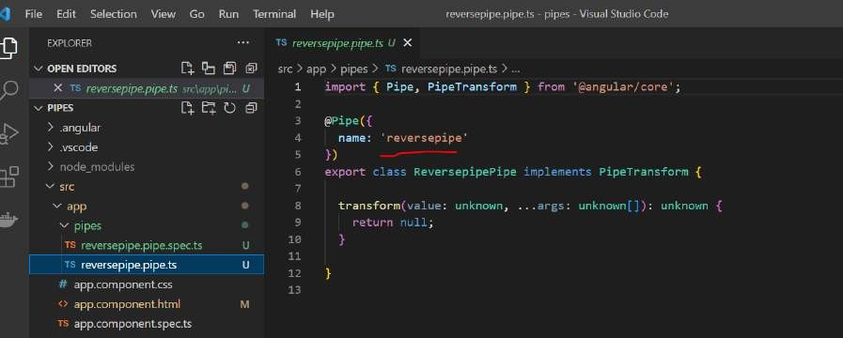

reversePipe is the name which we should use in Html template

###### In transform we will written logic and wtever we will return that will be render on ui

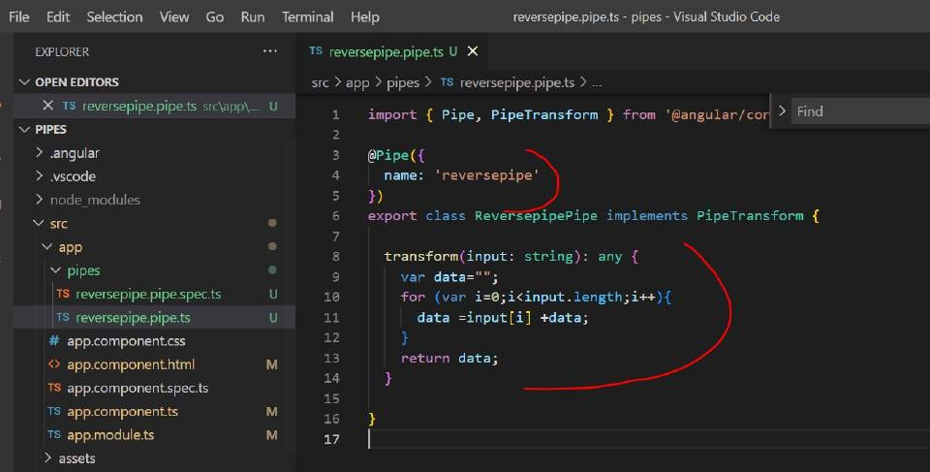

Let apply pipe on html that is **reversepipe**

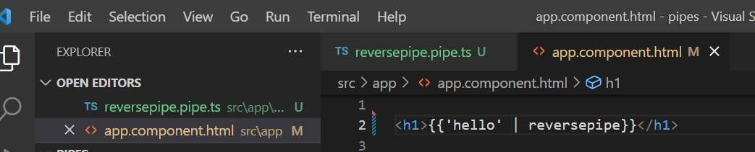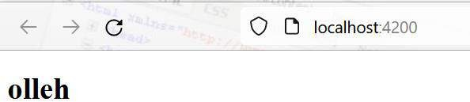

###### Note :

In pipe decorator we give a pipe name and pipe will automatically configured in app.module.ts and we can use it in other section

We took the input and send the reverse string back using pipes

###### Section 10 Reactive forms Forms

Forms are key part of any web application Form will allow end user to enter some data

In angular we can create and use form in **two different ways**

###### Model driven or reactive form :

will create component and then html and then bind using directives that angular provide

**reactive form module** give us two imp classes

**FormGroup** represent html form

**FormControl** represent input types . It will maintain the state of each input that value is entered by user. And also if

we add

validation. FormControl will have result of validation whether validation has succeeded or failed

###### Note :

FormGroup is a collection of various FormControl and the state of FormGroup is nothing but the combination of all the formGroup

So a FormGroup is valid only if all the FormControl validation is successfull

###### Template driven forms

**Usecase and project : Reactive / Model driven form**

**Objective :**

How to use model driven form in angular

We will capture person details First name

Last name Email Address

Street City Country Gender

Will first create a model that represent all these fields and then we mapped this field to html where we will create our form

###### Create project : ng new reactiveForms

**Note :**

Will use default component only that is app component Will also use bootstrap css just to add styling in html

###### Add bootstrap css

**Bootstrap css link**

<link rel="stylesheet" href="https://maxcdn.bootstrapcdn.com/bootstrap/3.4.1/css/bootstrap.min.css"> Paste it in index.html

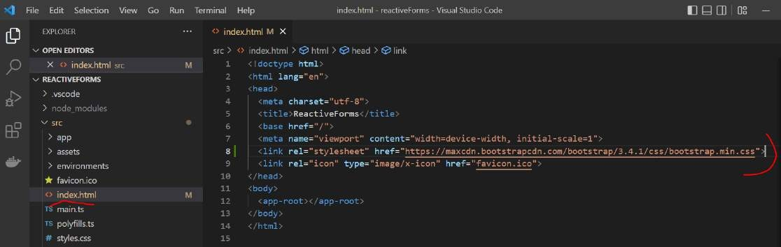

###### Create the model

**Step 1:-**

Import formGroup and formControl in ts file

**Subgroup** : within form ( like street,city , country)

**personForm** will represent html form when we will create it

**formGroup** constructor take an object within which we define all the **formcontrols**

###### We are creating instance of FormGroup within which we are defining all the formControl by giving them name

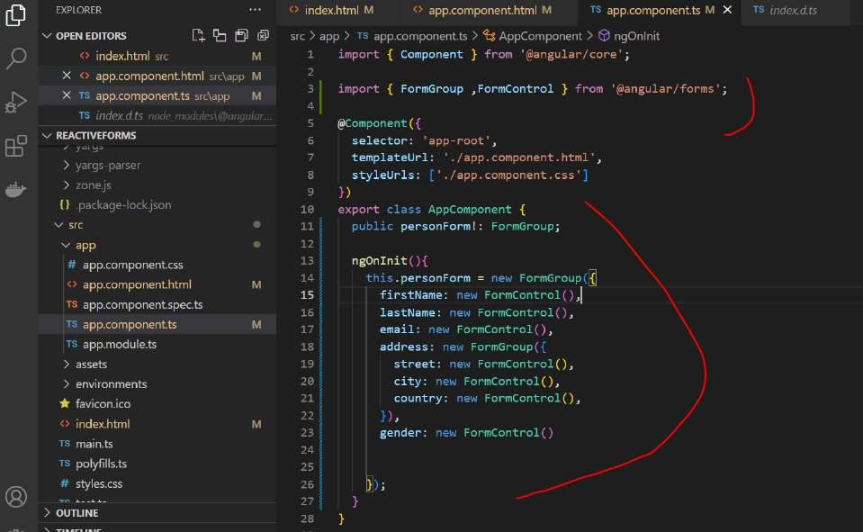

**Create the form view**

Will define div and the **root element always use a style** called container. This style comes from bootstrap. Within the container will define a form

**Step 1**: bind the form to the form object defined in model class

**formGroup** is directive that bind html form to our form defined in model and within this form we will define all the form element

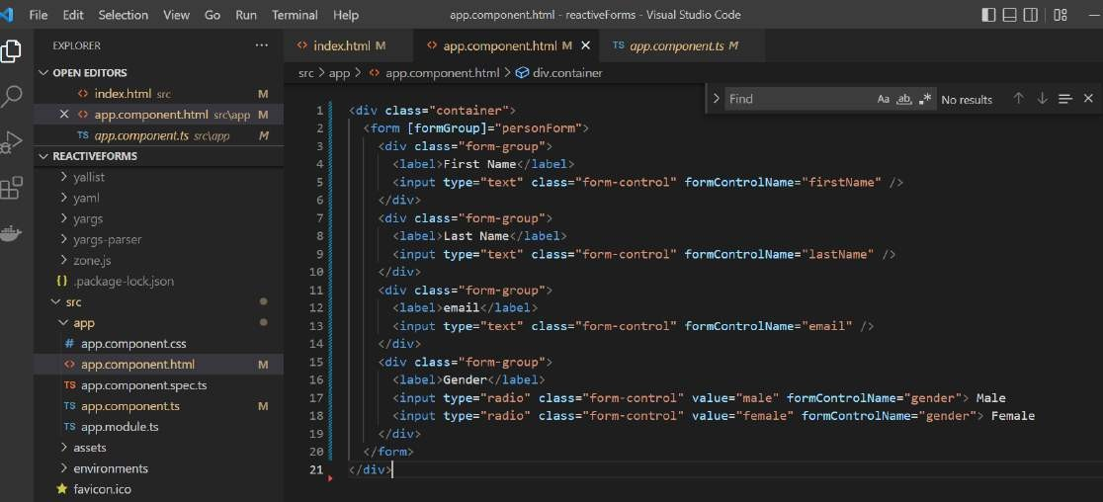**formControlName** : will bind value to defined in formControl in app.component.ts

###### Add a address sub group

Note :

Address is sub group , we are grouping it in another form group

We use **formGroupName** to map or bind a **sub group** which is **address here**

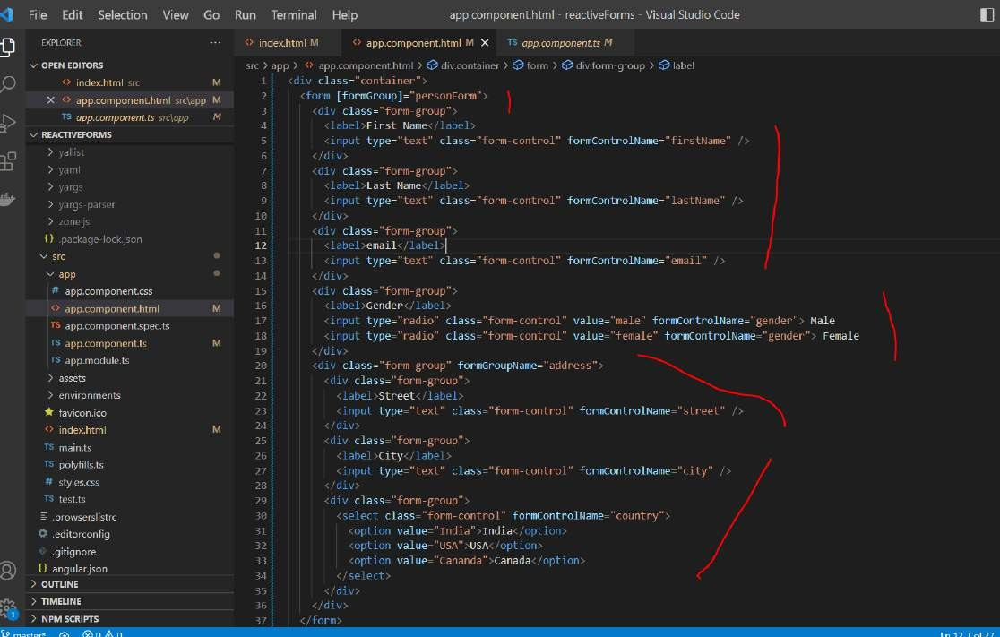

###### Add submit button

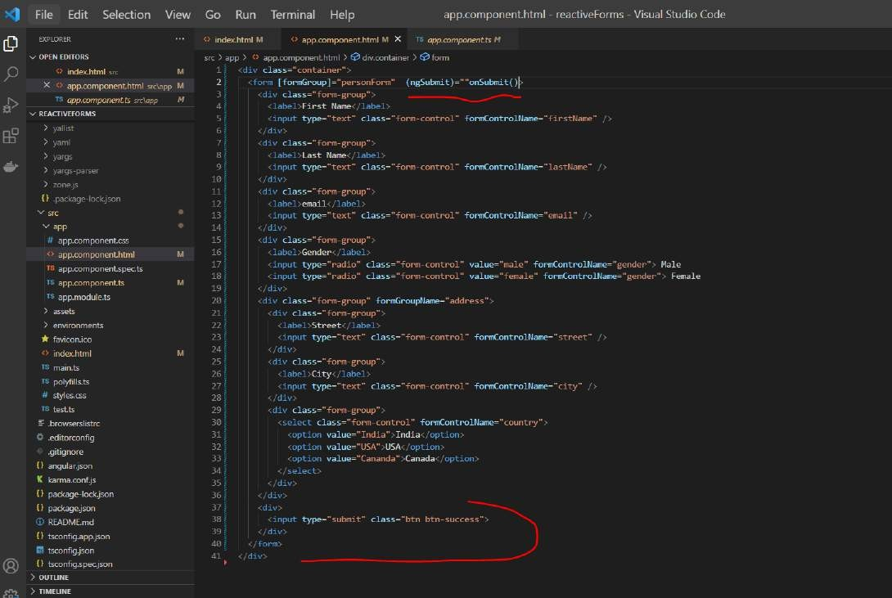

**Handle onSubmit**

Implement onSubmit method inside model

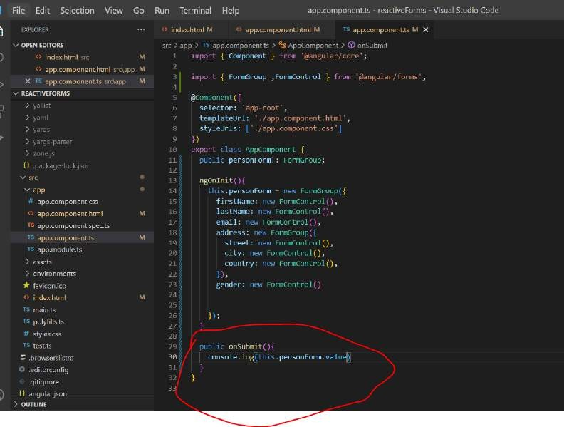

###### Test and Summary

We need to include ReactiveFormModule in angular.module.ts

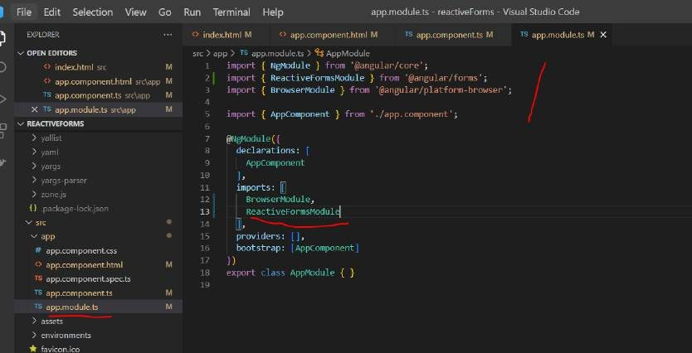

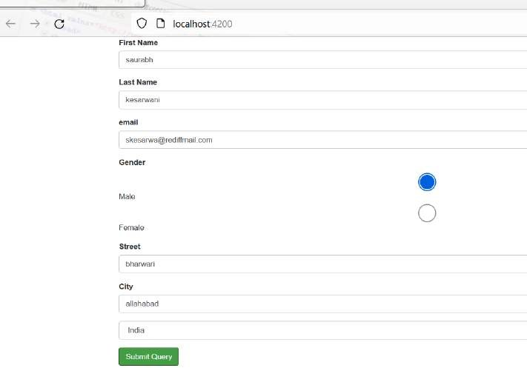

###### Default value and validations

Write default name in form

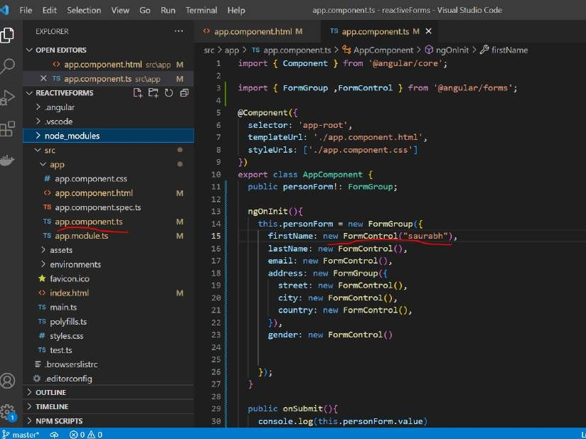

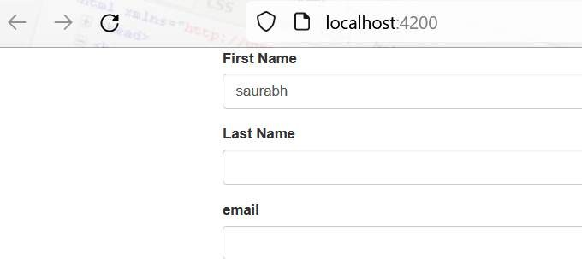

###### Note :

**Form control** accept array of validator as parameter

###### If all the validation is passed form is valid, all the error will be bind to html parameter like firstName

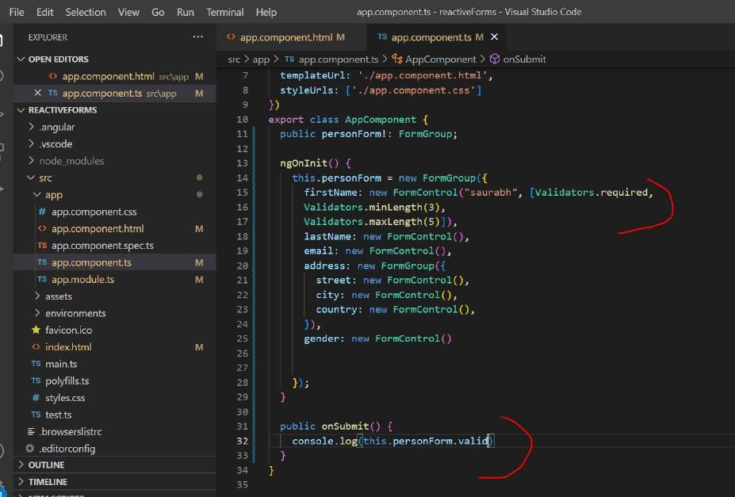

**Handling validation error**

**Note :**

Angular will bind the error to particular field or property and we can access them to html page to display those error We will define **new div** to handle each of error case

Controls is array which will have all the field name

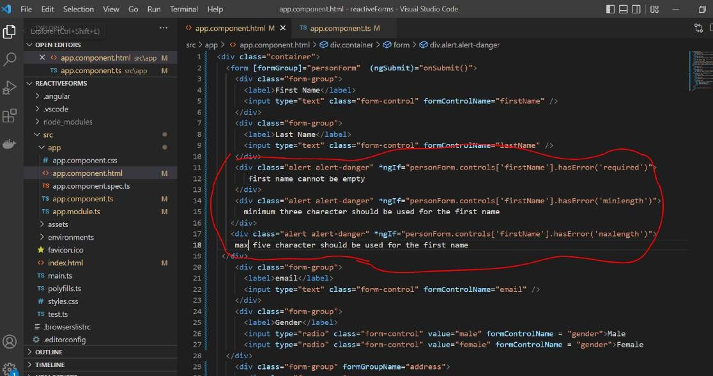

###### Get countries dynamically

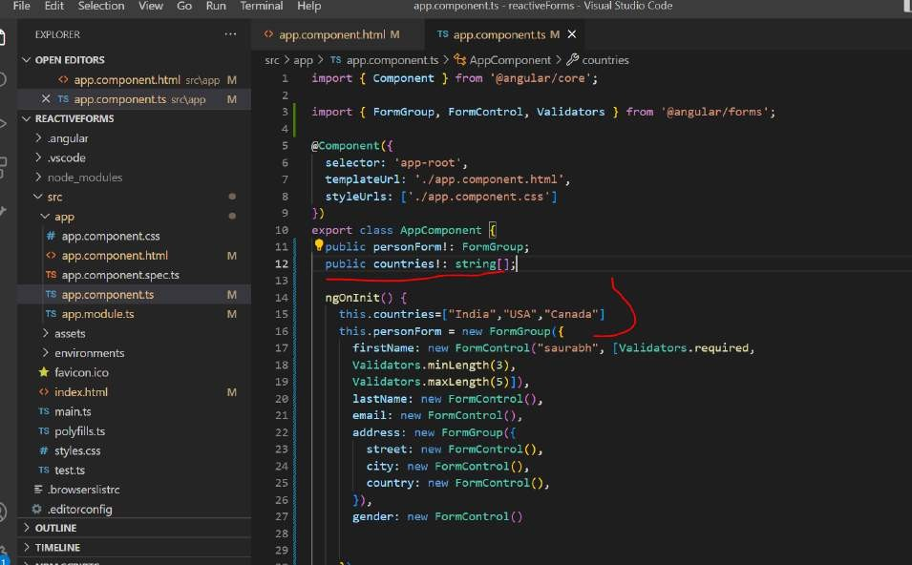

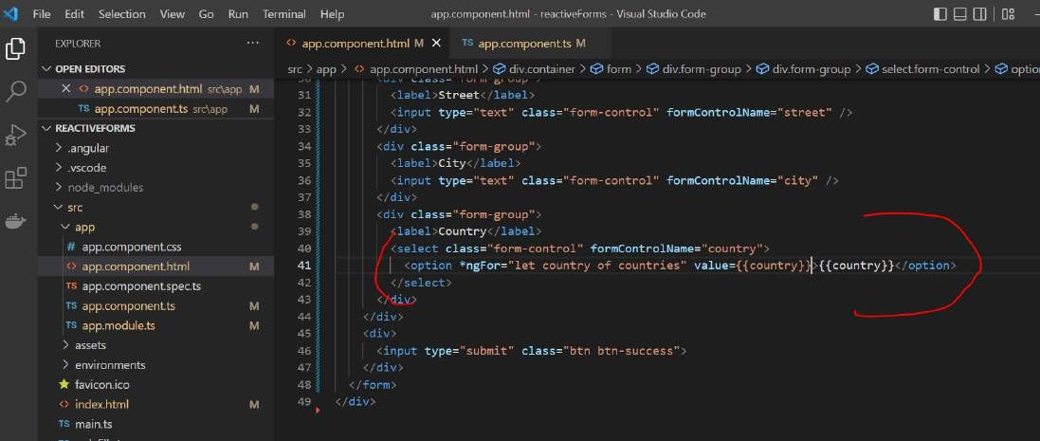

**Section 11: template driven forms**

**Template driven form are internally model driven form**

**but they are driven by the directive in the html instead of code in the model**

**Note :**

Here we will use directive given by angular in html

Just by adding FormsModule to the ngModule configuration we will get ngForm object that we can use in our html template.

Internall **ngForm** create **formGroup** object.

ngModel create a formControl object and name will map to property of model

###### Create the project

We will capture person details First name

Last name Email Address

Street City Country Gender

###### createProject : ng new templateForms

Will use bootstrap style in index.html

<link rel="stylesheet" href="https://maxcdn.bootstrapcdn.com/bootstrap/3.4.1/css/bootstrap.min.css">

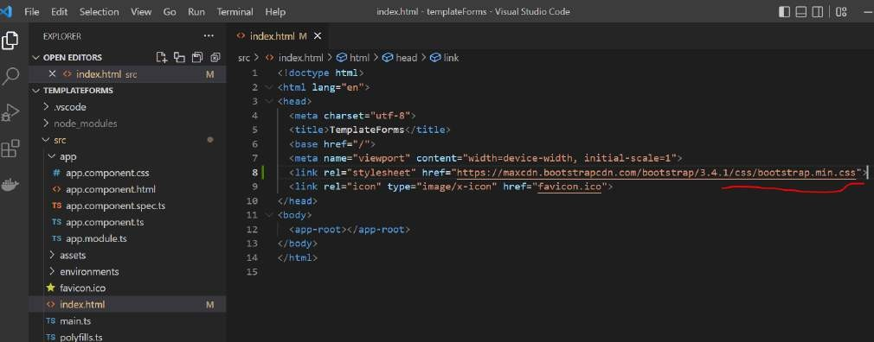

**Create the template and form**

**<form #personForm= "ngForm"> ( this will contain entire form object with name and values)**

Angular will internally create a form **instance** (group instance) and it will associated with this alias (**personForm**)

**#personForm= "ngForm">** this line equivalent to when we develop model driven form

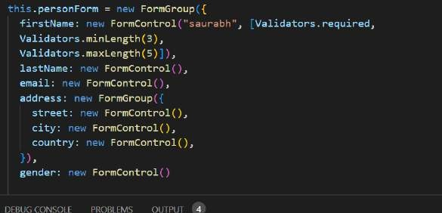

Next define input types or formLabel

**Name=firstName ngModel** :--- this is equivalent to formControl **firstName = new formControl**

**Angular knows it need to create formControl by firstName** and it should bind to model that’s what we are telling using ngModel which is two way data binding

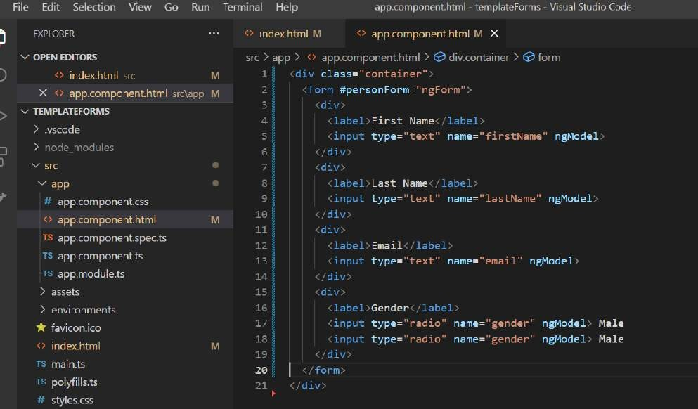

###### Add sub form group field ngModelGroup = address equivalent to address= new FormGroup

**Name and ngModel :** telling create a formControl and associate with this property name

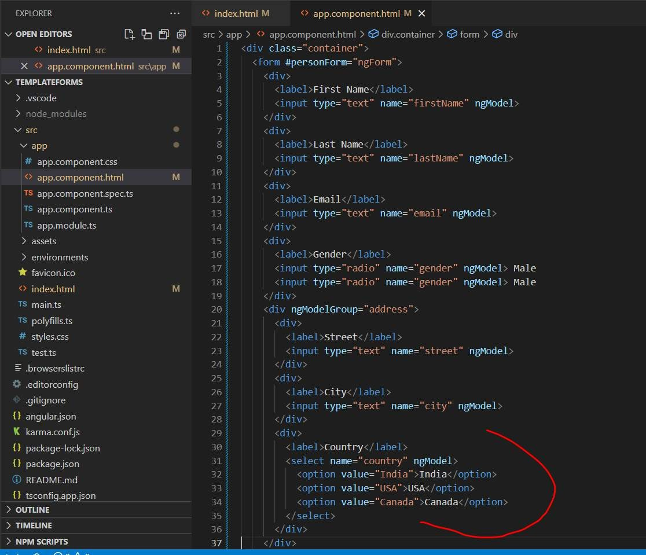

###### Handle Submit

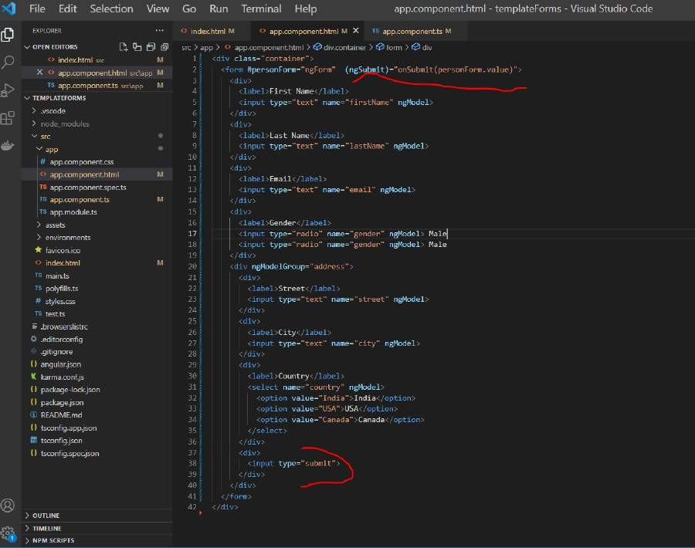

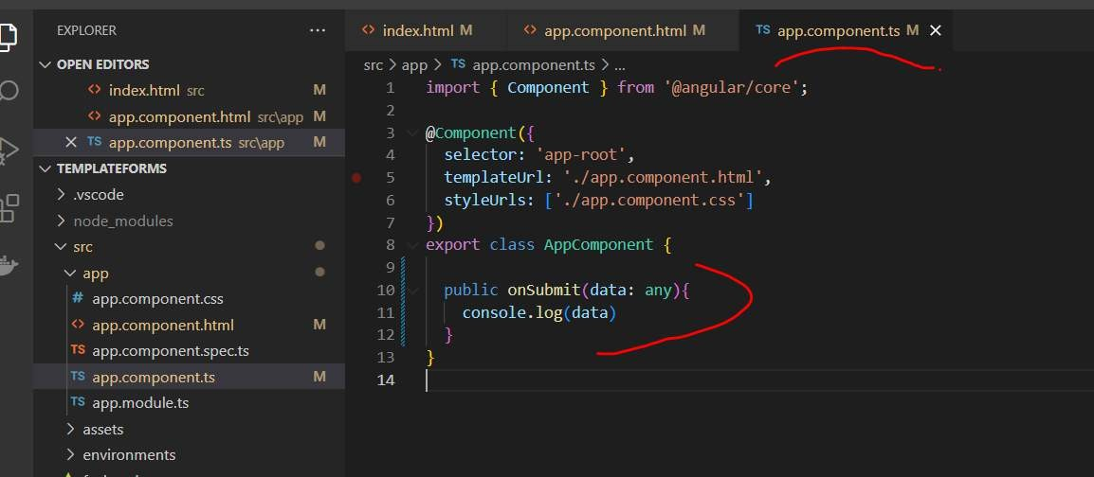

**Test**

**Import formsModule**

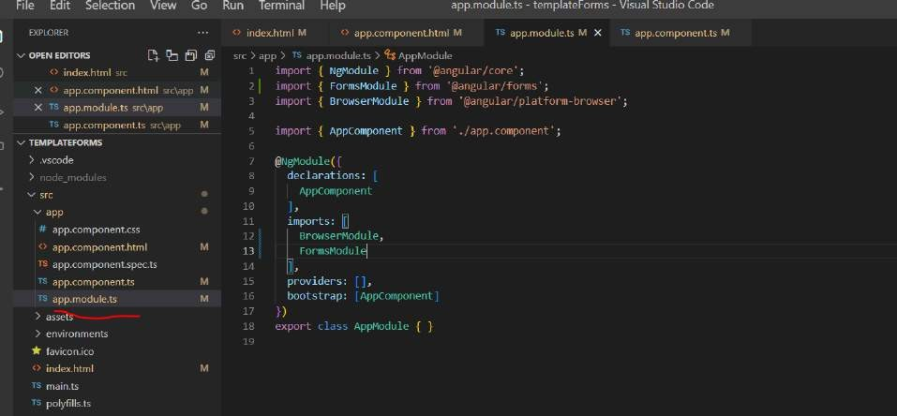

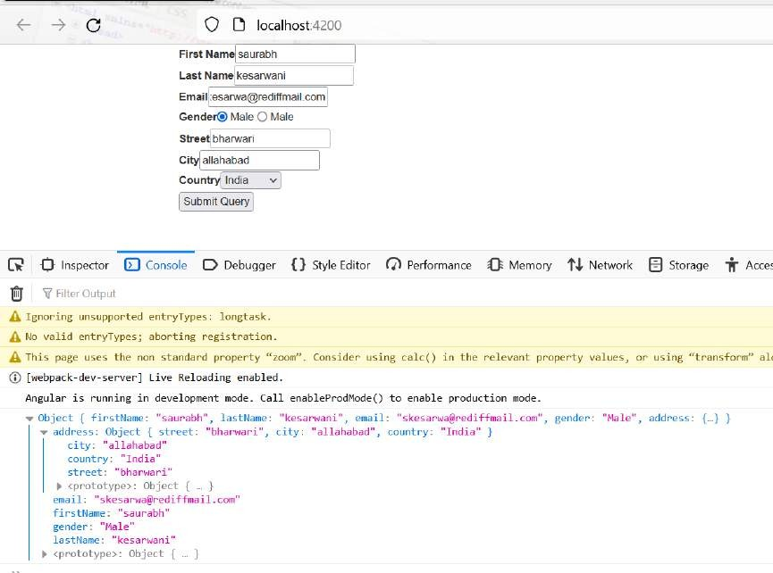

**Two way binding**

**[(ngModel)]**

OPEN EDITORS src app +* app.component.ts 7 @ AppComponent @ onsubmit

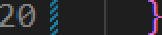

** index.html sic M I import { Component } from \@angular/core';

*^ app.component.html src*,app M

*TS* app.component.ts src\app M

TEMPLATEFORfK5

j ) .angular

} .vscode

v src

w app

# app.component.css

app.component.html

- selector: 'app-root',

1. templateUrl: ' ./app.component.html',
2. styleUrls: './app.compDnent.css'

- )

export c l o s s AppCompon ent {

I public firstName:string=”John”;

1. public lastName! : string;
2. public email!: string; M public street! : string;

TO app.cDmponent.spec.ts 14 public city!: string;

TS app.component.ts M I° public country!: string;

TS app.mad uIe.ts M ‹ p ubl c gender ! : str1ng;

assets

7 environments

6 favicon.ico

index.html M

TS main.ts

TS polyfil Is.ts

# styles.css

17

public onSubmit(data: any)(

19 console.lo this.firstName

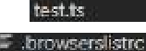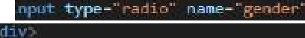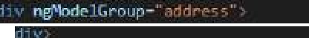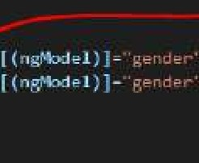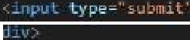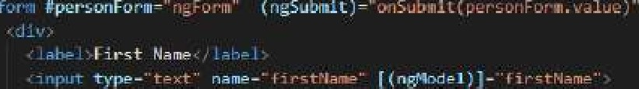

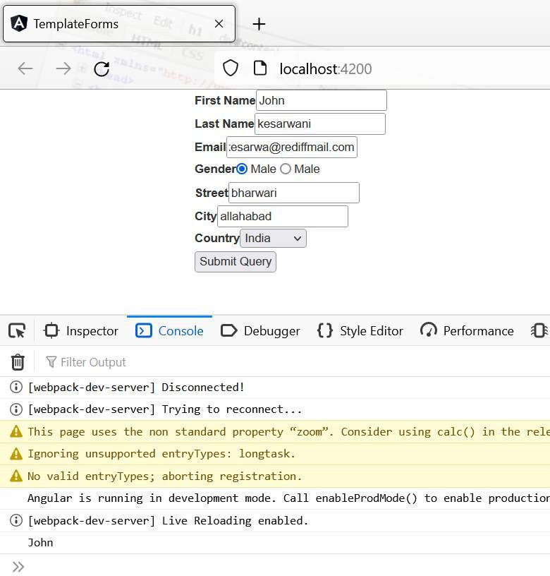

**Section 12 : Custom Directive**

**Objective:**



To create custom directive myIf this will work just like ngI**f Step :**

* Create the directive just like we create component
* Use TemplateRef and ViewContainerRef to manipulate the dom in html
* Implement the logic

**Doing** : if condition is true we will add it to view

###### Create project: ng new customdirectives Create directive : ng g d directives/myIf

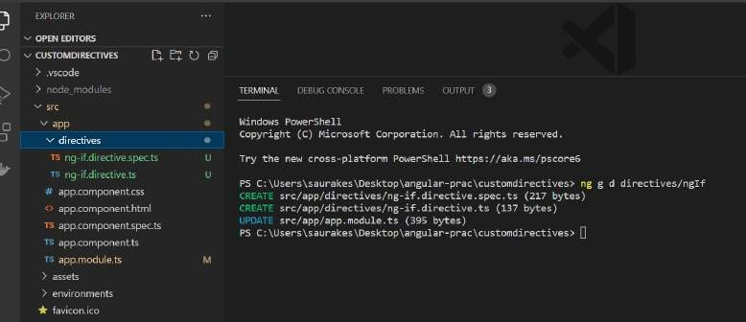

**Note :**

* it will also add to app.module.ts just like component

Every custom directive Is marked with decorator **@Directive**

* **Selector :** is name of directive this is what we have used in html . We can also change name of selector
* we need to inject **TemplateRef** in constructor which represent **current html element** and second one is

###### viewContainerRef

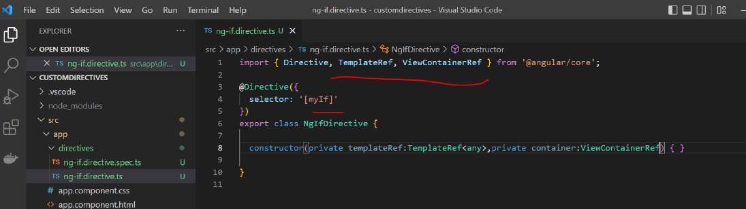

**Implement the conditional logic**

If condition is true we will display html.

Method name should be same as selector name

**Container.createEmbeddedVie**w will create a dom dynamically

**templateRef** always point to html element on which directive is used

To receive the input in **myIf** directive we need to mark this with **@Input** decorator

###### Note :

If we use different method name then selector name we need to pass in input decorator so that angular know this method is mapped

For which directive

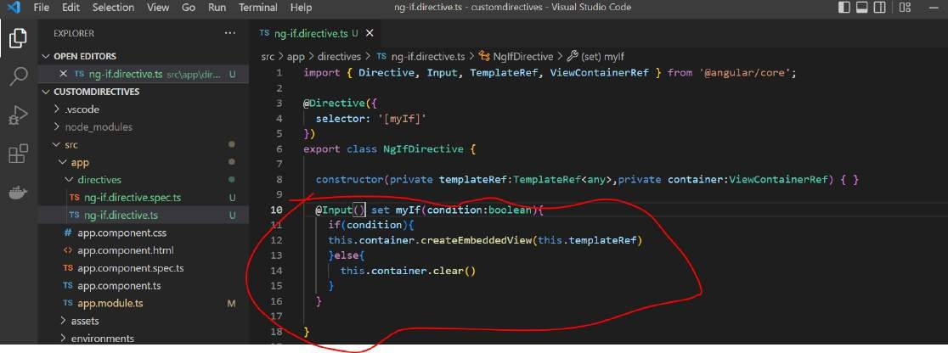

By default angular search method name with same by directive name

###### Use *myIf

**Objective :**

Will use custom directive myIf in template or html page

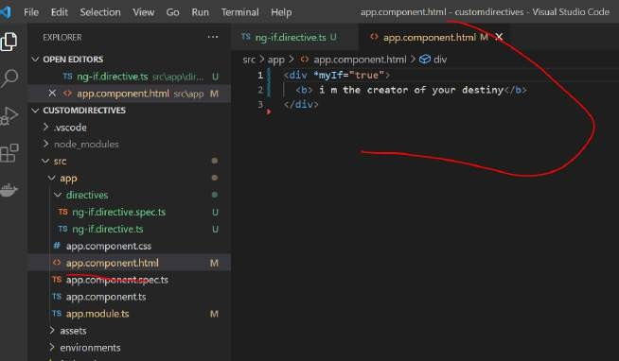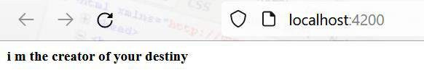

###### Create loop directive

It will act like a ngFor directive

###### Create directive Ng g d directives/myLoop

Will append templateRef **to dom**

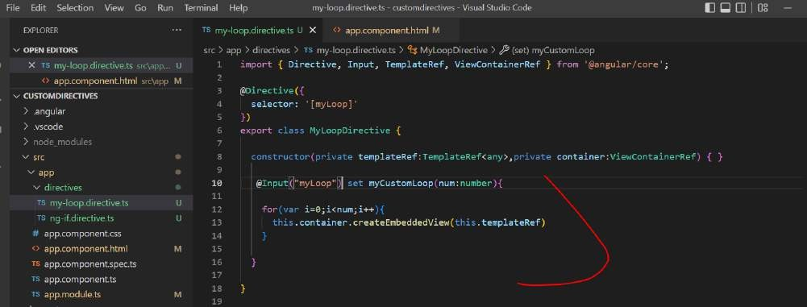

###### We are retrieving current html element in container

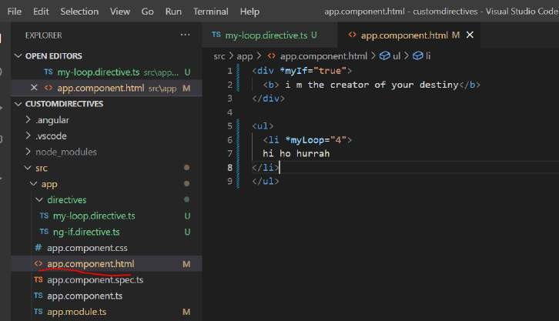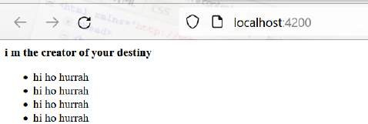

This directive will be added to app.module.ts

###### Create a attribute directive

**Create directive :- ng g d directives/myStyles**

**Note :** elementRef will reffer current element on which this directive is used

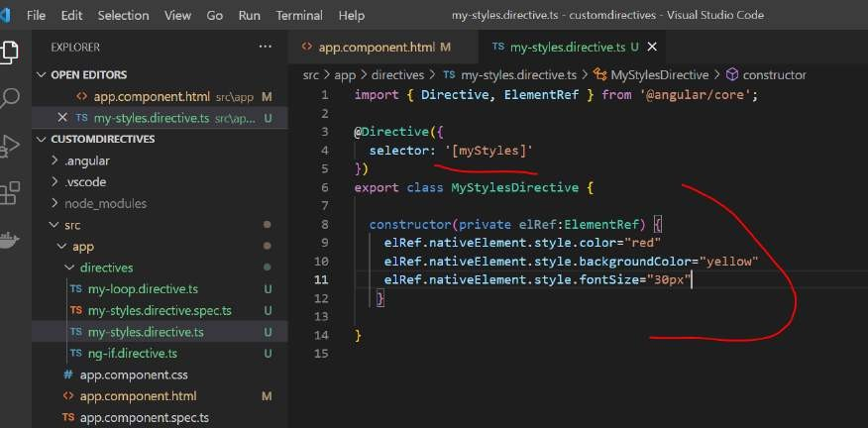

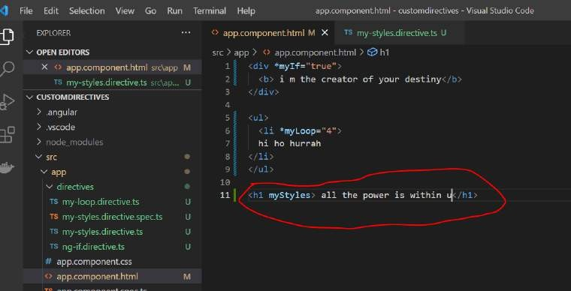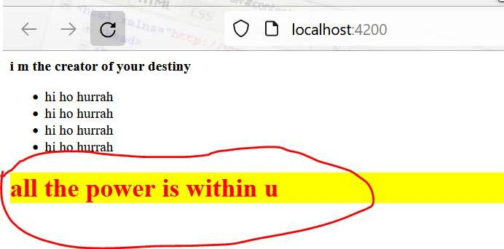

Note:

###### We are injecting elementRef which point the html element on which directive is used

**Pass Input**

**Objective :**

How to pass value dynamically to attribute directive and then use the to change the styling on our template

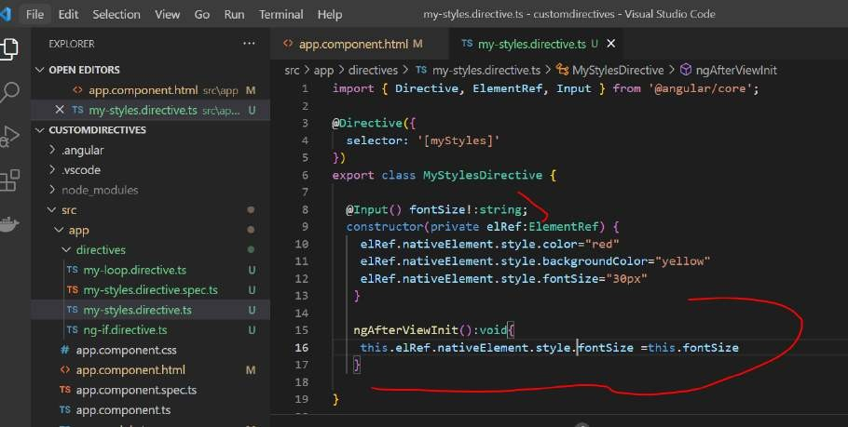

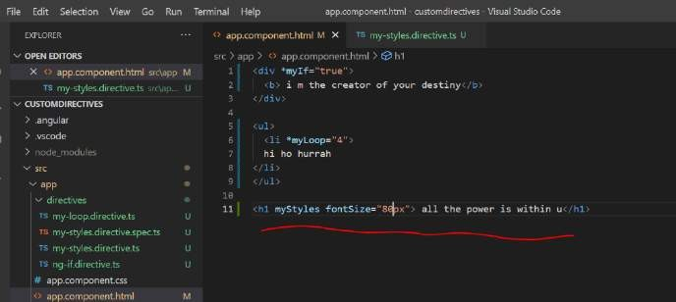

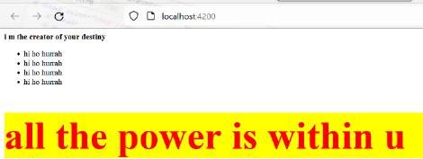

Note :

we are receiving input from html element

After th**e ui rendered ngAfterViewInit()** lifecycle hook method is invoked

###### Handle events

All the dom events we can handle and take appropriate action

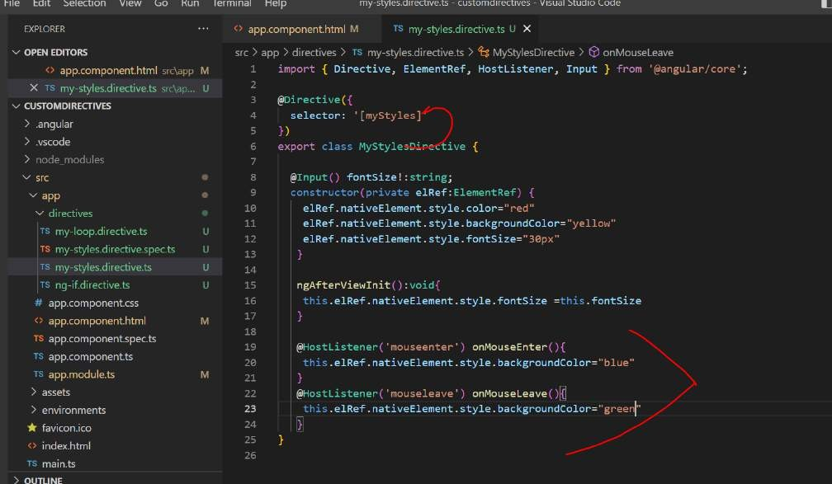

As soon as we enter the mouse the color will become blue:

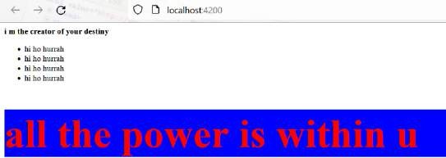

Section 13: project usecase

**Flight reservation :** to book a flight or create a reservation

**Checkin app :-**Once we have a reservation it will also allow fo**r checkin**

Both these application will use rest api . This api will communicate to d/b and responsible for all retrieval and create

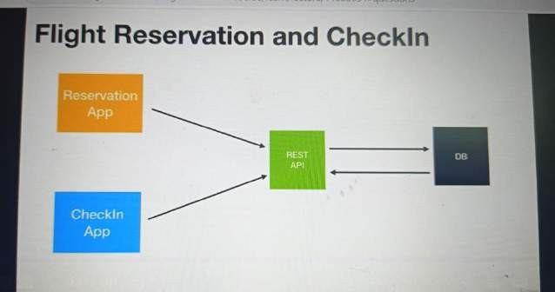

###### Step

Create backend then reservation app and checkin app

###### Flight reservation usecase

**First page :** find flight

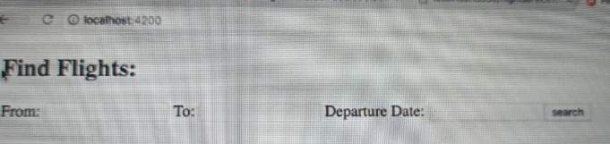

1. Once we click on **search** our angular application will make backend call which will return all the flight that match this criteria

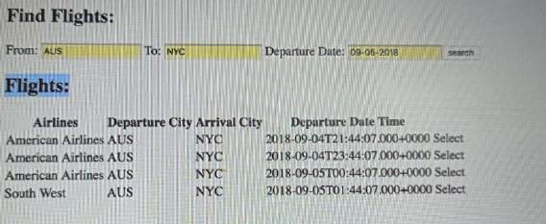

1. We can pick a flight by clicking on select button and it will go to next screen . It will make another backend call which will

fetch just flight info render it and then will ask him to fill passenger details. Once we will fill detail and confirm , it will call another backend call and the reservation will be save in the d/b

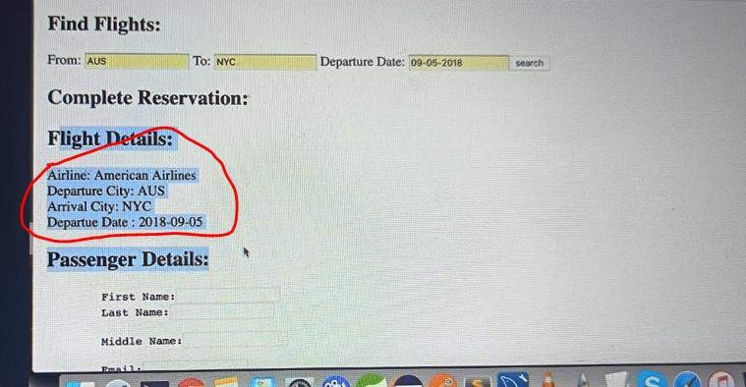

**Find, select , confirm :** so total three method will expose out

###### Flight checkin use case

* Once passenger has reservation we click on start to start checkin process.

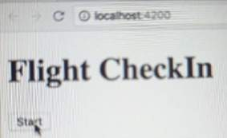

* It will prompt reservation id, give reservation id at this point it will make backend call

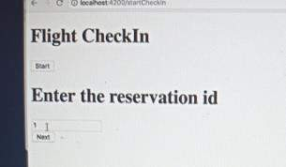

* Click on next the entire reservation will be fetch from backend
* Enter number of bags and click on checkin

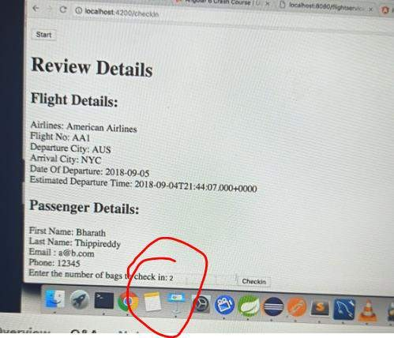

Two call required one fetches the info and other update the info.

Section 14: create the java backend Create d/b schema for flight reservation api

Note :

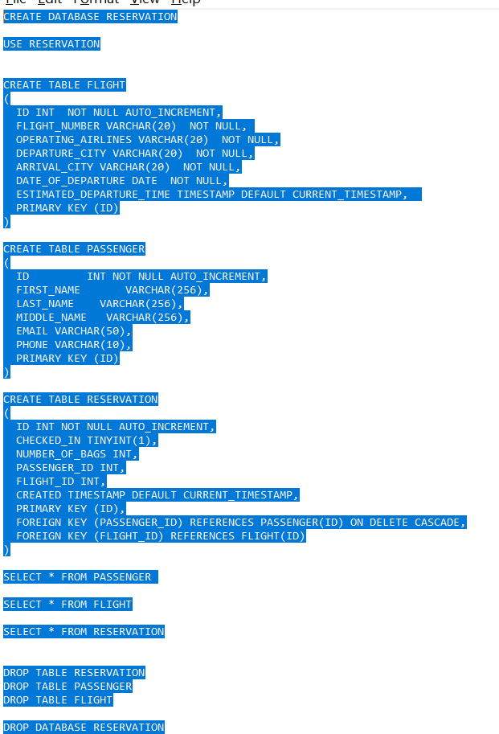

When reservation first created checkin will be false When we do checkin from ui will make flag true No of bags initially :-0

###### Create the project

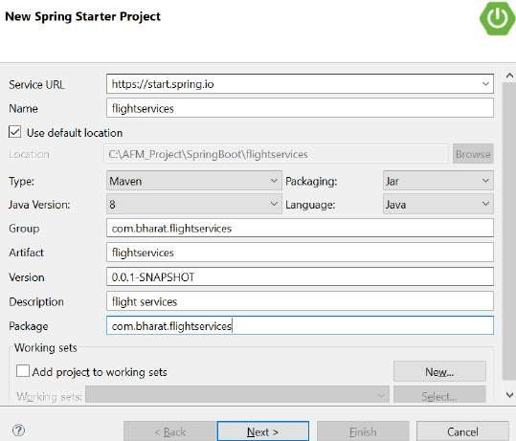

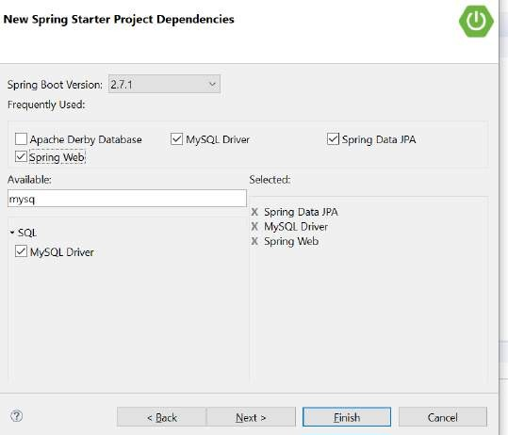

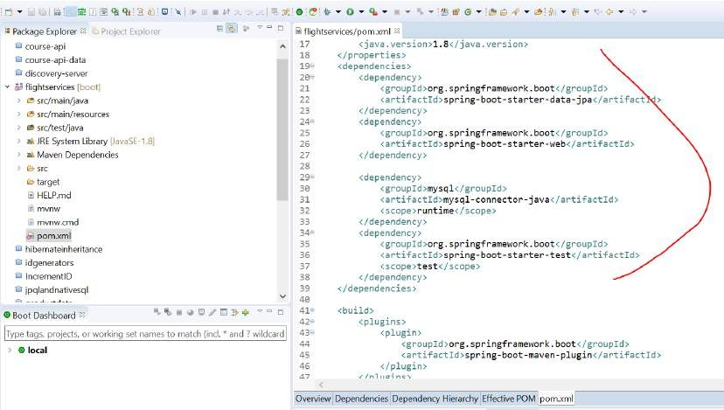

**Create the entities**

Create entities that represent d/b column

###### Flight.java

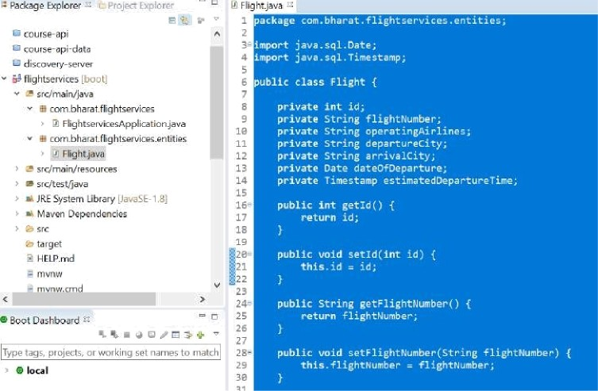 

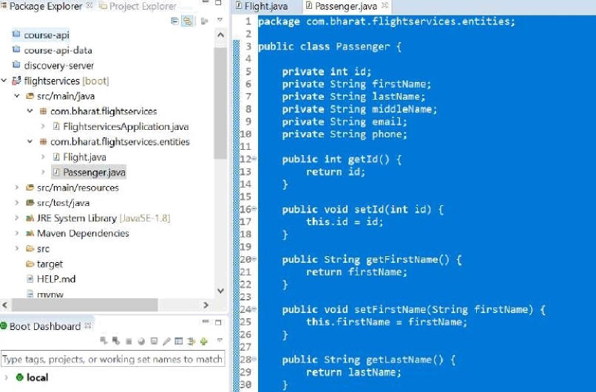File £dit Source Refador Refactor bevigate Search P_roject Bun @ndcnv iJelp

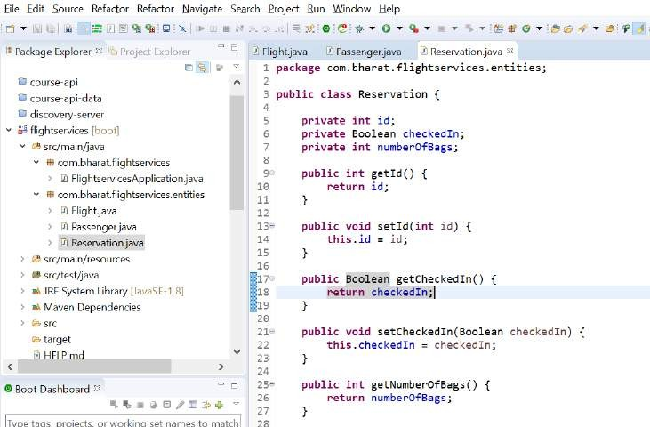

###### Marked them with JPA Annotation

**Extends abstractEntity** : it will get id field

###### We mapped out entity to database table

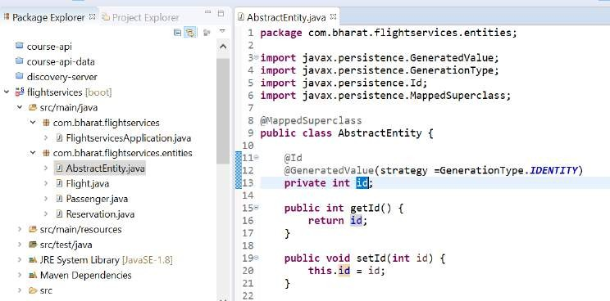

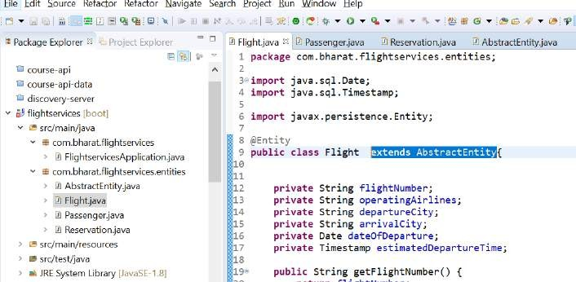

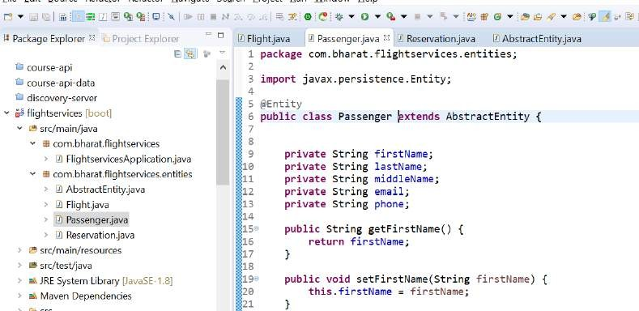

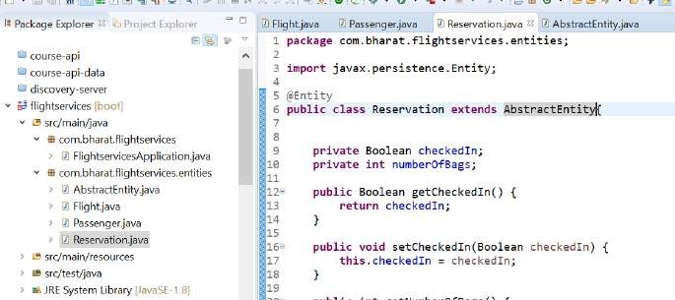

Class name and table name is same so @Entity will work

What is the use of @MappedSuperclass?

Annotation Type MappedSuperclass. **Designates a class whose mapping information is applied to the entities that inherit from it**. A mapped superclass has no separate table defined for it.

###### Define Relationships

**Note :**

Reservation table used flight id and passenger id

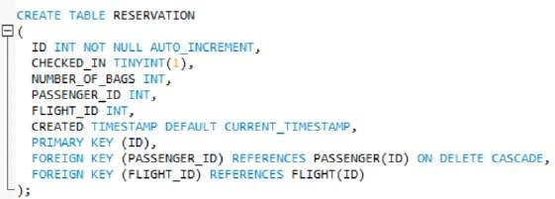

**Each reservation** will have only **one flight** and **one passenger** so it is **@OneToOne r/s Note :**

If passenger is not there in d/b ,row will be created in passenger table and it will save as foreign key in reservation table

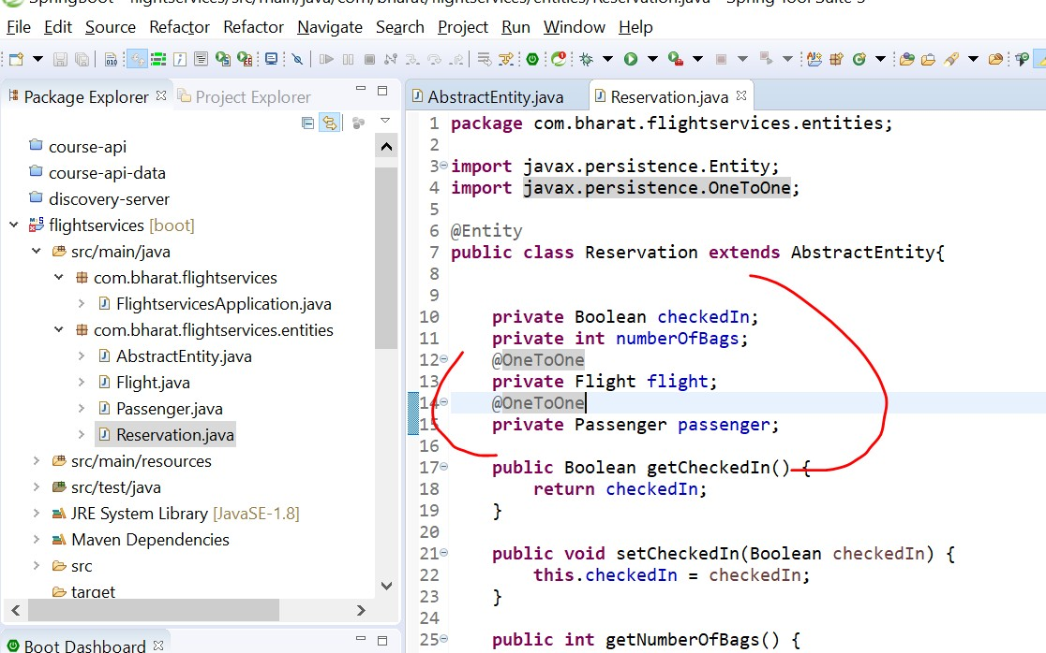

###### Create the repositories

Create one interface per entity

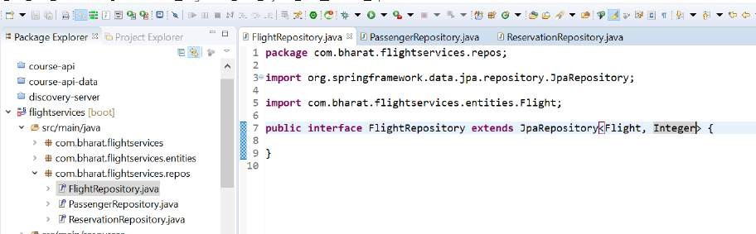

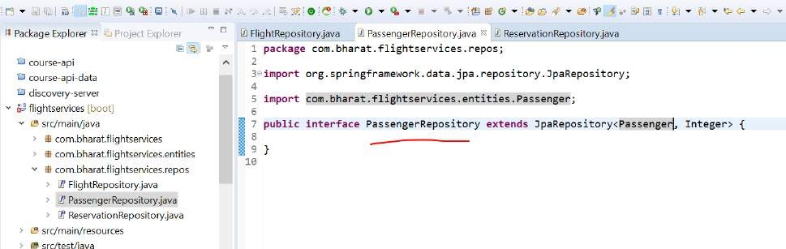

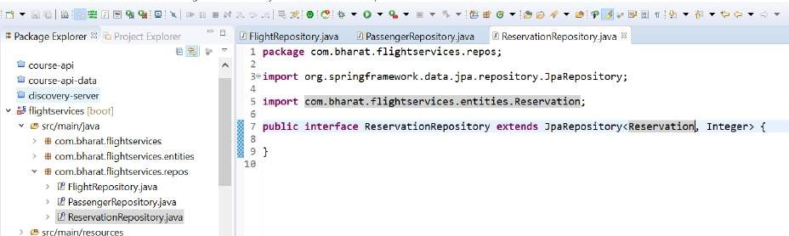

###### findFlight API

**Findflights**

**/flights GET**

When client will use this api it will get list of flight available

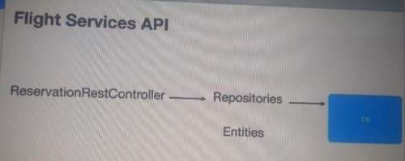

Internally findAll will call **select query**

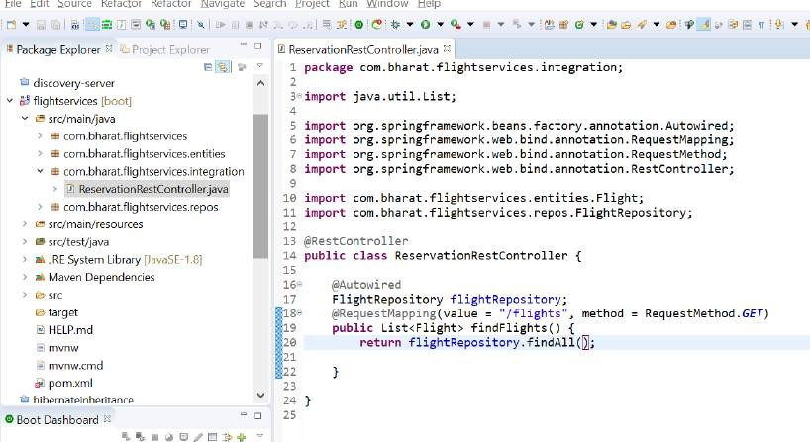

###### Save Reservation API

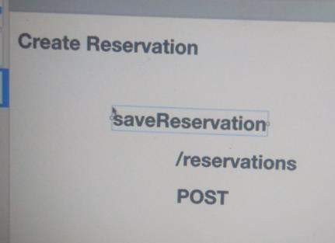

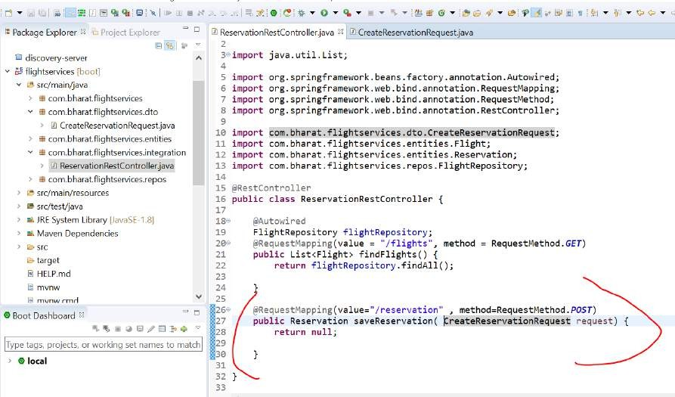

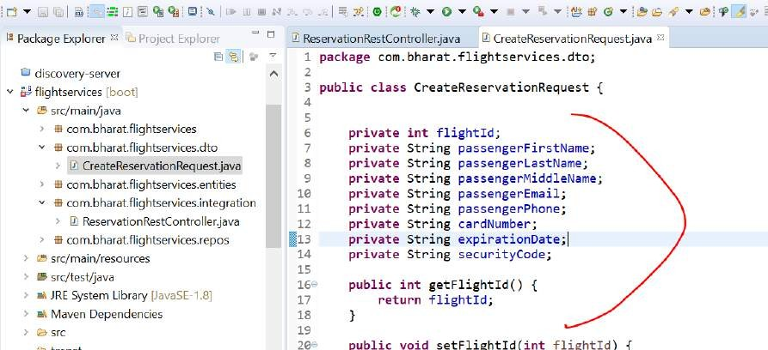

**Implement save Reservation**

**step 1 :- First fetch flight info from d/b.**

**Step 2: create a passenger entity ,Save the passenger in d/b**

**Then we will use flight info and passenger info to save reservation @Transactional**

All should happen or nothing should happen

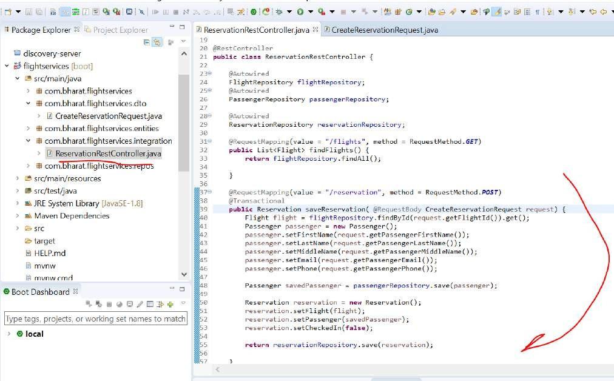

###### FindReservation

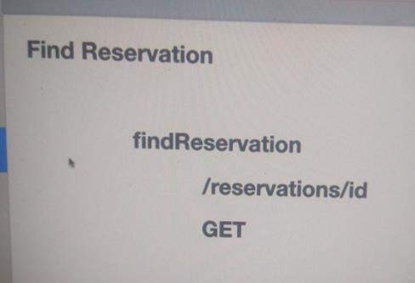

That will help client in checkin process.

It will fetch the reservation then allow no of bags and update the reservation

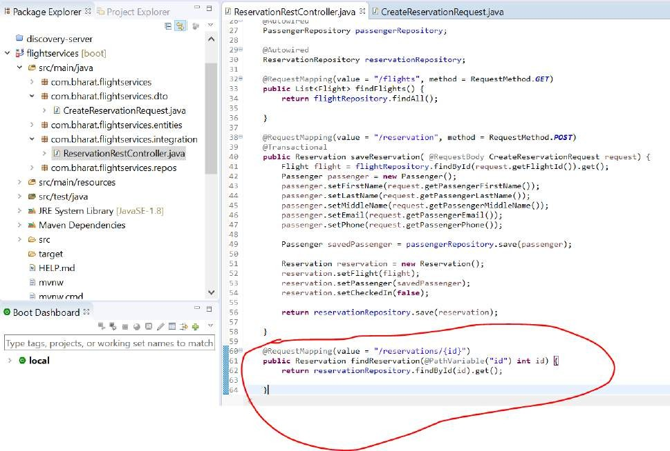

###### Update Reservation

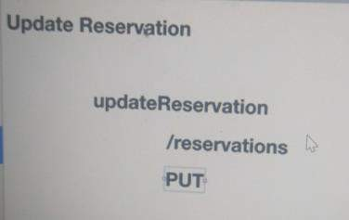

**Checkin :** this is where client will do checking, provide no of bag and also flag as true Step :

First fetch reservation so that we can update it

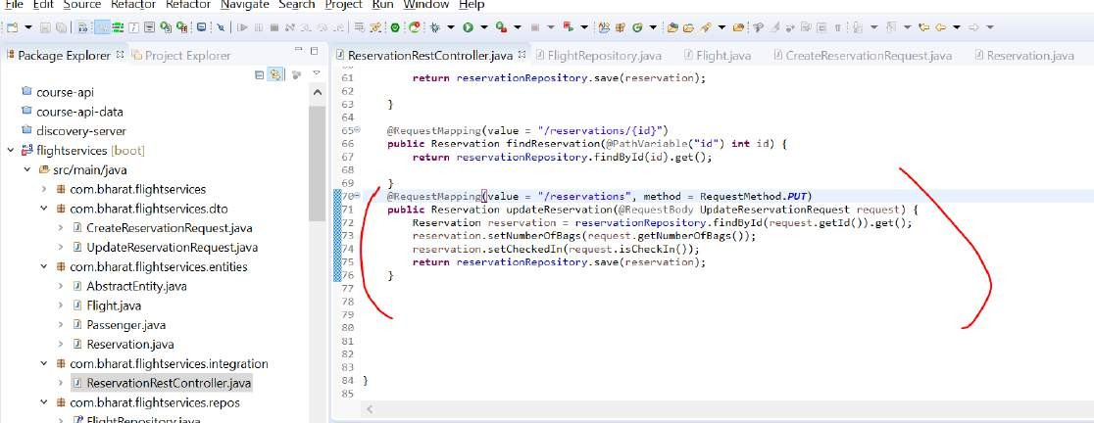

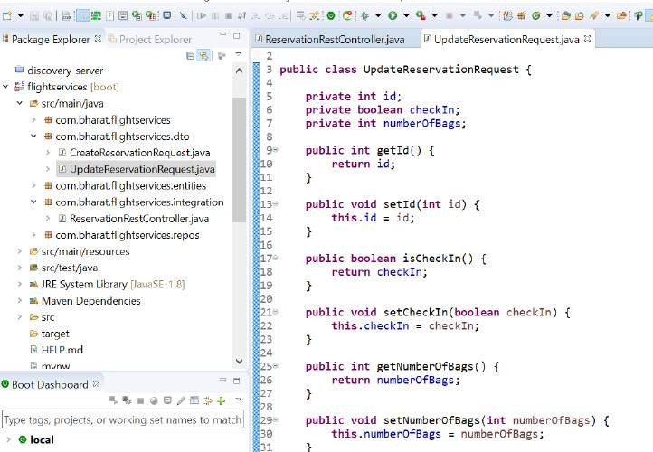

Note :

Save method will do both creation and updation

###### Configure the data source and run

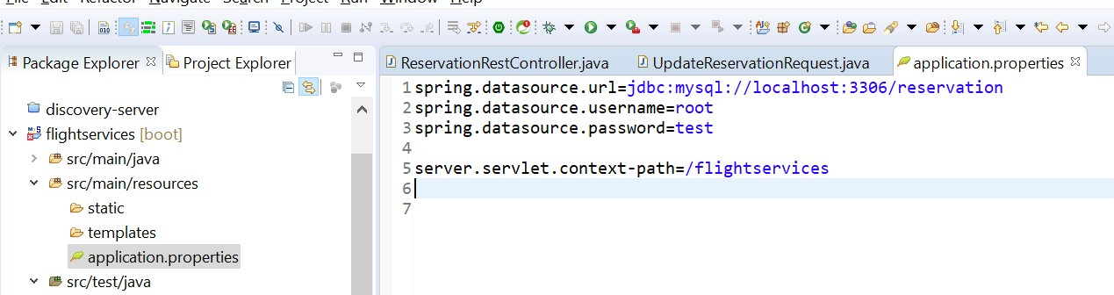

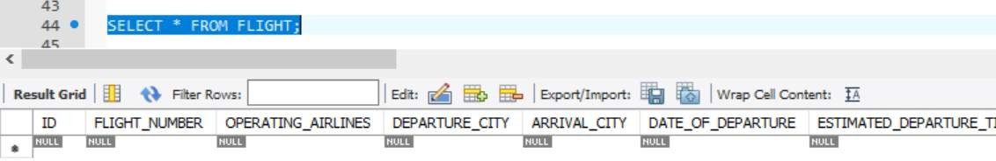**Add flights**

insert into flight values(1,'AA1','American Airlines','AUS', 'NYC',STR_TO_DATE('09-05-2018', '%m-%d-%Y'),'2018-09-05 03:14:07');

insert into flight values(2,'AA2','American Airlines','AUS', 'NYC',STR_TO_DATE('09-05-2018', '%m-%d-%Y'),'2018-09-05 05:14:07');

insert into flight values(3,'AA3','American Airlines','AUS', 'NYC',STR_TO_DATE('09-05-2018', '%m-%d-%Y'),'2018-09-05 06:14:07');

insert into flight values(4,'SW1','South West','AUS', 'NYC',STR_TO_DATE('09-05-2018', '%m-%d-%Y'),'2018-09-05 07:14:07');

insert into flight values(5,'UA1','United Airlines','NYC', 'DAL',STR_TO_DATE('09-05-2018', '%m-%d-%Y'),'2018-09-05 10:14:07');

insert into flight values(6,'UA1','United Airlines','NYC', 'DAL',STR_TO_DATE('09-05-2018', '%m-%d-%Y'),'2018-09-05 10:14:07');

insert into flight values(7,'SW1','South West','AUS', 'NYC',STR_TO_DATE('09-06-2018', '%m-%d-%Y'),'2018-09-06 07:14:07');

insert into flight values(8,'SW2','South West','AUS', 'NYC',STR_TO_DATE('09-06-2018', '%m-%d-%Y'),'2018-09-06 09:14:07');

insert into flight values(9,'SW3','South West','NYC', 'DAL',STR_TO_DATE('09-06-2018', '%m-%d-%Y'),'2018-09-06 10:14:07');

insert into flight values(10,'UA1','United Airlines','NYC', 'DAL',STR_TO_DATE('09-06-2018', '%m-%d-%Y'),'2018-09-06 10:14:07');

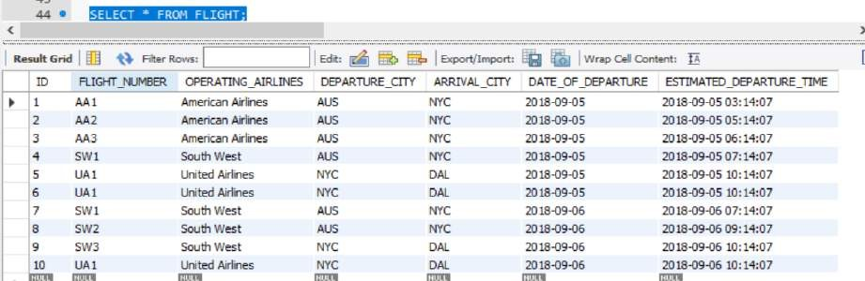

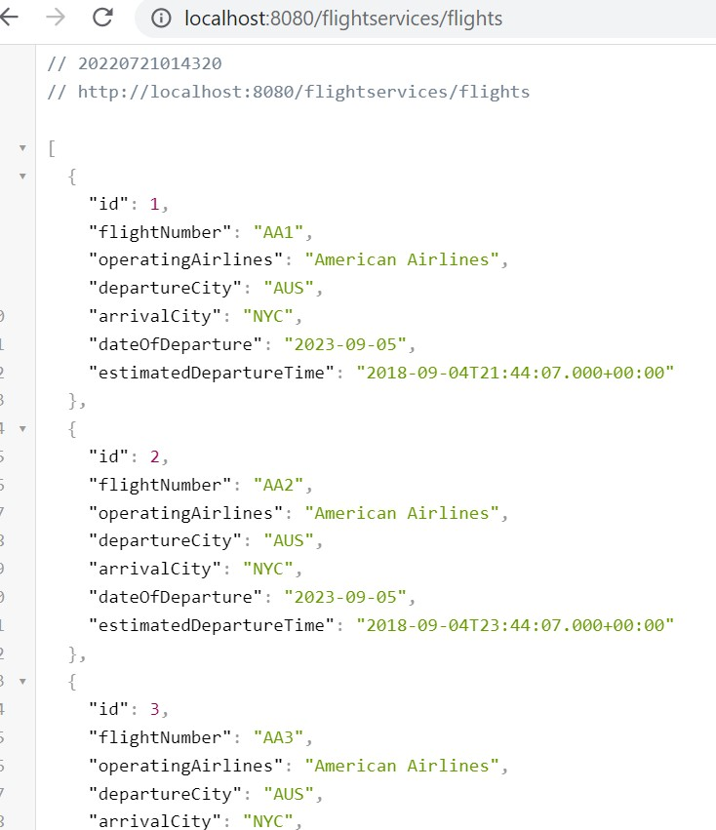

###### Filter flights

Right now findFlight returning all the flight from the d/b but that is not what we need for our application

###### We need to filter flight from city to city and departure date

**Step:**

Add a method to flightRepository that will filter out query

**@Query** : internally jpa will convert this into d/b query

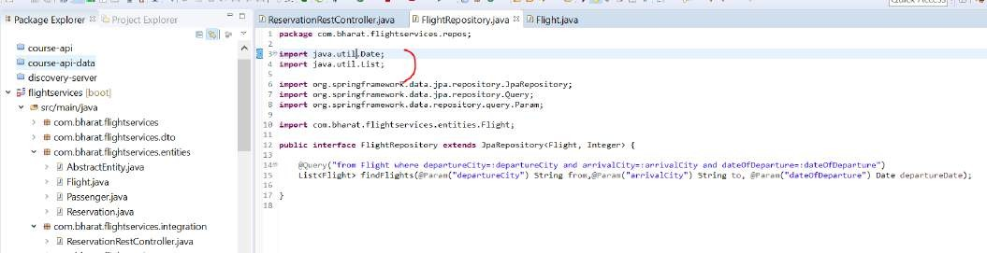

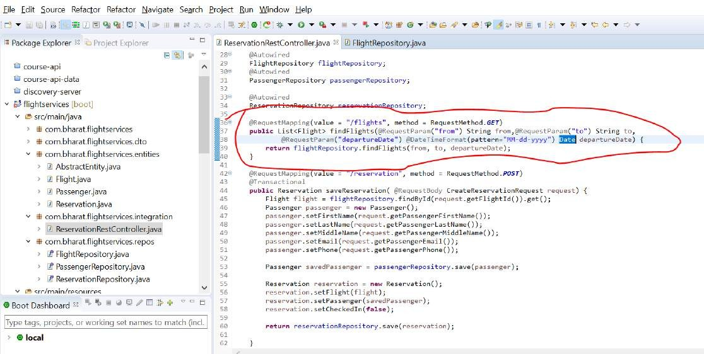**Using @Param** we are binding value from to departureCity

###### Test filter flight using postman

After filter we will get 4 record

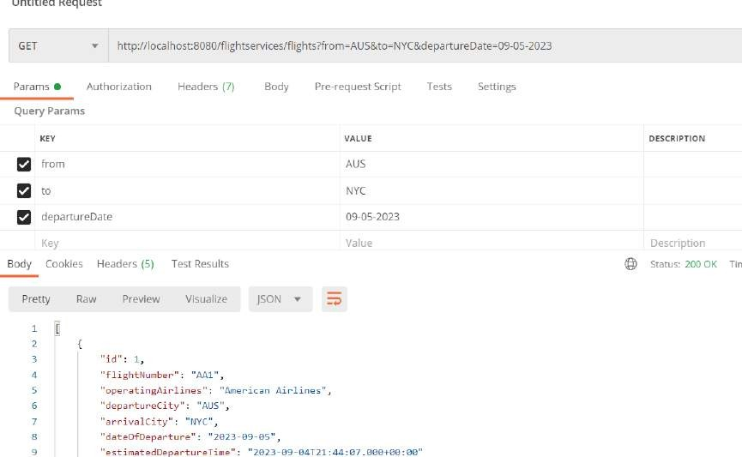

There are total 10 flight once we added criteria will get 4 flight

###### Test save and find reservation

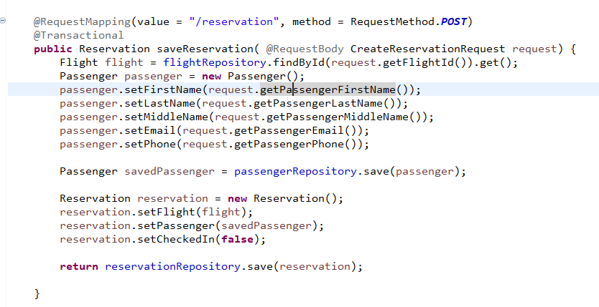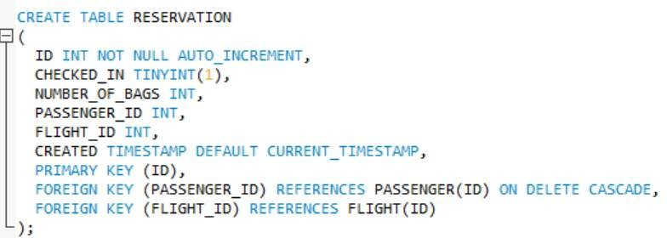

As a response we will get both flight and passenger info

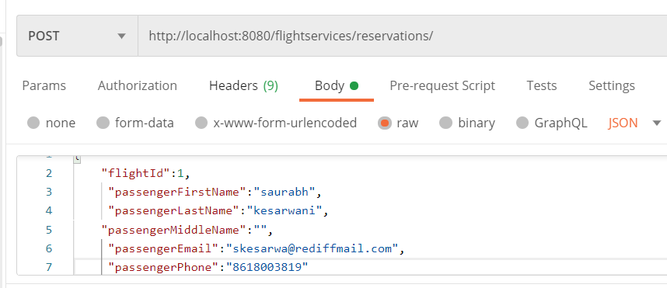

Response :

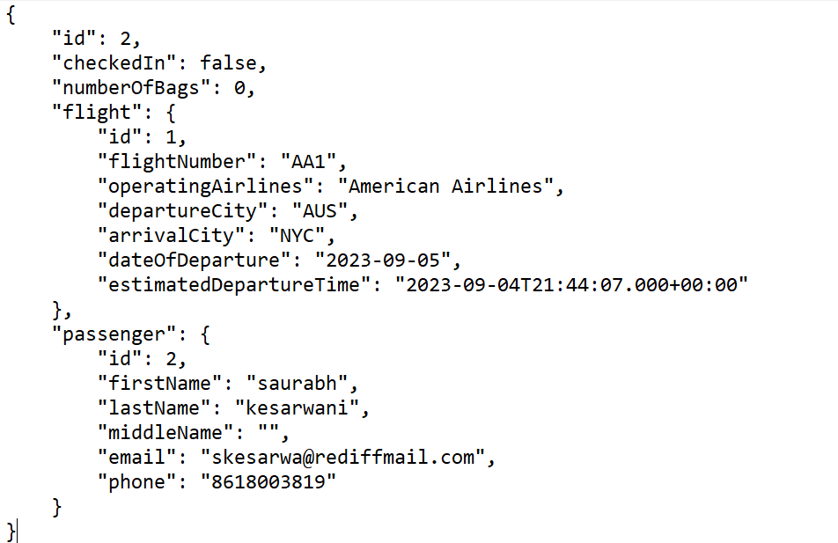

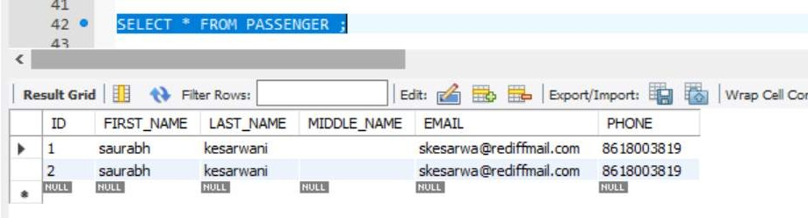

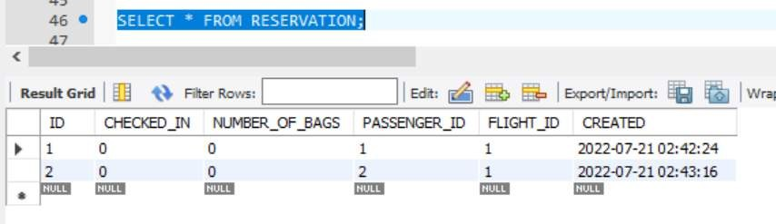

###### We can retrieve reservation

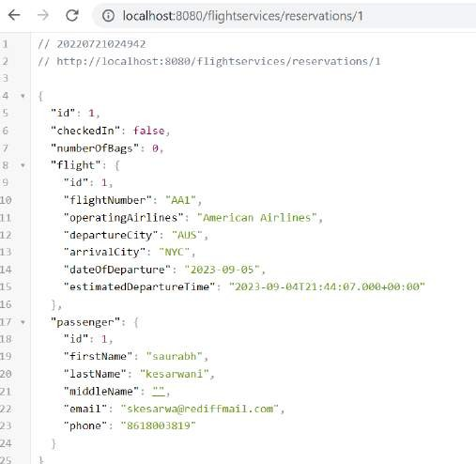

**Test Update We need to also pass id, checkIn,numberOfBags**

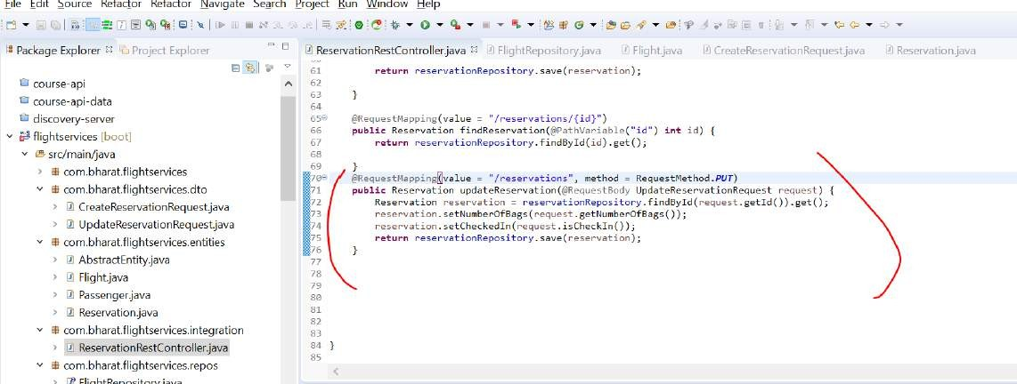

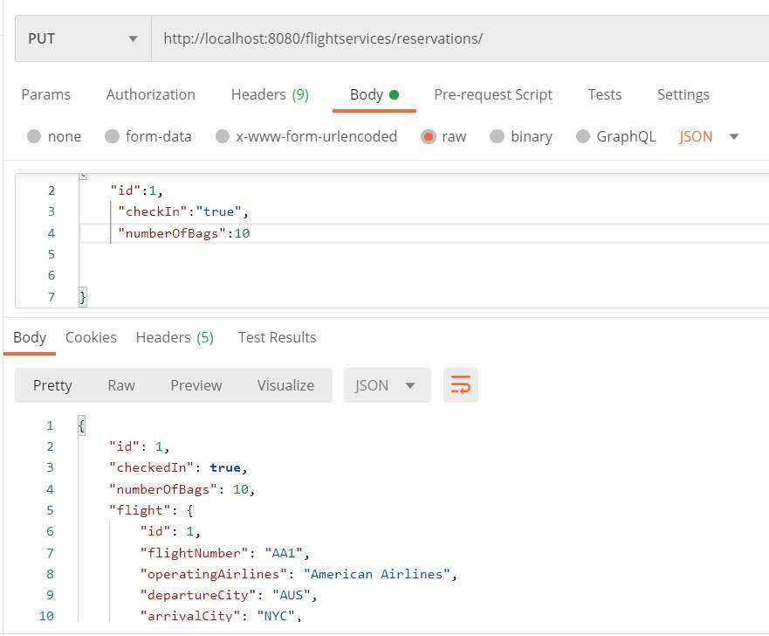

**Create and test findFlights**

In checkin process we need to fetch single flight info given a flight id

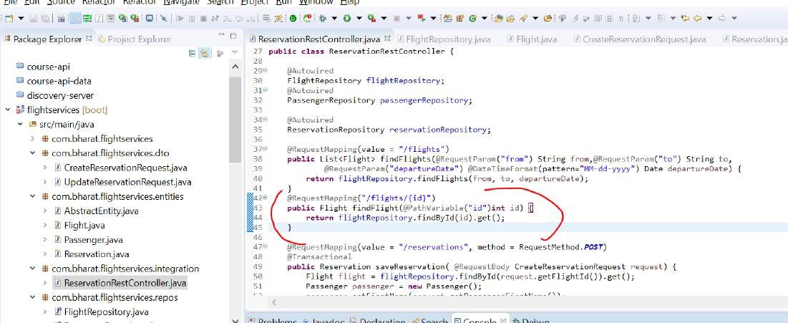

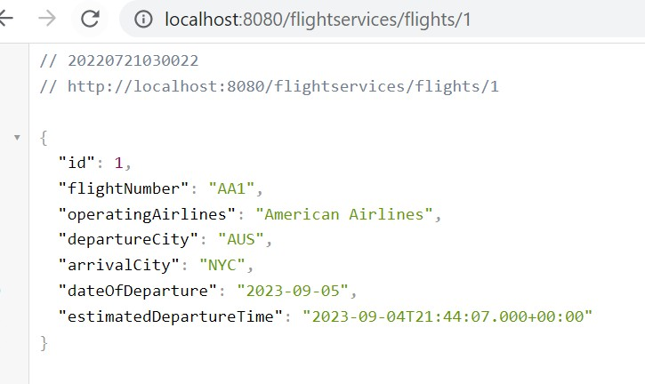

###### Add cross origin support site

**For angular app to communicate with restful application we need to turn on CORS**

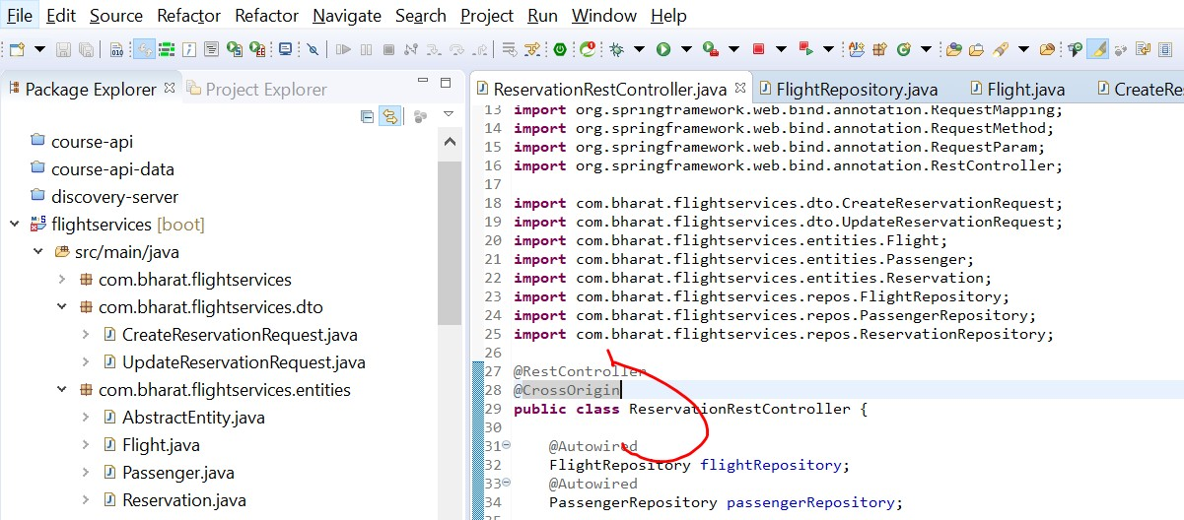

Section 15: create the flight reservation app

Four diff screen :

Screen 1:

Find flight:

Screen 2:

List of flight Screen 3:

Passenger details

Note: whichever flight he will select that flight will be fetch

###### FlightReservation

Find flight Display flight Passenger details

Confirm reservation

We have one service that is responsible for all the backend call : **reservationService**

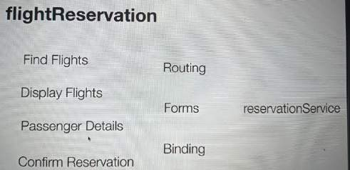

###### Create The project

Will create angular project with four component and one service

###### Create the project :

ng new flightReservation

###### Create components :

Ng g c components/findFlights Ng g c components/displayFlights

Ng g c components/passengerDetails Ng g c components/confirm

###### Create Service

Ng g s services/reservation

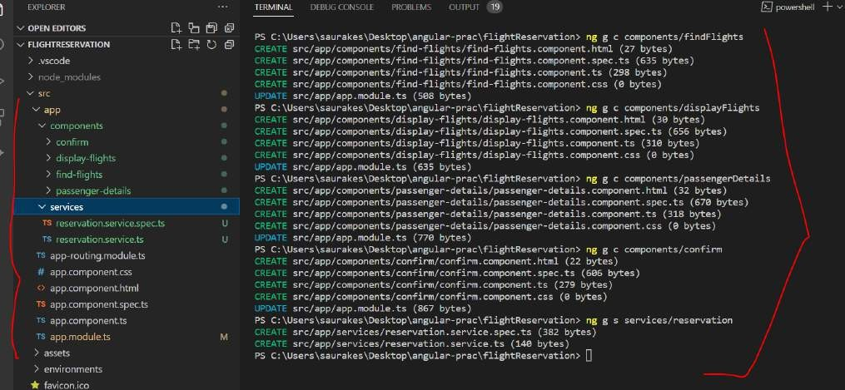

Note :

**Criteria** class is binded to **find Flight** display screen using angular. We can send them to backend

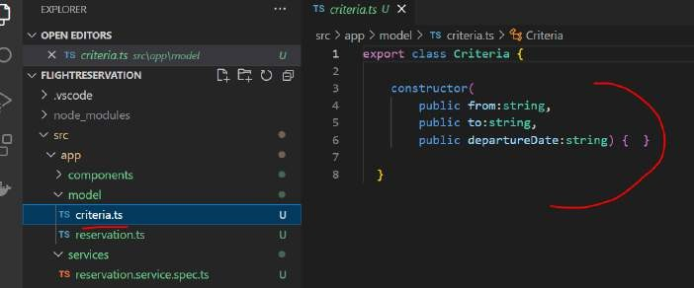

**Passenger Details** ( third screen) is binded to **Reservation class and** we can send data to backend using a restful call

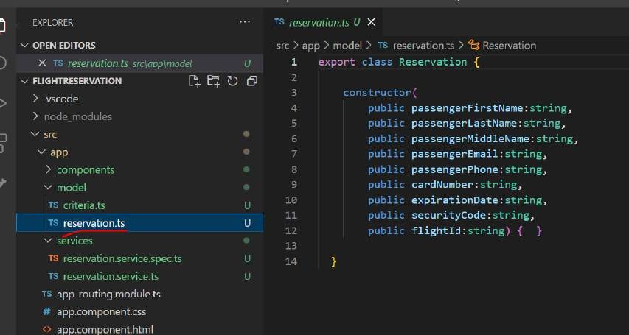

**Screen 1**: find flight (click on search) **Screen 2**: display flight (click on select) **Screen 3**: passenger details

**Screen 4:** once data is saved in d/b then confirm screen

###### Reservation Service part 1

**This service class is responsible for making three backend call**

* Click on search it will fetch flight details
* Click on select it will fetch single flight details
* Click on confirm it will save reservation For that we need **httpClient**

###### Step1

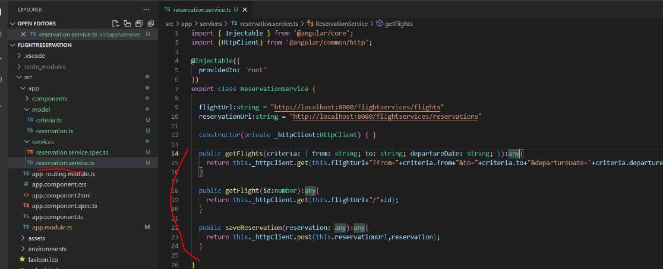Get all the flight when criteria is entered

###### Configure routing

**Routes : is the array which will hold various components**

**Select :** we need to pass flight id and display select flight and passenger details

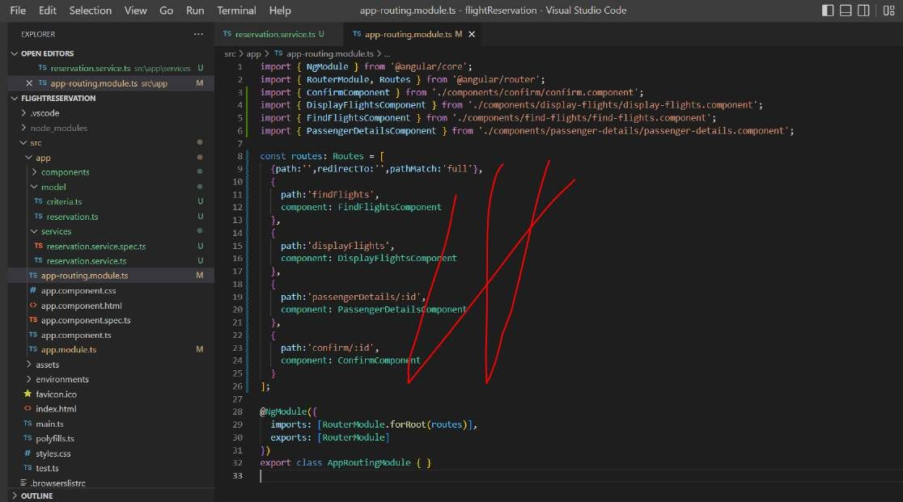**Confirm :-** it will get id and show confirmation

###### By default :

it will display index.html when we do without any route (localhost:4200)

###### Find Flights

**Implement findFlight component :**

**This is responsible for generating the data when we click on search**

Initially criteria will be blank , when user enter data automatically those field will be be binded to criteria Data will come in form of criteria object(ts file) from template

Note :

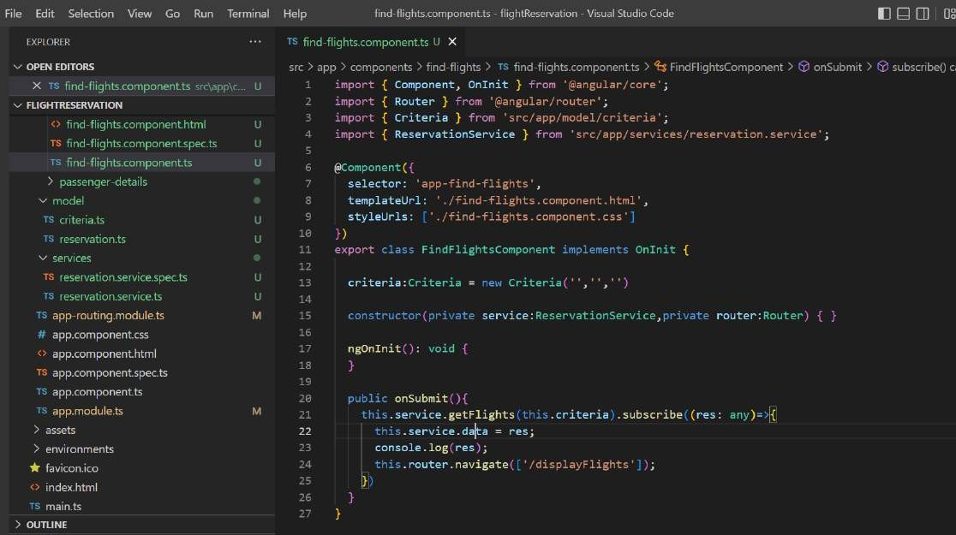Once we get data , we put data in service class data field. Because service will be there as long as application is up

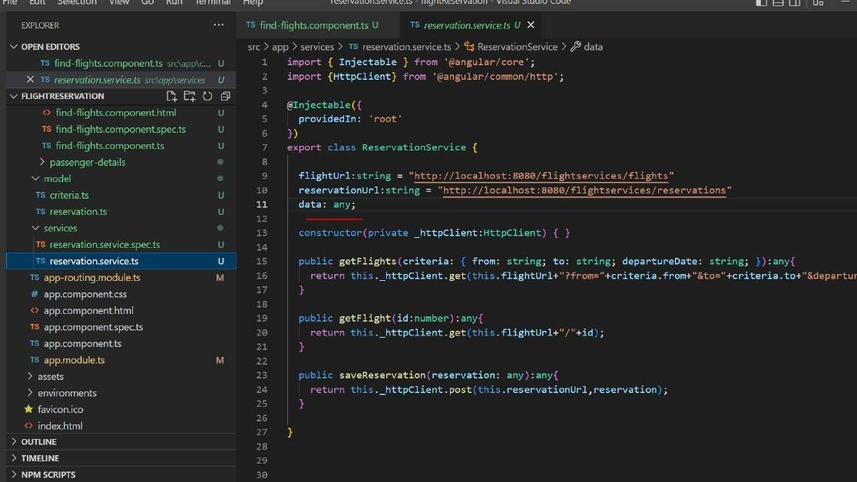

We send the response back so that next component can use it when we click on search

###### Bootstrap the application

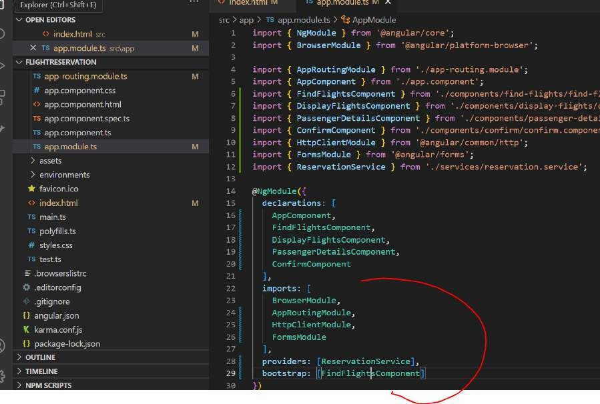

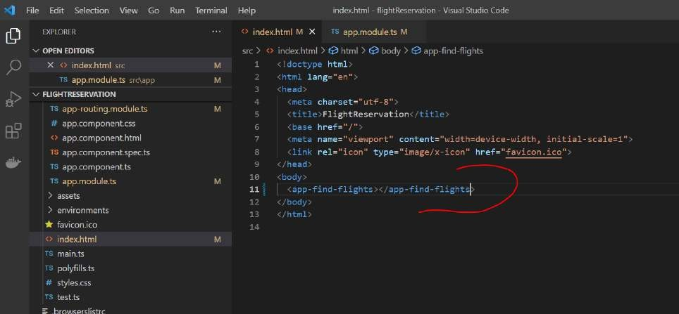

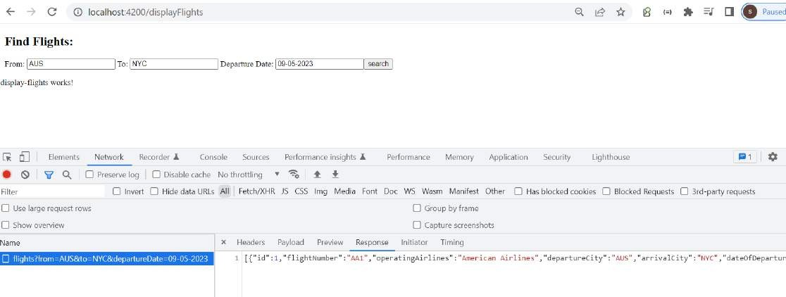**Test findFlights**

Because we havent implement display flight yet

###### Display flights

Will display all the flight that is fetch from backend We are retrieving the data from service to component

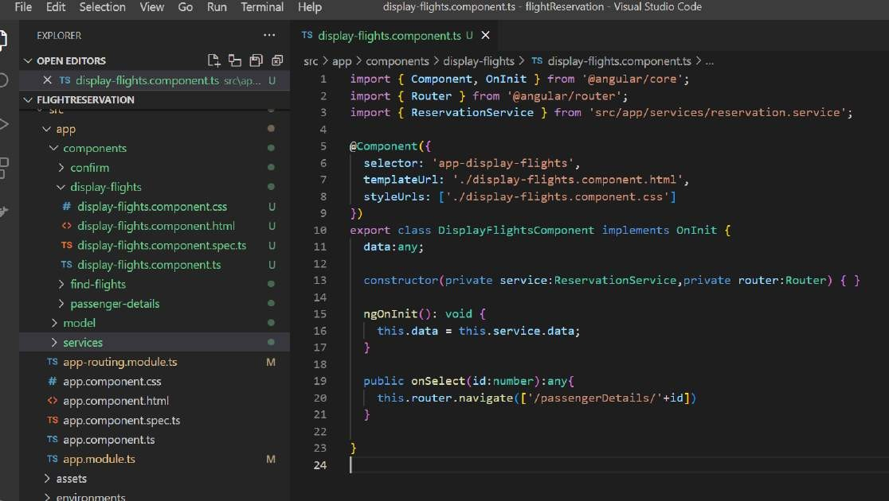

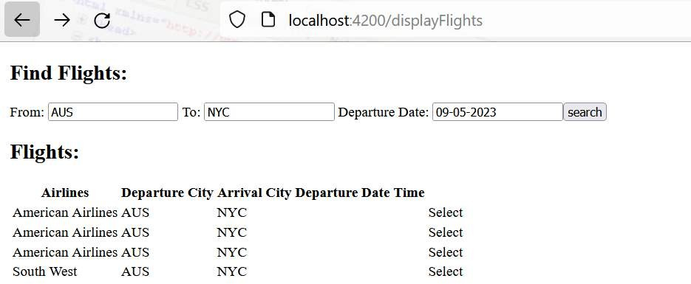

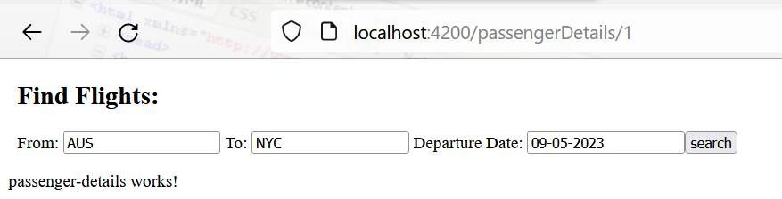

###### Passenger details part 1

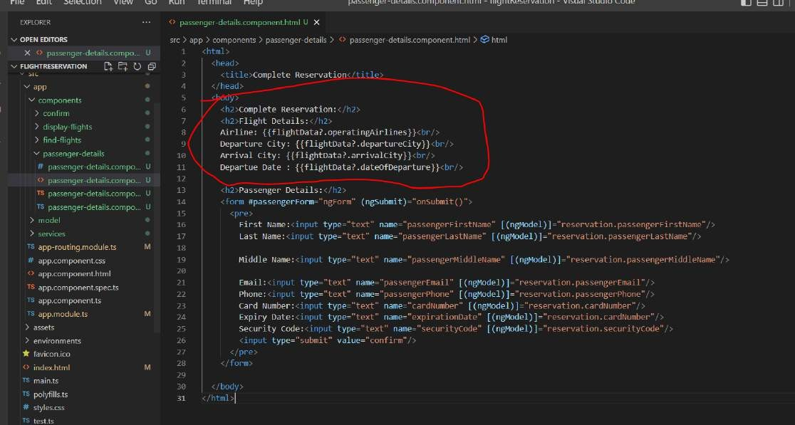**Will implement in two parts :** in this lecture we will get single flight details

**ActivatedRoute** : to get the value from the router

All the route parameter will be available through paramMap

###### Single flight information

**Passenger Details part :2**

For reservation need to make we also need flight id

###### Note

Along with passenger data , we also required flight id for reservation to be happened

**For confirm** : we are passing reservation id

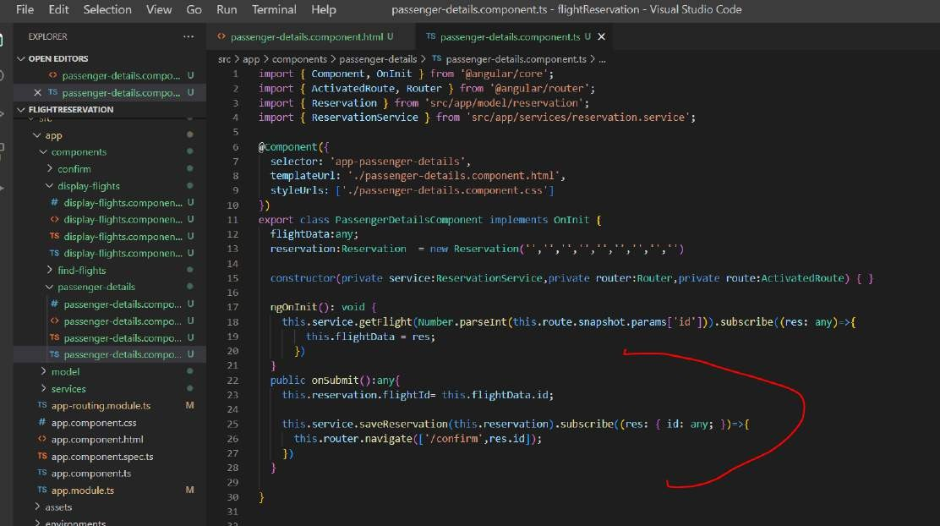

###### Confirm and test end to end

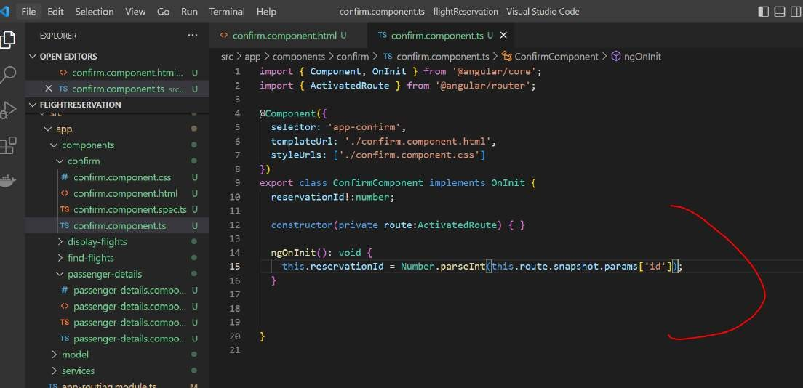

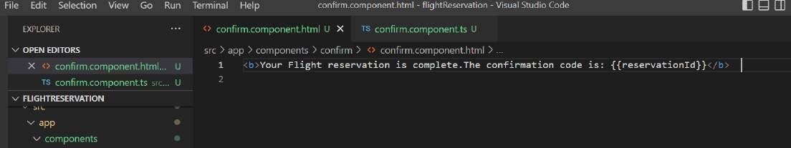

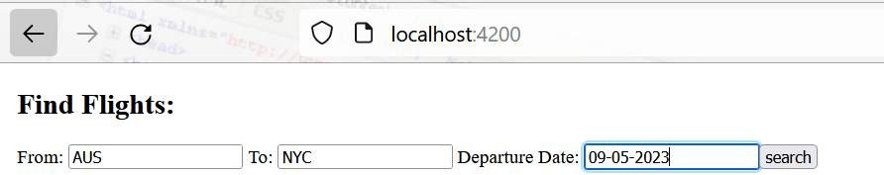

**Click on search**

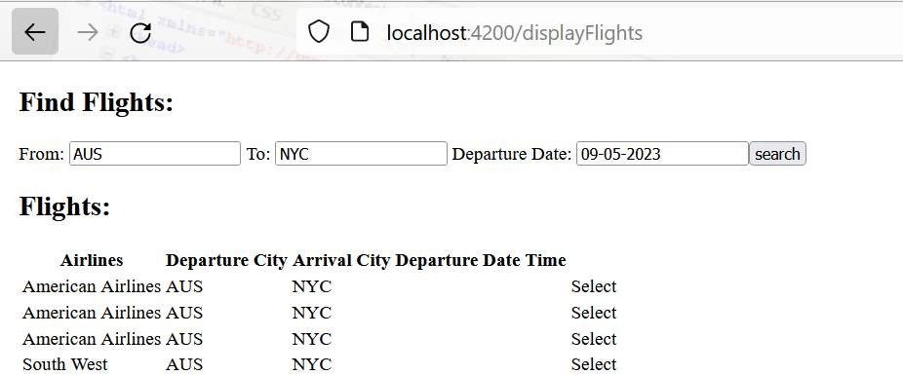

**Click on select**

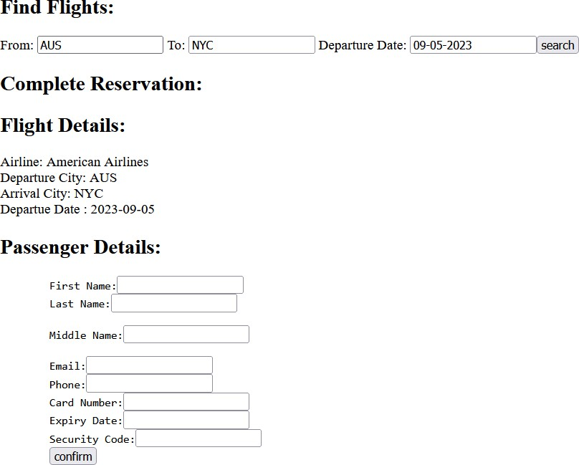

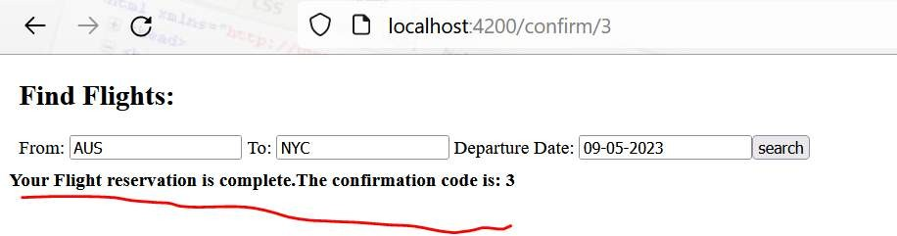

Section 16: develop flight checkin app

###### Create project

**Four screen**

**Screen 1**: user need to click on button . This will be generate by default app component

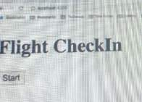

**Screen 2**: enter the reservation id for which we want to checkin. Click on next backend call will make to fetch the reservation details

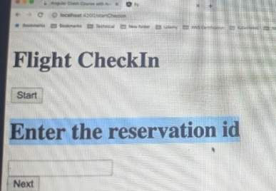

**Screen 3**: client can quicky review flight details and passenger details and enter number of bags

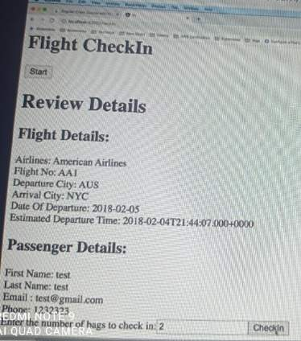

**Screen 4**: after clickin on checkin user detail will get updated in reservation and checkin complete message will get

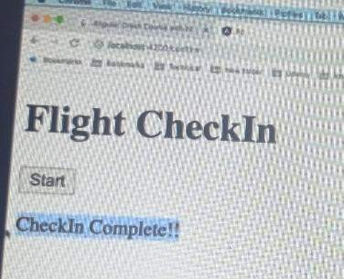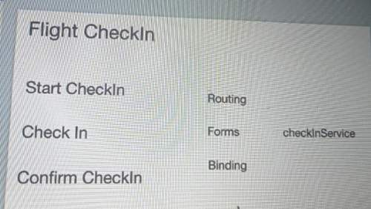

###### Create the project

Ng new **flightCheckin**

###### Total three component

two backend call we have

Ng g c components/startcheckin Ng g c components/checkin

Ng g c components/confirm

###### Create the service :

Ng g s services/checkin

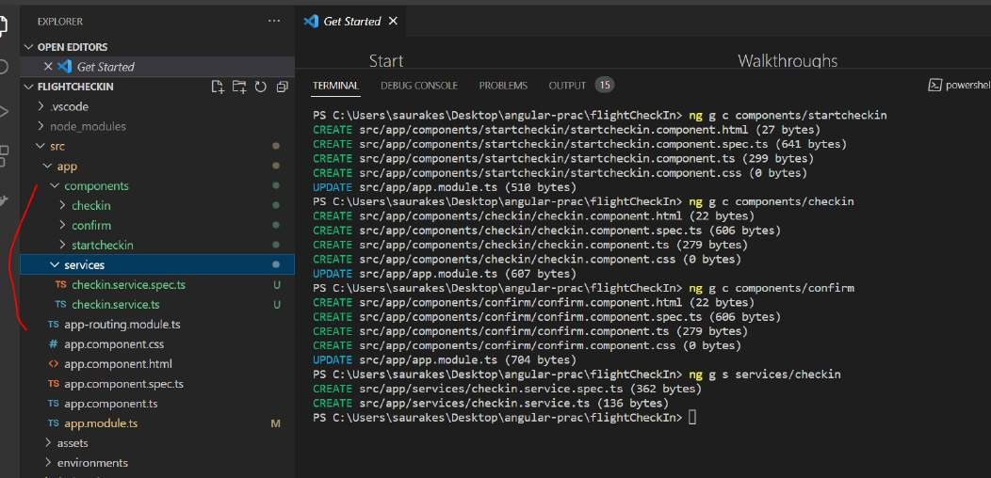

###### Implement the service This service is responsible for 2 backend call :

To fetch the reservation

And to update the reservation

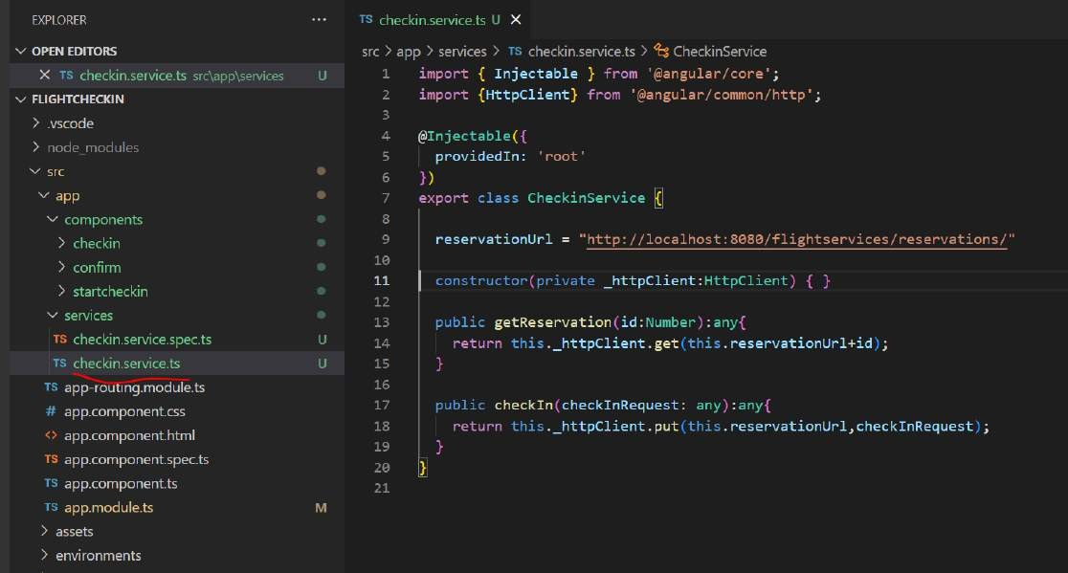

###### Configure Routes

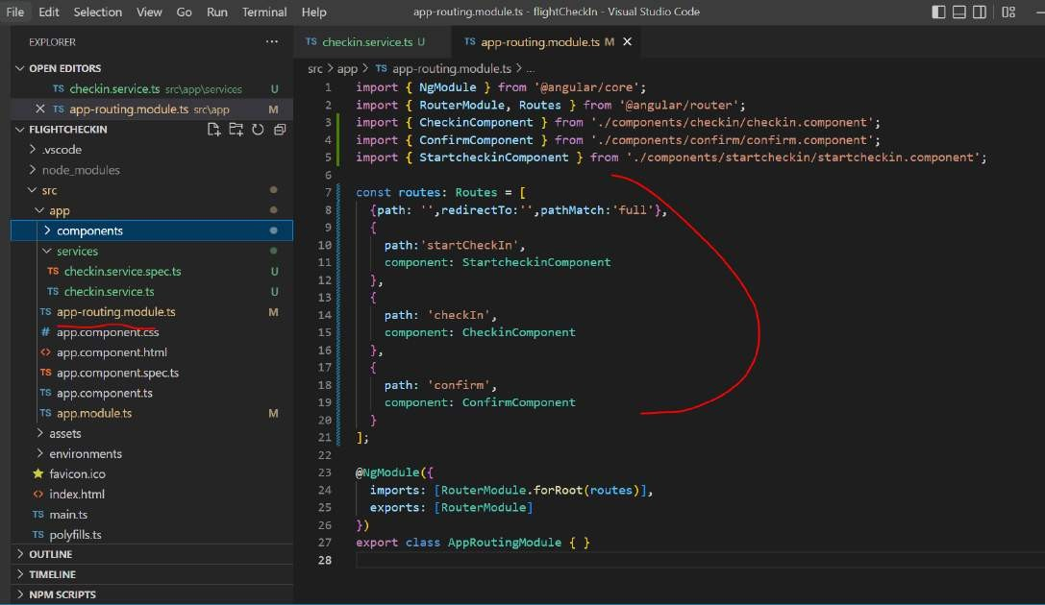

**Implement start checkin**

**Will implement two screen**

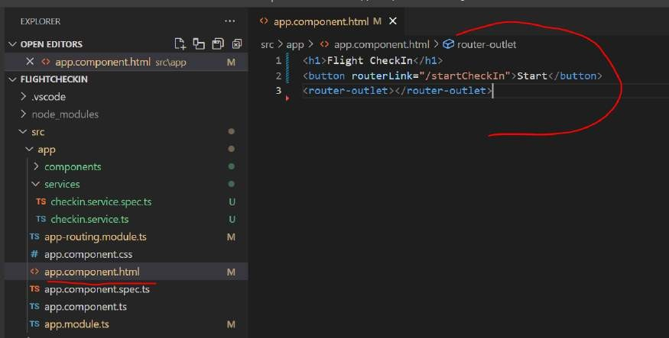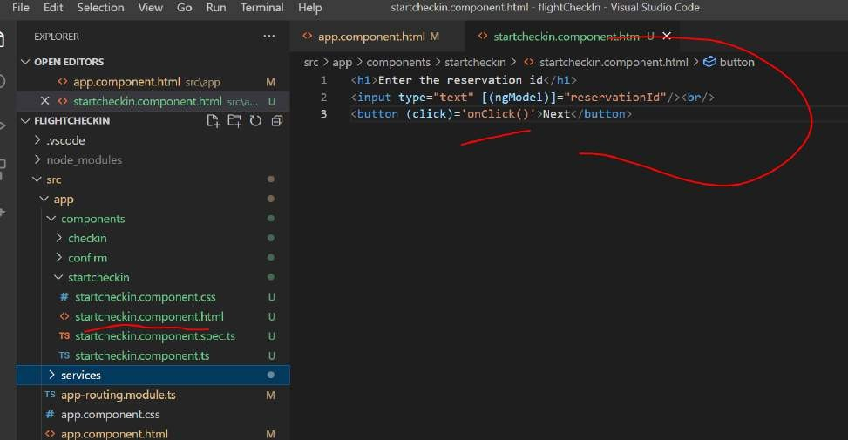

**Note**

The response will get from reservation api by id will put in data into service class this will be maintain into us which can be use by other component

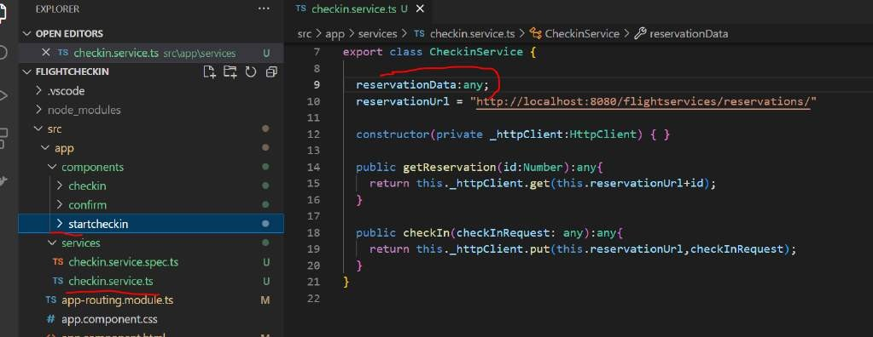

###### Bootstrap and test

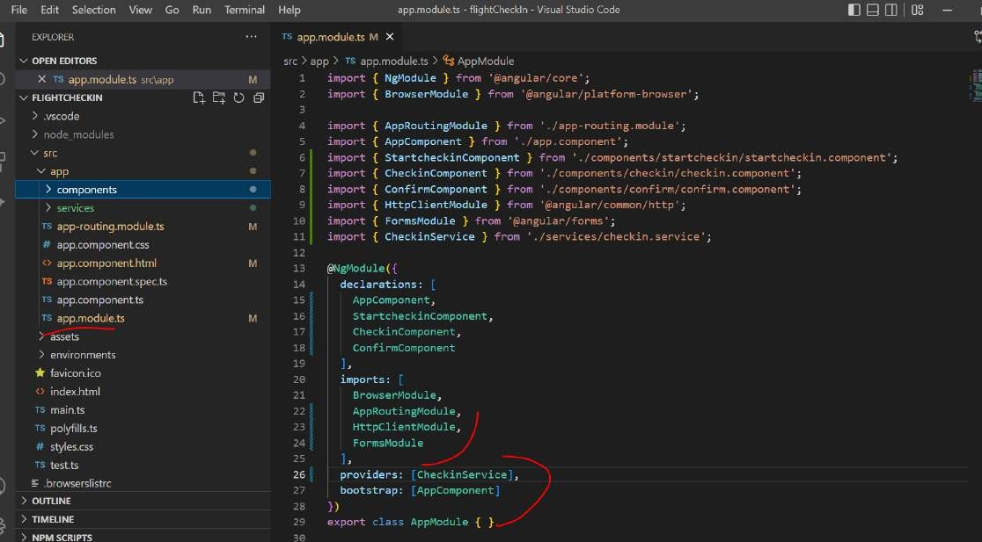

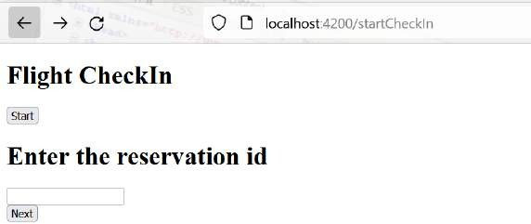

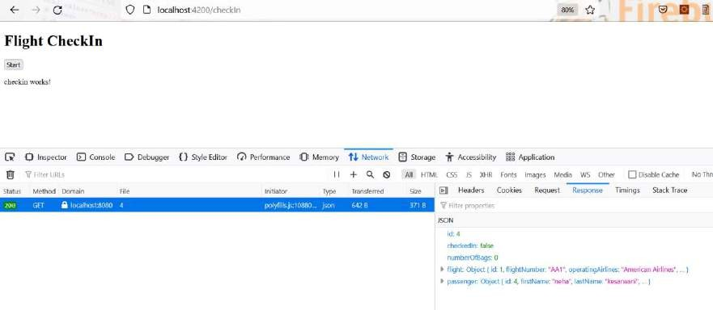

**Implement Checkin**

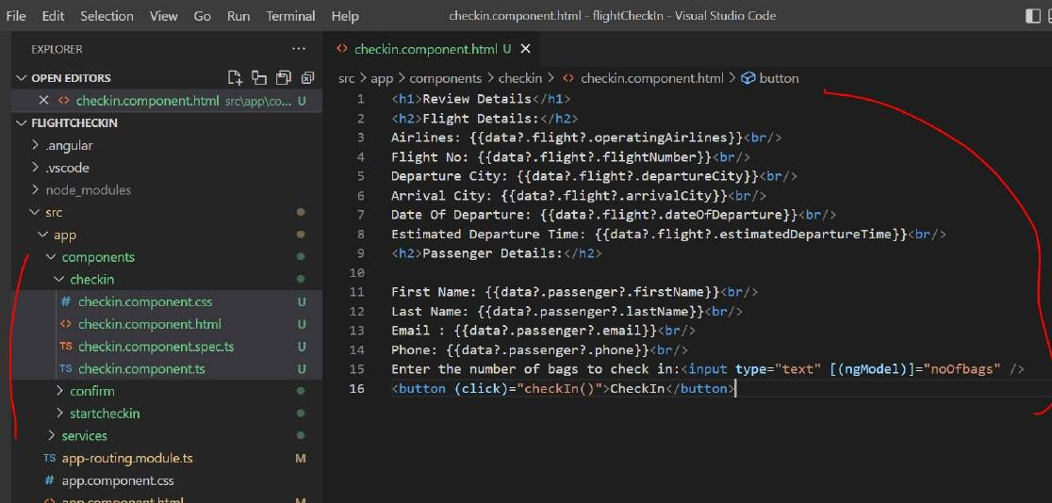User will quickly review the reservation. Enter the number of bags and check in Data and noOfBag field is expected on compoent

If we write list?.values, it means that if list.values is non-null, then it will show, and if list.values is null, it will not show. In any case, it will load the corresponding HTML part without any error.

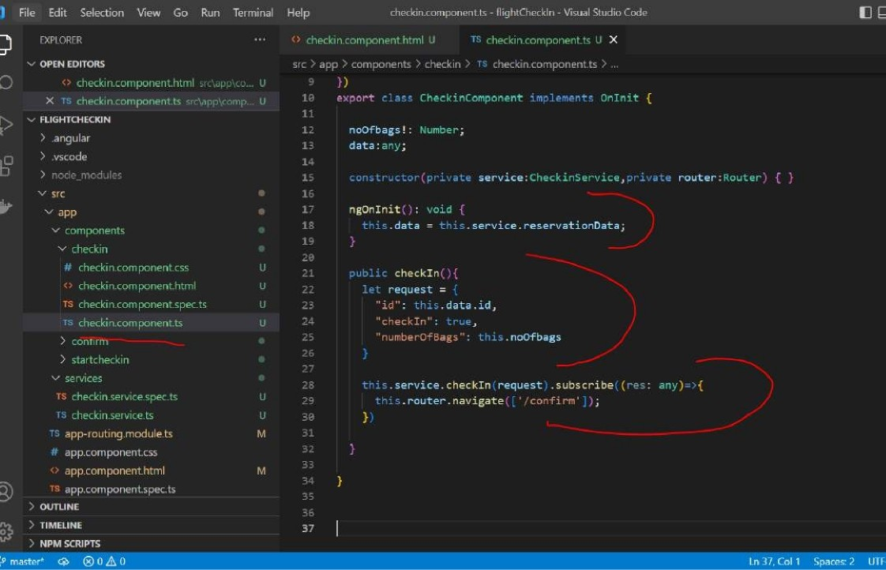

6 C's @ loceThoct-4200/startCheckln



Enter the reservation id

 localhost:4200/checkln

Flight Checkln

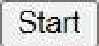

# Review Details

## Flight Details:

Airlines: American A lilines Flight No: AA1

Departure City: AUS

Date Of Depariiue: 2023-09-0ñ

Estimated Departure Time: 2023 —09—04T* 1:44: 07.000-00: 00

## Passenger Details:

First ñ'anie: neha

Last Naiiie: kesaru aui Email : neali

Phone: g s 888888

Enter the number of baps io check in: Checkln

#### C locafhost:4200/confirm

Flight Checkln

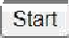

confam z orks!





|  |  |  |  |  |  |  |
| --- | --- | --- | --- | --- | --- | --- |
|  | ID | CHECKED_IN | NUMBBR_OF_BAG5 | PA55DNGDR_ID | PLIGMT_ID | CREATED |
| ¥ | 1 | 1 | 10 | 1 | 1 | 2022-07-21 02: 42: 24 |
|  | 2 | 0 | 0 | 2 | 1 | 2022-07-2102:43:16 |
|  | 3 | 0 | 0 | 3 | 1 | 202247-2t17:53:3d |
|  | 4 | 1 | 4 | 4 | 1 | 20Z2-07-2117:55:39 |